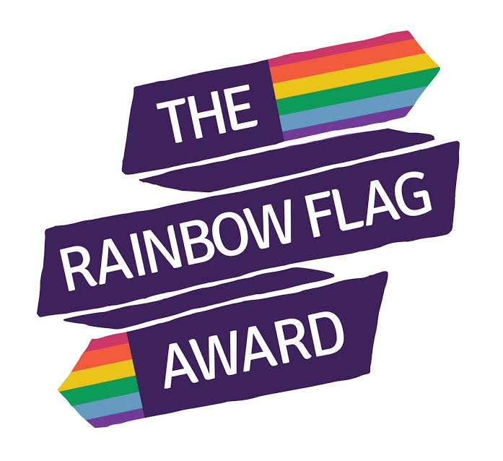
Rainbow Flag Award
Frequently Asked Questions

Why do we need to do LGBT positive education?
You don’t have to look far to find an overwhelming amount of evidence showing that LGBT young people are still disproportionally affected by mental health issues and teen suicide. Youth Chances (2014) reported that approximately three quarters of LGBT young people (74%) have experienced name calling, nearly a half (45%) have experienced harassment or threats and intimidation and almost a quarter (23%) have experienced physical assault. Why is this, given the wealth of legal changes in equality in this country? Laws and attitudes may have shifted positively in recent years, but many school’s education around LGBT identities has not changed, if it happens at all. The process of “coming out” remains – for many – as difficult as ever, unsure of the responses that friends and family will give. We are still leaving LGBT young people to “work it out” for themselves.

Might we “confuse” our children if we talk about this?
Many of the pupils in your care will already be experiencing confusion, because the identities that they align to are not being discussed, let alone affirmed. Queer Futures (2016) found that in terms of accessing support, LGBT young people are least likely to try and seek this from their school or teachers. Having a visibly LGBT inclusive school will not make more people identify as LGBT, but it may well enable those who do identify as LGBT, to feel more safe to be open about it and access any support they might need.

Is this kind of education appropriate in primary schools?
YES! Many of the pupils that exist in your primary schools will have LGBT family members. Many will realise that they are LGBT, if they haven’t already. All will have friends that “come out” as LGBT at some point in their lives. We are doing a great disservice to all pupils if we don’t prepare them for the world we live in. Taking part in this project will give you access to a wealth of age-appropriate resources such as lesson plans and toolkits. This will enable safe conversations to take place, for example, about different families or what it is to be a boy or a girl.

What if parents complain?
This is rare these days, as we find that most parents are supportive of inclusivity and anti-bullying. However, you may get questions from some parents asking about why you have introduced LGBT positive education. We will equip you with the responses to these questions, which will all be about your responsibilities – legally, through Ofsted and morally – to ensure practice is inclusive and meeting the needs of all your pupils. This kind of education will go a long way in the eradication of homophobic language and incidents in schools. We often find it helpful to say to parents that if they don’t want bullying to take place, then this sort of education is necessary.

What if parents want to withdraw their child from LGBT positive education?
Parents have the option to withdraw their children from Religious Education (RE) and aspects of the Sex and Relationships Education (SRE) curriculum. Many of the ways in which we will encourage your school to be more LGBT inclusive will not sit within either of these categories, and much of it can be badged as anti-bullying education. We would encourage you to treat any withdrawals from LGBT positive education as unauthorised absence.

We are a faith school…?
Faith schools are still bound by the same legal, Ofsted and moral requirements to meet the needs of all their students and to challenge bullying and discrimination. We must break down the misconceptions that LGBT people can’t have faith and that people of faith are homophobic. Instead we can look to the parallels in religious teaching about encouraging a world that is full of kindness and acceptance. The Church of England released some very useful guidance in 2014 – “Valuing All God’s Children” – highlighting how their schools should be, and can be, recognising and challenging homophobic bullying.

Further useful reading:

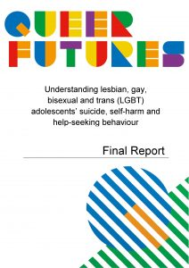
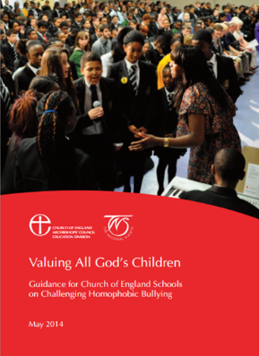
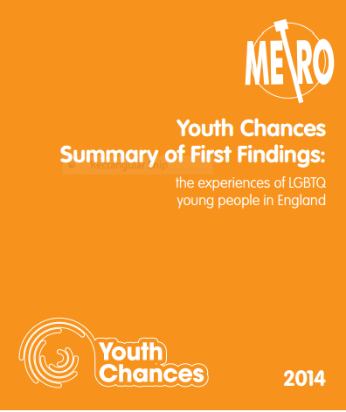

Valuing All God’s Children Youth Chances Queer Futures
(2014) (2014) (2016)

