Twitter Polls
A subgroup of the WAAW/EAAD planning committee with local representation from across England has developed digital resources for health care workers to be used and shared during WAAW 2020 including the following Twitter Polls.

This was to take into consideration the difficulty due COVID-19 in sharing resources and running local WAAW events. These have been approved by the national planning group.

The Twitter polls will be shared during WAAW using the UKCPA Pharmacy Infection Network social media account. An image and Twitter poll will be released each weekday during WAAW. The results of the poll will be shared the following day with a related image and message.

Some of the following polls will be updated when the ESPAUR 2019-2020 report is released

Twitter Poll 1

Antibiotics are effective against COVID-19 infection?
- True
- False
- Do not know

Answer
- False. Antibiotics are NOT effective against COVID-19?
- Cold, flu and COVID-19 are caused by viruses.
- Antibiotics are compounds that are active against bacteria.

Learning for health https://www.e-lfh.org.uk/programmes/antimicrobial-resistance-and-infections/

Twitter Poll 2
What are your local empirical guidelines influenced by? (If other, please comment below)
- National Guidance
- Resistance patterns
- Drug availability
- Expert opinion
- All of the above

Answer
Local empirical guidelines will always be based on national guidelines AND local resistance patterns. They may also take into account expert opinion and antimicrobial availability

Twitter Poll 3
When do you undertake review of an antibiotic prescription? (If other, please comment below)
  - Less than 24hours
  - Between 48-72hours
  - After 72 hours
  - Do not know
  - All of the above

Twitter Poll 4
In England what proportion of E.coli blood stream infections are now reported as resistant to co-amoxiclav?
- 10%
- 25%
- 37%
- 43%
- Do not know

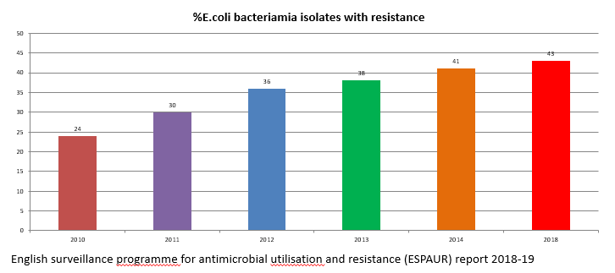
Answer

Twitter Poll 5
Antibiotic resistant bacteria can spread from person to person?
- True
- False
- Do not know

Answer

True - Antibiotic resistant bacteria can spread from person to person

Good Infection Prevention and Control is essential to help reduce transmission. Remember the 5 Moments for Hand Hygiene

