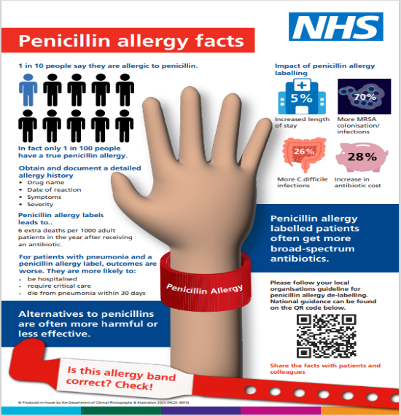
Penicillin Allergy De-Labelling (PADL)
Around 10% of patients in the UK report a penicillin allergy, yet studies show that over 90% of these labels are incorrect. Mislabelled penicillin allergies can lead to the use of less effective, broader-spectrum antibiotics, increasing the risk of antimicrobial resistance (AMR), treatment failure, and healthcare-associated infections such as Clostridioides difficile.

Download, promote and share the Poster

Why it matters:
- Patients labelled as penicillin-allergic are often prescribed second-line antibiotics, which may be broader-spectrum and less targeted.
- These alternatives can be less effective, cause more adverse effects, and contribute to the development of antimicrobial resistance (AMR).
- Structured allergy assessments and appropriate de-labelling can optimise antibiotic use, improve patient safety, and help preserve the efficacy of first-line treatments.

What You Can Do
- Take a detailed allergy history in line with NICE CG183 —clarify the nature, timing, and severity of reported reactions.
- Identify and support local champions for penicillin allergy de-labelling.
- Identify patients with penicillin allergy, assessing their drug allergy history, evaluating their risk and priority for de-labelling, and proceeding with de-belling where appropriate or refer to non- specialist PADL service in your local hospital.
- Set up a non-specialist PADL service BSACI guideline for the set‐up of penicillin allergy de‐labelling services by non‐allergists working in a hospital setting
- Engage patients in the process, explain the value of accurate allergy documentation and how reassessment can lead to safer, more effective treatment options.

Key Message: Addressing spurious penicillin allergy labels is a high-impact, low-cost intervention that supports safer, more effective, and more sustainable antibiotic use.
While PADL continues to be developed for 2025–2026, a wide range of resources is already available to support both primary and secondary care settings on the Futures platform.
Available now -The ALABAMA (ALlergy, AntiBiotics And Microbial resistAnce) trial results have been published in The Lancet Primary Care journal ALABAMA
Available soon on Futures
- A standardised training model to support non-specialist healthcare professionals in safely performing de-labelling.
- A global IT policy and strategy for penicillin allergy guidelines.
- A range of nationally agreed information from Scotland and Wales.

