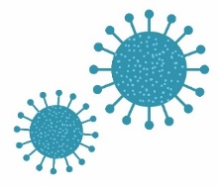

Name:
Please tick as many answers as appropriate
Which of these are microbes? |  |  | The smallest microbe is a:
Bacteria | X |  | Bacterium
Virus | X |  | Virus | X
Antibiotic |  |  | Fungus
Fungi | X |  | They are all the same size

Microbes are found: |  |  | Which foods or drinks are produced through the growth of microbes?
In the air | X |  | Cheese | X
On our hands | X |  | Bread | X
On surfaces | X |  | Yoghurt | X
Everywhere | X |  | Fizzy drinks

Microbes: |  |  | Which of these microbes causes the common cold?
Are all bad/harmful |  |  | Bacteria
Are all useful |  |  | Virus | X
Can be harmful or useful | X |  | Fungi
Have no effect on the human body

