
NHS Newborn Blood Spot Screening competency pack
Practitioner’s name:

Job title:

Department:

Contact details:
Good quality blood spot samples are vital in making sure babies with rare but serious conditions are identified and treated early. Good quality samples should be obtained first time to prevent the need for avoidable repeats. Avoidable repeat samples can cause anxiety for parents, distress to babies and delays in the screening process.
A good quality blood spot sample is one that:
- is taken at the right time (date of birth and date of sample are mandatory)
- has all data fields completed to enable identification of the baby (NHS number is mandatory), analysis and reporting of results
- contains sufficient blood to perform all tests (each circle filled and evenly saturated by a single drop of blood that has naturally soaked through to the back of the blood spot card)
- is not contaminated
- arrives at the laboratory in a timely manner
Practitioners involved in NHS newborn blood spot (NBS) screening should refer to information and guidance on GOV.UK, including:
- NBS screening sampling guidelines
- NBS screening programme handbook
- NBS screening standards
- programme overview
- pathway for movers in with no available records
- NBS pathway requirements specification
- e-learning for health
- guidance on managing safety incidents
- code of practice for residual spots
- Screening tests for you and your baby
Visits to local NBS laboratories can be arranged by appointment and are considered to be a good learning resource.

How to avoid puncturing the calcaneus bone, plantar arteries and nerves

1. Use the lateral and medial portions of the heel as puncture sites indicated by the shaded areas in the diagram below.
2. Draw an imaginary line from midway between the fourth and fifth toes laterally and medially from the middle of the big toe as the calcaneus rarely extends beyond this point (see diagram below). These points are also the furthest away from the arteries and nerves.
3. An appropriately sized measured lancet should be used depending upon infant’s weight.
4. Select a new puncture site for each time blood is collected.
5. Make sure the correct technique is used, as this will reduce the risk of having to repeat the procedure again and thus reduce the trauma to the baby’s foot.

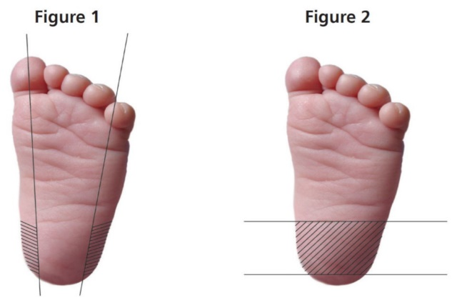

Figure 1. For full-term and preterm infants. An automated incision device with a penetrative depth of no more than 2mm is recommended

Figure 2. For infants who have had repeated heel punctures. An automated incision device with a penetrative depth of no more than 1mm is recommended.

These sites are also suitable for infants up to a year of age.

Governance competency checklist |  |  |  | Date achieved | Assessor signature
The practitioner:
- has completed e-LfH modules: Newborn Blood Spot (NBS) conditions, NBS sample, NBS interactive blood spot card
- has accessed professional handbook
- understands NBS standards
- has access to sampling guidance
The practitioner has awareness of contact details for child health staff and screening link health visitor.
The practitioner has contact details for local antenatal and newborn screening coordinator.
The practitioner knows the importance of using the maternity unit code and personal identification.
The practitioner can give appropriate information to parents on the newborn blood spot testing process, results sharing, residual spots retention and obtaining informed consent.
The practitioner has demonstrated a satisfactory technique when obtaining at least 3 observed blood spot samples – and completed the competency checklist
The practitioner understands the local system for safely transporting the sample to the laboratory, working according to national standards and local guidelines in practice, and the process for repeat samples in the case of rejected samples.
The practitioner has access to the newborn blood spot failsafe solution (NBSFS).
The practitioner has knowledge and awareness of incident reporting and guidance.
Name of practice assessor:  Name of practitioner: |  |  |  | Assessor signature:  Practitioner signature:  Date:
Practical competency checklist
The practitioner will demonstrate competence in bloodspot sampling of the newborn
Competence criteria  Demonstrated=D  Supervised= S  Competent=C | D | S | C | Comments
Knowledge:
- performs blood spot sampling on babies in accordance with legal, professional and policy requirements
- understands rationale for blood spot sampling
- has knowledge of anatomy and physiology applicable to blood spot sampling from heel
- can describe the procedure for obtaining a blood spot sample from the baby’s heel
- can discuss the factors that may help or hinder the procedure
- can discuss the risk factors associated with this procedure
- can discuss the correct procedures for minimising infection, including hand washing, use of aprons, gloves and aseptic technique
- can discuss knowledge of safe disposal of equipment
- can discuss the importance of accurate labelling of samples and completing request forms
- can discuss importance of record keeping
Practice:
- identifies the patient correctly
- explains the rationale for the procedure to the parents
- explains residual blood spots and research contact
- gains informed consent from the parents and documents appropriately
- selects appropriate equipment and blood collection device
- washes hands, wears gloves
- positions the baby appropriately, recommending comfort measures, for example breastfeeding, engaging in face to face contact, voice and touch
- inspects the foot and, avoiding underlying nerves and bone, selects the best site on the heel
- cleans the site with tepid plain water and leaves foot to dry for at least 30 seconds
- with the non-dominant hand, holds the ankle with the foot flexed
- pierces the skin with an appropriate newborn automated lancet (penetrative depth of less than 2mm for term infants) and disposes of the lancet directly in the sharps bin
- allows the blood to form into large drops, then collects blood as required without touching the card with the baby’s heel
- fills circles completely by natural flow, one spot of blood to each circle, ensuring the blood seeps through to the back of the card while avoiding layering of blood
- allows the blood spot card to dry completely before placing it in the glassine envelope
- applies pressure to the site using a cotton wool ball and applies a plaster if necessary
- encourages parents to calm baby
- documents accurately in appropriate records
- accurately labels the samples, ensures details match the request form and ensures despatch within 24 hours
- is aware that both hospital code and sample taker code (if applicable) should be added to sample card

