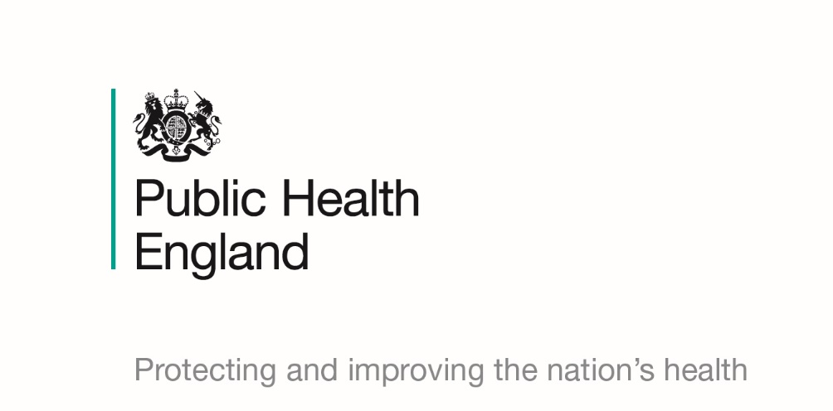

Resource X: Action plan template

This resource is part of Public Health England’s wider whole system approach to obesity programme. Please search to find the main guide and additional resources.
Brief description of action | Anticipated outcome | Feasibility | Responsibility | Alignment | Additional impacts on the system | Implementation timeframe | Commitment
Detail of the current or  proposed action.  What type of action is this (event, system structure, system goal, or system belief)? | What is the intended  outcome of this action and who should it  impact?  When will the action have an impact (short-, medium- or long-term)?  Should this action impact on health inequalities? | Is the action feasible to deliver at this time?  Are there the resources available to deliver (for  example, budget,  personnel, expertise) the action?  If no, how could the resources be obtained? | Who is responsible for the implementation of this action? | Does this action align with existing/proposed actions?  If yes, how does this align with other actions?  If no, what needs to be put in place for this to align with existing/proposed actions? | Who or what may  additionally be impacted by this action?  Both positive and negative unintended consequences.  Could this action widen or narrow health inequalities? | When can this action be implemented? | When will progress be reviewed?  What will success look like? How will you know that the action is  working?

