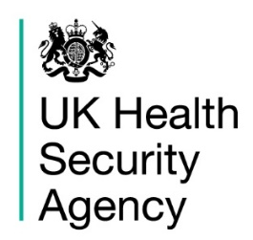
Health Protection (Notification) Regulations 2010:
notification to the Proper Officer of the local authority
Index case details
First name
Last name
Gender (M/F)
Date of birth
Ethnicity
NHS number
Home address  Postcode  Telephone number |  |  | Current residence if not home address  Postcode  Telephone number
GP name and address (if different from medical practitioner reporting the case) |  |  | Postcode  Telephone number
Occupation (if relevant) that is
food handler/healthcare worker/carer
Work/education/nursery name and address (if relevant) |  |  | Postcode  Telephone number
Overseas travel, if relevant (destinations and dates)
Disease/causative agent
Disease, infection, causative agent or contamination
Date of onset of symptoms
Date of diagnosis
Is the patient in hospital? |  | Yes |  | No | Hospital/ward:
Has a sample been sent?  If yes, is result positive? |  | Yes  Yes |  | No  No | Type: sputum/stool/blood/swab  Lab:
Has the patient been vaccinated against this disease? |  | Yes |  | No | Date(s) of vaccination
Date of death
Registered medical practitioner reporting the case
Signature
Name
Address
Postcode
Contact number
Date of notification

Please email/return to the Proper Officer, UKHSA, East Midlands
Seaton House, City Link, London Road, Nottingham NG2 4LA
Telephone: 0344 225 4524
Email: phe.emhpt@nhs.net

