

**Integrated Assurance and Approvals Strategy for Programmes and Projects**

**Portfolio and Project Delivery Directorate**

August 2018 – Version 2

Contents

Introduction 3

Purpose and scope 3

Application of assurance 4

Approvals 6

Responsibilities and accountabilities 7

Reporting 9

Integrated Assurance and Approval Plan (IAAP) 10

1st Line of Assurance 11

2nd Line of Assurance - Interventions 12

Gateway Assurance 12

Additional Assurance 12

3rd Line of Assurance - Interventions 13

Assurance Reviewers 14

Annex A – Integrated Assurance in the Home Office 15

Annex B – Sample IAAP 16

Annex C – Roles and Responsibilities 17

# Introduction

The Home Office Integrated Assurance Strategy for programmes and projects provides a strategic overview of the assurance regime required for all major, mission critical and transformation programmes and projects within the Home Office change portfolio. Programme and project assurance is a sub-set of the department’s overall assurance regime. The aim is to ensure that programme and project teams apply a consistent quality standard and approach to assurance and that this meets organisational, Infrastructure and Projects Authority (IPA) and HM Treasury (HMT) requirements for assurance planning and implementation. This Strategy aligns to the guidance provided by the IPA.

### Purpose and scope

This strategy sets out the assurance and approval arrangements for all programmes and projects within the Home Office change portfolio.

The Home Office’s portfolio assurance model is aligned to best practice in portfolio assurance, as defined by the new government functional standard for project delivery and the principles set out in Management of Portfolios™.

It also aligns with the ‘three lines of defence’ model (see the diagram on page 4) on which wider Home Office governance and assurance arrangements, and the new forward look-based Cabinet Office controls regime.

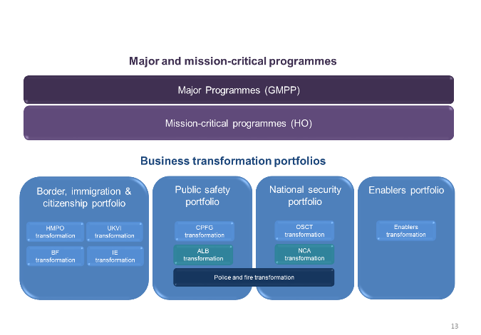The Home Office change portfolio has been structured so that governance and accountability arrangements are proportionate to the scale and criticality of the programme or project.

* **Major programmes** fall within the Government Major Projects Portfolio (GMPP) and are subject to oversight by the IPA and HM Treasury.
* **Mission critical programmes** are those programmes which fall outside the GMPP but are delivering strategic capabilities which are considered mission critical to delivery of Home Office strategic priorities and / or wider transformation.
* **All other projects and programmes fall within business transformation portfolios**. Funding for these portfolios is delegated and managed at business/system level, with Senior Responsible Owners (SROs) appointed by the business area Director General (DG). All projects over the £5m whole life cost threshold continue to need Portfolio, Investment & Change Committee (PIC) investment approval.

# Application of assurance

Programme and project assurance is a sub-set of the Home Office assurance and governance regime which aims to be ‘best in class’. It is important for programme and project teams, stakeholders and PIC, who need assurance that investment proposals are soundly based and are on track for delivery and realisation of benefits.

Programmes and projects forming part of the Home Office change portfolio are subject to regular assurance overseen by the Portfolio and Project Delivery Directorate (PPD) and based predominantly on the proven IPA assurance products.

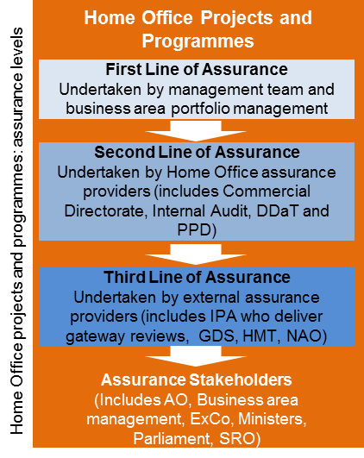Home Office programmes and projects are subject to the ‘three lines of assurance’ model as set out in the new IPA Functional Standards for Project Delivery (see diagram below) with SROs accountable for ensuring that appropriate assurance arrangements are in place. Annex A provides more detail on the assurance activities at each level.

* 1st line of assurance comprises assurance arrangements put in place by individual programmes and projects.
* Working with other corporate functions (Finance, Commercial, Digital, Data and Technology (DDaT)) and building on the 1st line, PPD integrates, manages and delivers the 2nd line of assurance. This is primarily assurance reviews based upon the IPA gateway process - a tried and tested approach which is used across all Government departments. Assurance and governance delivered at this level supports PIC investment approval considerations, and PIC approval itself is a 2nd line of assurance.
* 3rd line of assurance comprises corporate and external assurance including thematic reviews / audits provided by Government Internal Audit Agency (GIAA) or Major Project Review Group (MPRG), Government Digital Service (GDS), HMT and the National Audit Office (NAO) and also assurance reviews provided to GMPP projects through the IPA. It is co-ordinated with 2nd line of assurance interventions by PPD.
* Currently 2nd and 3rd line of assurance is provided without cost to the programme or project and supported by the government-wide reviewer community except for some GMPP programems, where IPA on occasion employs a freelance reviewer and that cost is passed on to the programme/project.
* PPD also provides advice and support to the projects and programmes in the Home Office change portfolio.
* The IPA mandates Integrated Assurance and Approval Plans (IAAPs) for all major programmes and PPD is promoting the creation and use of IAAPs by all programmes and projects (see Annex B for a template).

# Approvals

The Portfolio, Investment and Change Committee (PIC), a sub-committee of the Home Office Executive Committee (ExCo), and other portfolio boards at system/business level provide strategic oversight in addition to the governance provided by individual programme and project boards. Investment approval for all programmes and projects with a whole life cost (WLC) of over £5m is provided through PIC. PIC is supported by its sub-committees which are the Business Design Authority (BDA)[1], Technical Design Authority (TDA)[2] and the Commercial Assurance Board (CAB)[3]. It also has links to the Data Board and the recently established Policing Portfolio Board.

All Government spending is subject to formal oversight from Cabinet Office and HMT. This applies to Home Office spending on programmes and projects over £100m WLC. [Cabinet Office](https://www.gov.uk/government/publications/cabinet-office-controls) guidance on their approvals process is published on GOV.UK. Technical/Digital spend above £5m WLC also require approval from GDS.

# Responsibilities and Accountabilities

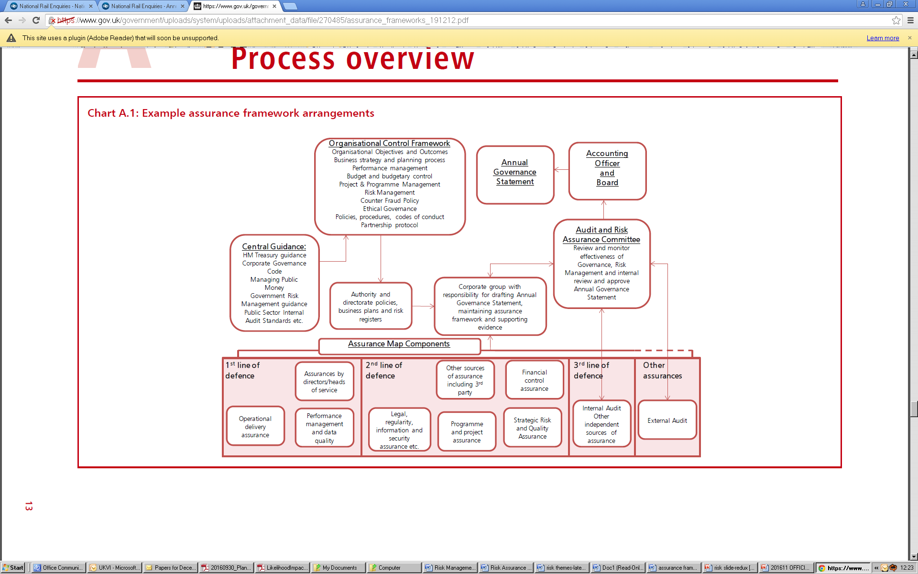As illustrated below, the Home Office Assurance Framework is based on best practice guidance from HMT. It provides assurance on different areas of organisational control which form the government framework for the department, as set out in the Annual Governance Statement.

Programme and project assurance forms a core part of this control framework, given the criticality of the department’s change plans and the significant investment in change over the current spending review period.

SROs are responsible for ensuring appropriate governance and assurance at programme and project level, including agreeing an IAAP with PPD and/or their sub-portfolio board, with Project Assurance Reviews (PARs) /Gateway reviews/internal assurance reviews at key points in the delivery lifecycle, and commissioning any other assurance deemed necessary or helpful. For major and mission critical programmes, SRO responsibilities are set out through [formal appointment letters](https://www.gov.uk/government/publications/home-office-major-projects-appointment-letters-for-senior-responsible-owners).

The Chief Portfolio Officer (CPO) is responsible for ensuring appropriate governance and assurance at portfolio level and the commissioning of PARs or Gateway reviews and any other assurance deemed necessary, e.g. deep dive reviews or audits.

PIC and its sub-boards (BDA, TDA and CAB) are in place and meet at least monthly to consider programme and project investment approvals. PIC also reviews portfolio progress, spend, resourcing, risks and issues monthly and quarterly, and agrees any necessary mitigation action and the latest view of portfolio delivery confidence. This includes monthly programme reporting to ExCo on Major (GMPP) and mission critical programmes, and quarterly to the IPA on the former.

Accountability for delivery of transformation plans, and the associated portfolio, lies with the DG of each business area, and the Chief Executive in the case of the Home Office’s Arm’s Length Bodies. Strategic direction is provided for transformation by the Strategic Capabilities Board, which is responsible for identifying the strategic capabilities which the sector needs, with executive oversight through the Departmental Board and ExCo. PIC is also responsible for overseeing delivery of business transformation portfolios.

### Reporting

Home Office major and mission critical programmes report monthly to PPD. These are collated into a monthly portfolio report for PIC. In addition, Major Programmes provide quarterly updates to the IPA, which feeds into the annual IPA report on the Government Major Projects Portfolio (GMPP).

Business Transformation Portfolios are required to update PIC regularly on progress. Some of their programmes and projects area also subject to investment approval from PIC.

Progress in meeting agreed assurance recommendations is tracked through individual programme boards. PPD also collates, monitors and analyses all assurance recommendations. The findings inform thematic internal audits and direct the support provided through the PPD capability team. PPD also monitors progress against internal audit recommendations.

# Integrated Assurance and Approval Plan (IAAP)

An IAAP is designed to ensure that appropriate assurance and approval activities are effectively planned, scheduled, coordinated and that resources are secured in advance.

The IAAP should initially be developed at the outset of a major programme, alongside the Project Initiation Document (PID) or equivalent, and from then on should be integral to the overall programme or project plan. Ideally, it should form part of the management section in the business case for the programme or project.

IAAPs are mandatory for Home Office major programmes and compliance with the agreed IAAP will normally be a condition of HMT approval. It is particularly important that the initial IAAP is defined, and validated by the IPA and HMT in sufficient time for appropriate planned assurance to take place prior to submission of a Strategic Outline Business Case (SOBC) to HMT for approval. IPA and HMT will jointly validate the IAAPs of the highest priority major projects, and will expect to have sight of the IAAPs for all other major projects within the GMPP. An updated IAAP is part of the quarterly reporting regime to IPA.

The IAAP should be periodically reviewed and updated, if appropriate, after each assurance review, change in scope or in the risk potential of the project. The IAAP should be maintained until the project is closed and delivery responsibility passes to the operational business.

While IAAPs are not mandated for Home Office mission critical and business transformation programmes and projects, PPD recommends that they should all create and maintain IAAPs. Please see Annex B for a sample IAAP for Home Office programmes.

PPD collates assurance and approval information into a portfolio IAAP, which is made available to other assurance providers regularly.

# 1st Line of Assurance

1st line of assurance is the responsibility of the individual programme or project. Business cases provide the overarching structure for programmes/projects and their approval. PPD expects programmes and projects to comply with the IPA Functional Standard for Project Delivery. The SRO is responsible for ensuring that their programme or project remains within set tolerances and, if subject to PIC approval, reporting back to PIC when not. Please see Annex C for further information on roles and responsibilities.

Programme and project boards usually meet monthly to review progress, spend, resourcing, risks and issues, agree action to be taken and the latest view of delivery confidence.

Monthly programme or project reporting to portfolio level will set out the latest view of time, cost, scope, benefits and capability, and flagging risks and issues to delivery.

Programmes or projects should work with their local business design authority and technical design authority to assure strategic fit, process and technical design. They should also consider other areas of functional assurance, e.g. technical, health and safety, quality, data security, information, regulatory, construction, financial and due diligence.

# 2nd Line of Assurance - Interventions

The aim of project assurance reviews is to test whether a programme or project is delivering to agreed time, cost and quality. Other assurance activities can focus on narrower elements of a programme or project’s work, for example, risk management or stakeholder engagement.

The Home Office approach to assurance is detailed in the Home Office assurance framework which includes the Gateway assurance process as well as a toolkit for assurance interventions. This includes guidance for assurance of agile projects.

The [Gateway process](https://www.gov.uk/government/collections/infrastructure-and-projects-authority-assurance-review-toolkit) is owned by the IPA. The graphic overleaf shows how the Gateway assurance process maps against the investment approval process.

#### Gateway Assurance

The SRO uses the [risk potential assessment](https://www.gov.uk/government/publications/risk-potential-assessment-form) (RPA) to determine the level of risk associated with their programme or project. Once the programme or project brief has been agreed, a first RPA should be completed and forwarded. This will form the basis of an assurance review. Before a new major programme or project gets properly underway, a starting gate (Gate 0) or project validation review (PVR) helps to identify practical delivery issues and risks much earlier in the policy-to-delivery lifecycle and helps prevent common causes of project failure. For GMPP projects, starting gates are replaced by PVRs which are a mandatory, enhanced validation process for all new major projects. Gateway reviews require a 12-week lead in time to ensure proper assessment, planning and recruitment of a team.

#### Additional Assurance

In addition to Gateway assurance, the Home Office has introduced alternative assurance interventions that can be tailored and applied proportionately to a programme or project depending on its size, risk, nature and requirements. This includes, readiness assessments, health checks, critical friend reviews, and risk assurance reviews. In addition, PPD or PIC may commission cross-cutting deep dive reviews over a range of programmes or projects, or on areas of project delivery.

# 3rd Line of Assurance - Interventions

The 3rd line of assurance is delivered at corporate level and externally. What constitutes 3rd line of assurance interventions will depend on the complexity of the project; for instance smaller projects are unlikely to be subject to external assurance. This includes independent assurance reviews by the IPA, who apply the OGC Gateway process, for the Home Office major programmes as well as thematic reviews through MPRG, GDS, HMT and NAO. Additionally the Home Office Assurance, Audit and Risk Committee may commission internal audits carried out by GIAA. GIAA will also agree an annual plan of thematic major projects audits.

# Assurance Reviewers

PPD manages a pool of assurance reviewers. Becoming an assurance reviewer is voluntary and PPD is grateful for their contribution to Home Office programmes and projects but also across government.

Assurance reviewers for the 2nd and 3rd line of assurance have been accredited by the IPA. Reviewers must have a demonstrably strong background in delivering large programmes or projects or initiatives, with practical experience in one or more of the following core areas: project delivery; digital & technology; operational delivery; change management; policy; construction; commercial & procurement, estates, property and facilities and other sector specific skills.

PPD runs regular networking events for reviewers and is working with the project delivery community to encourage new reviewers to join the pool. Releasing reviewers is part of departments' investment in their people and growth of their delivery capability. Reviewers directly contribute to the successful delivery of critical programmes and projects. They can reflect on their own skills and the incentive to 'up their game' and develop their leadership skills. Undertaking a review provides the opportunity to focus solely on a single task from start to finish and deliver a high-quality outcome in a very short space of time.

# Annex A – Integrated Assurance in the Home Office



# Annex B – Sample IAAP

Please use the table below to plan the approval and assurance of your programme or project for the next 18 months. The plan should be reviewed quarterly on a rolling basis, hiding or deleting the columns of past months and adding new columns for the next quarter. Please indicate the assurance and approval intervention and date in the appropriate box (e.g. ‘Gate 3 17-19 Aug’ or ‘BDA 25 Aug’).

All investment above £5 million whole life cost needs to be considered by the Home Office Portfolio, Change and Investment Committee (PIC). PIC will normally consider a Strategic Outline Business Case (SOBC), Outline Business Case (OBC), Full Business Case (FBC) or an annual Programme Business Case (PBC). You should schedule a pre-PIC consideration by the Business Design Authority (BDA), Technical Design Authority (TDA) and Commercial Assurance Board (CAB) as appropriate; ideally this should be 4 to 6 weeks before the business case is considered by PIC.

You should also plan an appropriate independent assurance review before PIC consideration. Please note that assurance reviews require a lead in time of 10 to 12 weeks. Please contact the [Portfolio Governance](mailto:portfoliogovernance@homeoffice.gsi.gov.uk) Inbox for any advice on assurance and approval.

|  |  |  |  |  |  |  |  |  |  |  |  |  |  |  |  |  |  |  |
| --- | --- | --- | --- | --- | --- | --- | --- | --- | --- | --- | --- | --- | --- | --- | --- | --- | --- | --- |
| Assurance/Approval intervention | Jan | Feb | Mar | Apr | May | Jun | Jul | Aug | Sep | Oct | Nov | Dec | Jan | Feb | Mar | Apr | May | Jun |
| Gateway reviews |  |  |  |  |  |  |  |  |  |  |  |  |  |  |  |  |  |  |
| Additional Assurance incl. Readiness Assessment |  |  |  |  |  |  |  |  |  |  |  |  |  |  |  |  |  |  |
| Pre-PIC consideration HO BDA, BICS PDPB or local BDA |  |  |  |  |  |  |  |  |  |  |  |  |  |  |  |  |  |  |
| Pre-PIC consideration TDA, TSG or Hub TDA |  |  |  |  |  |  |  |  |  |  |  |  |  |  |  |  |  |  |
| Pre-PIC consideration CAB |  |  |  |  |  |  |  |  |  |  |  |  |  |  |  |  |  |  |
| PIC approval |  |  |  |  |  |  |  |  |  |  |  |  |  |  |  |  |  |  |
| External Approval (GDS/Cabinet Office/HMT) |  |  |  |  |  |  |  |  |  |  |  |  |  |  |  |  |  |  |
| Other |  |  |  |  |  |  |  |  |  |  |  |  |  |  |  |  |  |  |

# Annex C – Roles and Responsibilities

| **Responsible bodies and roles** | **Responsibilities for Assurance** |
| --- | --- |
| **First and Second Line of Assurance** | |
| SRO/Sponsor | Agrees IAAP  Sponsors assurance reviews  Communicates and actions assurance findings and recommendations  Owns programme/project response and implementation of recommendations in assurance reports  Ensures IAAP and assurance activities comply with Integrated Assurance Strategy |
| Programme/Project Board | Oversees first line of assurance  Approves IAAPs (where applicable)  Monitors progress against assurance action plans and internal audit recommendations |
| Programme / Project Manager | Manages engagement with local BDA and TDA  Manages execution of the IAAP schedule and requirements  Accountable for first line of assurance  Implements review recommendations |
| Programme / Project Management Office | Implements first line assurance  Ensures that first line of assurance activities are monitored (e.g. risk registers, engagement with local BDA and TDA)  Develops initial IAAP through consultation with stakeholders and independent and internal assurance providers  Completes Risk Potential Assessment (RPA) and sends it to SRO for approval to instigate each assurance review  Liaises with potential assurance providers to schedule and resource assurance reviews in line with IAAP  Reviews IAAP after each assurance activity and updates IAAP if appropriate – sends amended IAAP to IPA for validation  Monitors execution of IAAP and actions exceptions |
| Stakeholders | Indicate assurance requirements  Receive assurances (e.g. reports) |
| Portfolio and Project Delivery Directorate (PPD) | Develops and maintains the Integrated Assurance Strategy for Projects and Programmes  Monitors indications of significant new initiatives which are likely to be delivered through a major project  Advises IPA about requirement(s) for appropriate assurance interventions for these emerging initiatives  Liaises with investment bodies to ensure their assurance requirements are considered and appropriate  Provides local guidance on project assurance including IAAPs |
| Portfolio Investment and Change Committee (PIC) | Major assurance stakeholder  Oversees effectivce assurance |
| Home Office Executive Committee (ExCo) | Overall responsibility for assurance within the department including project assurance. This is assessed through the assurance toolkit |
| CAB | Provides authority for expenditure on individual programmes and projects within the portfolio allocations |
| TDA | Provides expertise, guidance and stewardship to ensure technical organization and procedures will be joined up, consistent and that optimal outcomes are achieved |
| BDA | provides the initial gateway for consideration of future programmes and projects, before they enter the Home Office portfolio to ensure strategic fit |
| **Third Line of Assurance** | |
| Infrastructure & Projects Authority (IPA) | Validates (in partnership with HM Treasury) IAAPs for highest risk major projects in the GMPP  Oversight of IAAPs and monitor execution of IAAPs across the GMPP including escalation of non-compliance or slippage.  Implements consequential assurance, applied support and/or intervention (as appropriate) when planned assurance identifies that a major project is in significant difficulty  Monitors indications of significant new initiatives which are likely to be delivered through a major project – identifies requirement for Project Validation Review |
| HM Treasury | Monitor indications of significant new initiatives which are likely to be delivered through a major project  Advises IPA about requirement(s) for appropriate assurance interventions for these emerging initiatives  Indicate assurance requirements  Receive assurances to inform decision making (e.g. reports) |
| GDS | Carries out an independent assessment of the proposed investment and provides final approval. |
| Cabinet Office | Make sure there is spend oversight and accountability |

1. BDA supports development of work on strategic capabilities and the department’s target operating model; provides the initial gateway for consideration of future programmes and projects, before they enter the Home Office portfolio, to ensure strategic fit; takes decisions on business design issues, to ensure alignment with the department’s strategic plans and target operating model; provides governance and assurance to resolve cross-cutting business design issues.
2. TDA decides how requested business services are best delivered across DDaT, promotes and protects strategic solutions that align with, and advance, the Home Office transformation agenda and which will create efficiencies and enhance the effectiveness of the department; provides expertise, guidance and stewardship to ensure technical organization and procedures will be joined up, consistent and that optimal outcomes are achieved and works collaboratively with technical areas on cross-cutting matters, resolving any issues and promoting synergies across the Home Office.
3. CAB provides departmental assurance on commercial aspects of programme and project delivery. It also provides assurance and approvals for procurements and contract changes where the value of proposed spend is £5m+. It provides this assurance to the business, projects, and programmes and where relevant PIC; CAB approval is a pre-requisite for approval by PIC in cases where commercial activities are present; and considers whether the commercial decision-making process is robust, and offers the best potential for high quality high value outcomes.