Home Office Project / Programme Management Office (PMO) Guidance

December 2018

Contents

Purpose 3

The purpose and value of a PMO 4

PMO structures and services 6

Building a great working relationship with the Project 7

Roles within a PMO 7

PMO best practice and standards 9

PMO capability: learning and career development 10

The Home Office PMO community 11

# Purpose

This document aims to provide projects (and programmes) with guidance on running a Project or Programme management Office (PMO) and it:

* Explains the role of the PMO and the value it adds.
* Helps projects to identify their customers and stakeholders, and how to work effectively with them.
* Describes PMO structures, services and job roles.
* States best practice standards for PMOs.
* Provides access to relevant development options to build project delivery staff capability.

**The term “project” is used throughout but the principles apply equally to programmes.**

# The purpose and value of a PMO

The Project or Programme Management Office, or PMO, is a temporary unit set up to support the delivery of a change project or programme within an organisation.

Some PMOs are referred to simply as ‘Project Support’

The PMO exists to provide scrutiny, challenge and support for the project, with the aim of providing efficiencies and driving successful delivery. This includes a range of services, including sharing best practice and the development and application of project procedures, techniques and tools.

The PMO provides information that supports sound decision making. The PMO also provides expert guidance and insight, and acts as the source of all project/programme information and metrics.

If you are a Project or Programme Manager, the PMO can act as your critical friend, as it:

* Links projects with other programmes and the wider community.
* Offers control, support and co-ordination.
* Offers a range of specialist services to support delivery.
* Is best placed to provide an overarching viewpoint of the project/programme.
* Offers independent assurance – PMOs are the single source of truth for management information.

Diagram 1. The purpose and value of a PMO.

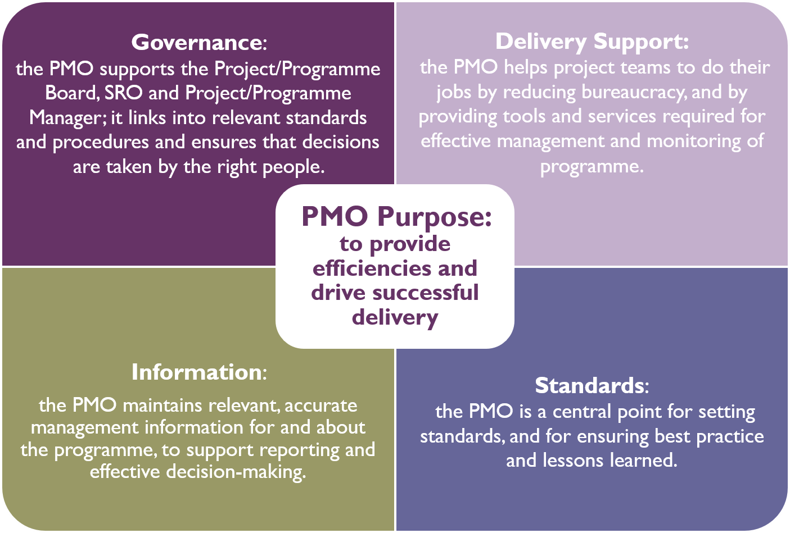

A Portfolio Management Office oversees multiple programmes within an organisation and offers strategic challenge and perspective on questions like: ‘Are we doing the right things?’ and ‘Are we getting the benefits from our investment?’

You may hear Project, Programme and Portfolio Management Offices described collectively as “P3O”.

There are some common misconceptions about PMOs which can impact on their ability to deliver a quality service. Let’s bust some of the myths:

Diagram 2. What a PMO is not.

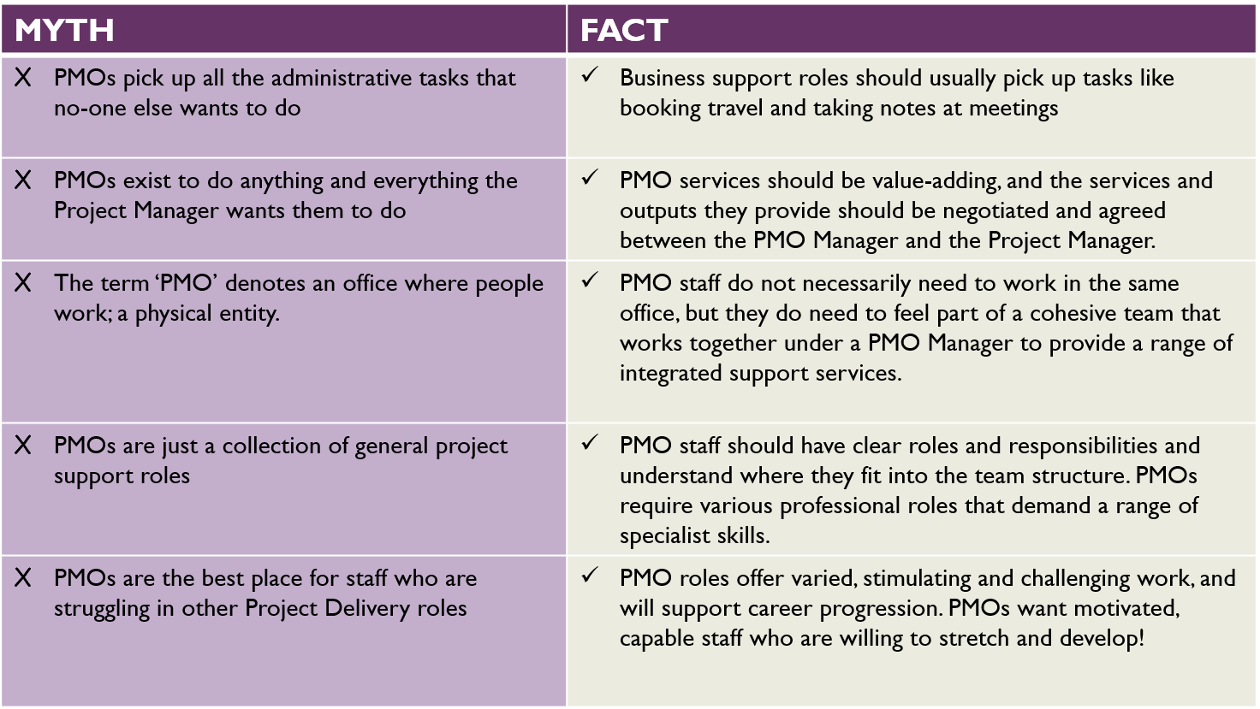

# PMO structures and services

The shape and structure of a PMO depends on the size and value of the projects and programmes it supports and the services these customers require.

PMOs can operate at Portfolio, Programme and Project level. The table at Annex 1 provides examples of the detailed services and activities that may take place at each level but detailed below are some typical PMO services:

* Stakeholder Management and Communications
* Developing and Embedding Standards and Methods
* Planning
* Business Case Development.
* Resource Management.
* Benefits Management.
* Performance Reporting.
* Risk and Issue Management.
* Managing Dependencies across multiple projects.
* Change Control
* Financial Forecasting and Reporting.
* Quality Assurance.
* Information Management.
* Transition Management.
* Ensuring Best Practice and Lessons Learned.

The definitive list of services provided by a PMO should always be discussed and agreed by the PMO Manager and the Project/Programme Manager.

You can find more detailed information and examples of PMO structures and services at [Axelos Best Practice](https://publications.axelos.com/p3O_2013/content.aspx?page=p3o_58&showNav=true&expandNav=false) - contact the PPD [mailbox](mailto:ProjectDeliveryCommunity@homeoffice.gsi.gov.uk) for log in credentials.

In the Home Office you will most commonly come across Programme Management Offices. There may be a large central hub overseeing the entire programme or smaller units providing services for specified projects. Portfolio and Project Delivery (PPD) Directorate acts as a Portfolio Centre of Excellence for the Home Office overall.

There is no one-size-fits-all operating model for PMOs, but they all MUST have the aim of providing efficiencies and driving the successful delivery of projects.

## Building a great working relationship with the Project

The PMO Manager needs to work in partnership with the SRO and Project/Programme Manager to help steer decisions and discussions throughout the project.

PMO Managers need to negotiate with Project/Programme Managers and agree the services they will offer. The PMO should:

* Know how to challenge.
* Needs to show that it is adding value.
* Ensure regular engagement and communication to ensure understanding of key issues.
* Ensure there is trust and respect on both sides.
* Understand the perspective and value each side brings.
* Provide clarity on boundaries and responsibilities.

## Roles within a PMO

The new [Project Delivery Capability Framework](http://www.gov.uk/government/uploads/system/uploads/attachment_data/file/613477/project_delivery_capability_framework.pdf) (PDCF) has been developed by the Infrastructure and Projects Authority (IPA) in collaboration with government departments for use by project delivery professionals across the Civil Service.

In the Career Pathways section there are 19 project delivery roles, many of which will be used in a PMO.

The roles within each PMO will depend on the organisational structure, the projects and programmes supported, and the services required. A large Portfolio Office may include many specialist roles alongside teams of project support staff, whereas a smaller PMO may need to combine several specialist functions into one role.

The roles below are often identified as PMO’s core roles - but roles within a PMO will vary and the list is not exhaustive.

* PMO Manager
* Planner
* Risk and Issues Manager
* Stakeholder Manager
* Project or Programme Support Officer
* Assurance Manager
* Benefits Manager
* Configuration Manager
* Business Case Manager
* Resource Manager

# PMO best practice and standards

The Government Functional project Delivery Standard has been developed to set expectations for the direction and management of portfolios, programmes and projects ensuring value for money and the successful, timely and cost effective delivery of government policy and business objectives. It is available on Gov.UK: <https://www.gov.uk/government/publications/project-delivery-functional-standard>

It contains 7 main elements:

* The purpose and scope of the standard
* Principles for directing and managing portfolios, programmes and projects
* Overview of portfolio, programme and project management
* Governance and roles of portfolios, programmes and projects
* Portfolio management
* Programme and project management
* Practices which support project delivery

Section 7 sets out management practices and standards which support project delivery and will be relevant to anyone working in a PMO. It also provides a set of 9 key principles, definitions of a project, programme and portfolio, and best practice guidance - e.g. on benefits and change management.

Diagram 3. When a PMO works well and when it doesn’t.

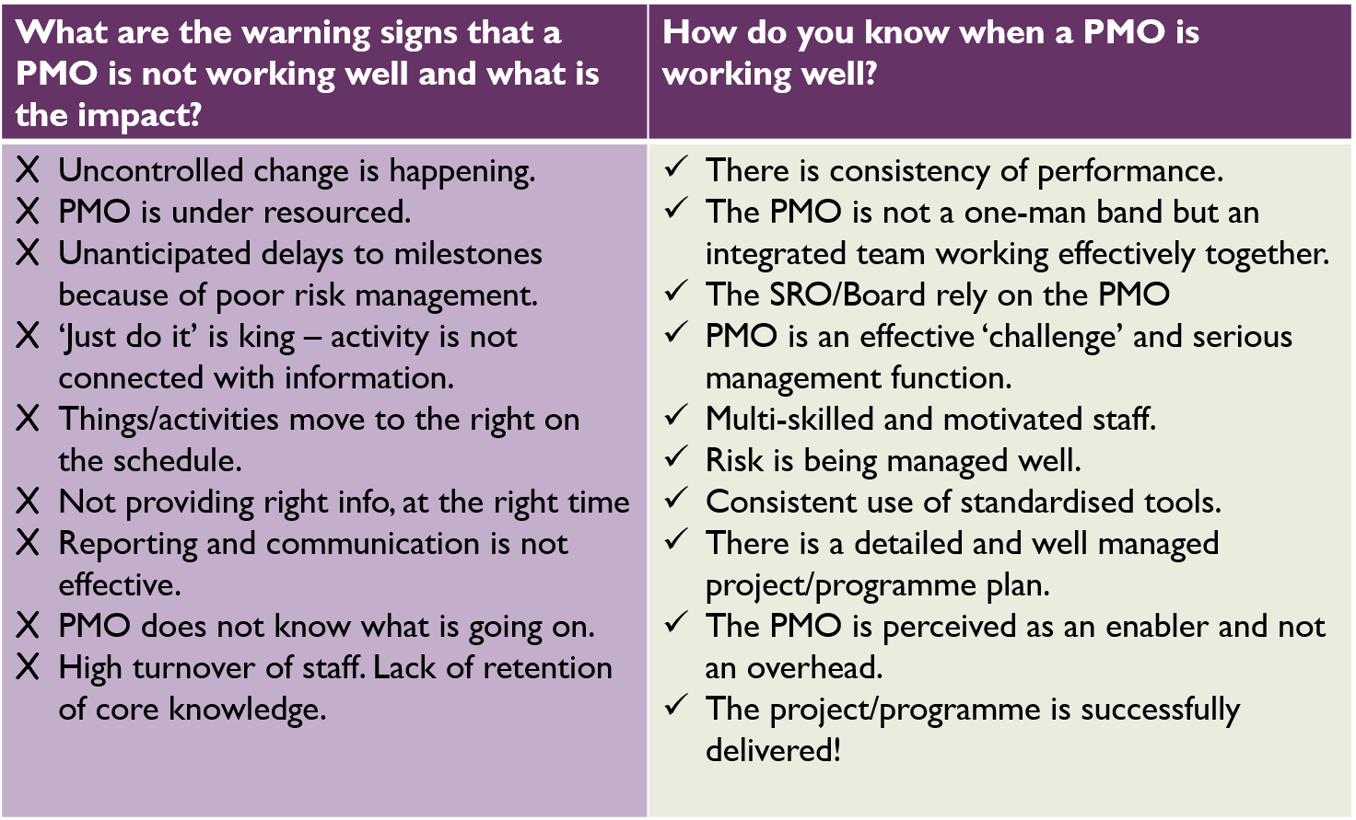

# PMO capability: learning and career development

The Development section of the [Project Delivery Capability Framework](https://www.gov.uk/government/publications/project-delivery-capability-framework-for-civil-servants) contains a wealth of information and guidance about learning, and will help you identify suitable formal learning options in discussion with your line manager.

Whether you are looking for activities to help you get to grips with your current PMO role, develop a specialism, or prepare yourself for a new job, the framework is an excellent starting point.

However there is more to learning than formal courses. Whilst these are certainly important, they don’t address all our development needs. Furthermore, by identifying only classroom-based solutions, we may be overlooking a myriad of fantastic learning opportunities.

The 70:20:10 approach encourages you to consider a range of learning activities on, near and off-the-job, with only 10% of learning taking place in a formal classroom environment. See Annex 1 for some useful PMO learning options.

# The Home Office PMO community

The Home Office PMO Steering Group drives capability building, knowledge sharing and best practice in order to develop our PMO community.

The PMO Steering Group also oversees three Special Interest Groups (SIGs) for Planning, Risk and Benefits, who operate via our online collaboration platform, [Knowledge Hub](https://khub.net/)

Members are identified by the Steering Group as experts in their given field who are proactive in building the community. If you are interested in finding out more, please contact [ProjectDeliveryCommunity@homeoffice.gov.uk](mailto:ProjectDeliveryCommunity@homeoffice.gov.uk).

**Annex 1. Examples of detailed services and activities that may take place at Project, Programme or Portfolio level.**



**Annex 2. PMO Capability – Learning ideas.**

|  |  |  |
| --- | --- | --- |
| **PMO CAPABILITY - LEARNING IDEAS** | | |
| **On the job 70%** | **Near the job 20%** | **Off the job 10%** |
| * Attend a variety of PMO/ project meetings, some at board level if possible * Attend team, directorate and departmental events * Review documentation for your PMO’s projects * Review and continuously improve your PMO’s internal processes * Take responsibility for your PMO’s communications * Benchmark high performing PMOs and create an action plan for your PMO * Deliver/share learning to develop others in your PMO * Seek out feedback on your performance * Take on new responsibilities, including at the next level * Run a team meeting or event * Deputise for your PMO Manager | * Join the HO PD community for events, our newsletter and the [Knowledge Hub](https://khub.net/) PMO special interest group * Visit the PD pages on Horizon * Check out the wealth of information available at [Axelos Best Practice](https://publications.axelos.com/p3O_2013/content.aspx?page=p3o_58&showNav=true&expandNav=false) (contact PPD [mailbox](mailto:ProjectDeliveryCommunity@homeoffice.gsi.gov.uk) for login info) * Join/set up a PMO Action Learning Set * Review your skillset and career aspirations with the [Project Delivery Capability Framework](http://www.gov.uk/government/uploads/system/uploads/attachment_data/file/613477/project_delivery_capability_framework.pdf) * Build networks with other PMOs – seek out your counterparts and compare notes * Get a mentor or buddy – or become one! * Job shadow a specialist in your PMO * Spend a day with the project/s your PMO supports * Seek a job swap or secondment to another PMO | Civil Service Learning’s  [Project Delivery foundation online learning courses](https://civilservicelearning.civilservice.gov.uk/browse/project-delivery-0/project-delivery-1), such as:  How Projects Run; Project Planning  Civil Service Learning’s full range of  [Project Delivery accredited learning and qualifications](https://civilservicelearning.civilservice.gov.uk/learning-opportunities/qualifications-and-accredited-learning), such as:  APM Project Management Qualification  Portfolio, Programme and Project Office (P3O)  Managing Successful Programmes  Agile Project Management  Management of Risk  For Senior PMO Leaders:  [Project Leadership Programme](https://civilservicelearning.civilservice.gov.uk/professions/professions/project-delivery/curriculum/project-leadership-programme-plp)  Other learning:  [Understanding and using business cases](https://civilservicelearning.civilservice.gov.uk/learning-opportunities/understanding-and-using-business-cases)  [The commercial cycle](https://civilservicelearning.civilservice.gov.uk/browse/commercial-01/29410)  [Continuous improvement and quality management](https://civilservicelearning.civilservice.gov.uk/browse/customer-service/29417)  [Negotiation](https://civilservicelearning.civilservice.gov.uk/gsa_advanced_search/site/alllearning/meta/false/keyword/negotiation) |