DDaT Profession case study series

Common solutions for common capability challenges: Skills assessment

How teams are using the Digital, Data and Technology Capability Framework to assess skills

Introduction

Building digital, data and technology capability across government is a priority of the Government Transformation Strategy.

The Digital, Data and Technology (DDaT) Profession team at the Government Digital Service, Cabinet Office, has developed a number of cross government strategies to help organisations attract, recruit and retain the right people and skills.

The aim is to find ways to solve common capability problems once for everyone in government.

A key area of focus is DDaT Profession skills assessment, where organisations need to ensure that DDaT Profession staff have the appropriate skills against those set out for a specific role in the Digital, Data and Technology Profession Capability Framework.

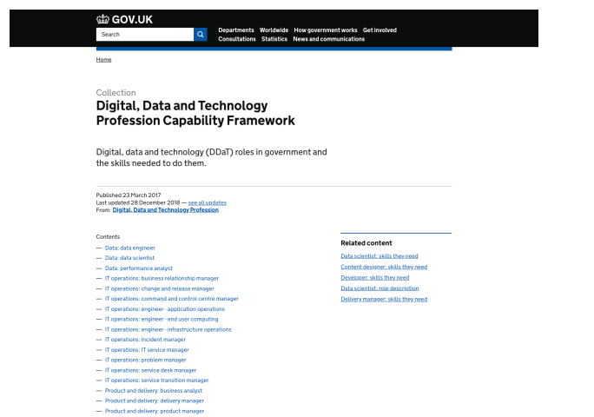

This case study focuses on skills assessment approaches using three examples:
- Companies House is a Cardiff-based executive agency of the Department for Business, Energy and Industrial Strategy (BEIS). It employs 200+ DDaT professionals
- Highways England is based in Bristol, Birmingham and 5 other locations across England. It is an executive agency of the Department for Transport (DfT). It employs 200+ DDaT professionals
- Cabinet Office is mainly based in London and employs 500+ DDaT professionals, a majority of these professionals being part of the Government Digital Service (400+).

Assessment of DDaT professionals in government using the DDaT Capability Framework
Organisations can use the DDaT Profession Capability Framework to assess the professional skills of their staff. This allows them to identify potential skills gaps and plan appropriate learning and development at a functional level.

Individuals and line managers can use capability assessments to:
● evaluate the individual’s skill levels
● identify skill or knowledge gaps
● inform decisions about career development
● provide supporting evidence for capability-based pay awards where appropriate

Before starting on assessment, an organisation should map its jobs to the roles in the DDaT Profession Capability Framework in readiness for assessing the proficiency of their DDaT professionals. The most common approach taken by government organisations which have been through this process is for department heads and team leaders to meet and discuss each DDaT job in the organisation, and select which role in the Capability Framework it best aligns to. We have a guidance document available on Knowledge Hub that explains more about mapping to the Capability Framework.

The four stages of alignment to the Capability Framework and Pay Approach are:
- Map all DDaT jobs in the department to the DDaT Capability Framework
- Recruit to job descriptions and skills
- Carry out Capability Assessments for members of staff already in DDaT roles
- DDaT pay alignment 1-3 months 3+ months 3-6 months 6+ months

Assessment approaches
After the initial stages of implementing the DDaT Profession Capability Framework, organisations reach the point of assessing the capability of DDaT Profession staff.

We recommend that you read the skills assessment summary guidance that explains more about the purpose of the skills assessment.

It is up to organisations how and when to carry out capability assessments for incumbent DDaT professionals.

We will illustrate how 4 different approaches have been taken:

- Companies House (August 2018) - 200+ people
- Highways England (December 2018) - 200+ people
- Cabinet Office (September 2019) - 500+ people

The assessment process
- For each skill, the member of staff provides an example that demonstrates their level of proficiency.
- Each member of staff meets’ with their line manager (and/or a specialist) to review the examples and agree the levels.

Resources to help with assessment
The DDaT Profession team has prepared a set of resources that can help with capability assessment that can be found on our Knowledge Hub portal:

- Skills assessment guidance
- Skills assessment templates
- A draft outline presentation to use when briefing staff
- An example of a completed assessment (Technical Architect)

At Companies House and Highways England, each member of staff was sent a spreadsheet which defined the skills for their specific role level (for example, Junior Software Developer, Senior IT Service Manager). Cabinet Office is using an online self-assessment tool which was built in-house by GDS.

We are also aware of some organisations using commercial online tools to assess their teams. If the organisation does not have an existing tool for assessing technical skills, a set of assessment templates for each role-level is also available.

Please visit Knowledge Hub or contact the DDaT Profession team at GDS for these resources:
ddatprofession@digital.cabinet-office.gov.uk

Setting up for success before starting the process:
- Get buy-in from the Senior Management Team and make sure they advocate the approach you are taking.
- Consider early stakeholder involvement from HR, Communities, Line Managers, local Trade Unions, internal Communication specialists including Content Designers (for any communication assets you are creating) and Finance (if pay related assessments are involved). User Research may also be useful to inform the approaches that you take.
- Make assessment mandatory. Ideally, undertake the assessment as part of the yearly performance review process, so staff can see what skill levels they need to achieve to progress in their careers.
- Run a number of briefing sessions on the process, so all staff know what will happen, why, when and how.
- Ask line managers to organise a session for their teams to explain to their reports what will happen and when, and give them an opportunity to ask questions.
- Make the whole process and all associated tooling and content fully accessible.
- Establish a governance mechanism around the skills assessment process.

‘Scoring’
Departments and delivery bodies will be using the DDaT Capability Framework to capability assess DDaT professionals where teams are implementing capability based pay. There is a separate guidance document on the DDaT Pay Approach which Pay & Reward specialists may request through the DDaT profession mailbox:
ddatprofession@digital.cabinet-office.gov.uk
In summary, the guidance explains that capability based pay is assessed at three levels :
- If an individual meets some but not all the required skill levels for the relevant skills in the Capability Framework they should be considered as a candidate for ‘Developing’ pay.
- If an individual meets all the required skill levels for the relevant skills on the Capability Framework, they should be considered as a candidate for ‘Proficient’ pay.
- If an individual exceeds most or all of the required skill levels for the relevant skills on the Capability Framework they can be considered as a candidate for ‘Accomplished’ pay.
In these circumstances some teams have created a scoring mechanism to work alongside their process to help identify whether an individual is meeting criteria for developing, proficient or accomplished pay. Effectively this provides a means to objectively assess individuals for pay awards.
There is no definitive way to ‘score’ the assessments because each organisation may have a slightly different implementation approach and it is important that you choose an objective assessment methodology that best suits your purposes.
Here is how three different organisations have approached scoring:
 | Highways England  Assigned one number to each skill-level | Companies House  Approach allowed for more latitude in assessing the ‘fit’ to a skill-level: | Cabinet Office  For each skill an individual selects a status - this provides the most latitude in assessing the ‘fit’ to a level.  this skill-level
  Working towards | Working at | Working above
Expert | 4 | 7 or 8 | 1 or 2 or 3
Practitioner | 3 | 5 or 6 | 1 or 2 or 3
Working | 2 | 3 or 4 | 1 or 2 or 3
Awareness | 1 | 1 or 2 | 1 or 2 or 3
 | Advantages:  Simple and straightforward, easy to explain and understand  Drawbacks:  Does not give much flexibility in differentiating levels | Advantages:  Some flexibility | Advantages:  Greatest differentiation:  each level has three scores that could be assigned.  Scores are not incremented to focus on a common level of stretch across all skill levels.  Drawbacks:  Reduces flexibility in differentiating levels
The totalled points achieved for the assessment are used to allocate a pay level. Pay levels will then be reviewed and approved by a governance panel.

Do not underestimate the time needed for assessments
The time you need for the assessment process will vary depending on the number of DDaT staff in the organisation. For a small organisation, it might take 1 month to complete the whole process from beginning to end. For larger organisations, with 1,000 - 3,000 staff, it might take 3 to 6 months to complete it.

Establish sponsorship
⇩
Initial briefing for all staff
⇩
Brief team leaders/line managers
⇩
Distribute documents for relevant role-levels to each individual member of staff
⇩
Each staff member adds examples to demonstrate their levels of proficiency for each skill
⇩
Line managers hold Individual meetings with each report to agree skill levels demonstrated
⇩
Moderation and/or collation process
⇩
Establish local policy including future frequency to re-run the above process

Benefits
Companies House and Highways England have found that the assessment process helped them to identify potential skills shortages and plan appropriate learning and development for their staff.

In some cases, they were able to use the details they collected during these skills assessments to build business cases so they could make capability-based pay awards.

Capability assessment at Companies House
By Mark Fairhurst, Head of Architecture

Background

Our primary reason for implementing the DDaT Capability Framework was so that we could implement the Pay Approach, incorporating the Pay Framework, to resolve issues we were having with recruitment and retention.

A secondary reason was to align to a cross government standard set of roles and skills rather than continuing to use our own bespoke job descriptions.

How was the capability assessment process carried out?
The Heads of Professions within Companies House were given the task of mapping existing roles to the roles within the Framework. This was completed quickly and easily, given that most roles had direct mappings to roles in the Framework.

Once our roles had been identified then a baseline skills assessment was completed for each individual by the Heads of Professions and line managers. A spreadsheet was created for each person (the DDaT team have subsequently released templates for each role which can be found on Knowledge Hub). A score was given for each competency defined within the job description, with a single average score then produced. The average score was used to determine at which level within the role an individual was operating – developing, proficient or accomplished. These levels were ultimately used to determine pay within the Pay Approach.

To ensure consistency across the department, a panel consisting of Departmental Heads, HR and Finance reviewed all the scores. They also acted as the arbiters of any appeals raised by individuals relating to their capability scores.

Our experience
Implementing the Pay Framework alongside the Capability Framework elicited the natural, emotive, response from individuals whose roles were outside the Pay Framework. We had to explain that some roles were more scarce than others and attract higher levels of pay to reflect market conditions.

We quickly learned that communicating the reasons behind implementation, and the benefits it could bring, was critical. Staff are not valued differently: pay is aligned to demand for roles within the jobs market. We believe that individuals will ultimately see the DDaT Capability Framework have a positive impact on their career progression and personal development.

Useful advice
Allow time and communicate well. Do not underestimate the amount of time and effort required to implement the Capability Framework – not just the mechanics of carrying out the work but the amount of emotional investment required with individuals to take them with you on the journey. You need to keep people informed on progress and set realistic expectations.

Outcomes
The initial improvement has been pay benefits for those roles included in the Pay Framework.

However, we are now also beginning to see changes in personal learning and development, as individuals have a framework to work within to guide them in achieving the skills necessary to progress to higher levels within the job families. These conversations now take place within one-to-ones, and also form part of the end of year review process. We have also seen improvements in staff retention and recruitment. Please see the separate Companies House Case Study explaining more about their journey.

Capability assessment at Highways England
By Julia Thorne, Head of Business Insights and Analysis, Information and Technology
and Sarah Taylor, former Transformation Lead

Background
The Information and Technology directorate at Highways England had seen a fair amount of change and, as a newly formed directorate (made up of teams from across the company), we were looking at a restructure as part of the Organisational Change Programme that was being driven by our Highways England 2020 strategy. This included process, system and culture change.

There was a need for increased clarity of roles and responsibilities to support the revised operating models, and the DDaT and other Frameworks provided the detail and consistency needed to deliver on these requirements. It also gave us the opportunity to align capabilities with the company’s needs.

In some instances there was a need for increased ownership and accountability.It was felt the DDaT Capability Framework would help support this goal.

How was the capability assessment process carried out?
Before the reorganisation, we used the DDaT Capability Framework to inform colleagues about roles they might wish to apply for, if they were not automatically aligned to them. This helped increase awareness of the DDaT skills and terminology before any formal consultation began.

We involved trade unions at an early stage and gave updates as we progressed. Our HR Business Partner was heavily involved, particularly as this was being run alongside the introduction of a new pay and grading policy.

The capability assessment process was manual: we had templates for each of the roles. We ran workshops across the offices to help colleagues understand the process, and then asked them to complete self-assessments. After this came discussion with line managers to validate the information.

Assessments were then carried out formally when people were in post. This allowed us to identify skills gaps at an individual and team level; it also enabled us to create development plans.

Our experience
Because it involves people’s working lives, the implementation process can be emotive. In our case, as it was coupled with pay and grading activity, some colleagues were sceptical. We had to ensure that everyone understood the need for the assessment, and the benefits it would bring to individuals, teams and the company. We also had to communicate how it could be used for targeted development opportunities and capability plans.

The exercise provided a real focus for individual’s personal development conversations. It gave people the opportunity to think about career development and the types of roles that could be achieved through specific learning paths.

Reactions to the process were varied, as you would expect when assessing people’s capabilities and competencies. Where individuals and team leaders understood and bought into effective performance management, the process was a lot smoother.

We experienced a level of challenge in some areas where implementing a consistent framework exposed ineffective people management practices. Support from HR and Senior IT Resources was needed to drive forward change in a fair and consistent manner.

Ownership within each team is necessary or there is a risk of no buy in and dilution of the DDaT Capability Framework. Establishing communities of practice within the workforce can help with this.

One lesson we learned was not to try to force roles into the DDaT Capability Framework that should sit outside – such as Business Support. Utilise other frameworks but acknowledge that work may be needed to be able to assess capabilities in a similar way to those in the DDaT Capability Framework.

Useful advice
The most vital aspect of the whole process is communication. It’s impossible to overstate the importance of this.

Put in the leg work up front to establish an operating model before assuming DDaT is the answer to all organisational challenges.

Do not underestimate the amount of time and effort associated with people change. One person cannot implement DDaT across a team by themselves: it is a join effort across job families, senior teams and line management.

Use all the resources available (such as role profiles and assessments) and try to keep these as generic as possible to prevent ongoing rework such as bespoke assessment templates.
Adopt the DDaT Capability Framework job families and roles as they stand: do not adapt them to fit the individual characters who work with you.

Outcomes
The exercise was completed in February 2019 and we have now finished a review. We validated 50% of the completed assessments from a quality and quantitative view. We captured information to support capability planning and we are using this for dedicated learning channels across a number of media. This has shown us where the gaps are – where we need to focus and invest in developing capability.

If we were to repeat the process, it would be a good idea to automate it. This is next for us, aligning with the company career path approach and ensuring that people have the benefit of both. It’s also valuable to make sure everyone understands this isn’t a one off exercise – the assessments need to be reviewed and amended to reflect conversations. They also serve as a good record so people can see how they have developed.

The approach we took was to map roles to people, rather than the other way round. If we were going through this again, I would recommend mapping people to roles and drive a change in ways of working, rather than focus on what turned out to be a mere change in role title in some cases.

Establishing communities of practice at Highways England would also have helped to bed in the change.

Capability assessment at the Cabinet Office
By XXX

Background

In September, Cabinet Office launched it’s DDaT skills assessment pilot to gather a clear view of specialist proficiency across the different business units and to inform capability retention actions.
The DDaT skills assessment encompassed the 39 roles of the DDaT Capability Framework and was set up as a component of performance conversations between staff and their Line Managers.
The pilot initial round of skills assessment has also been used to model and work out implementation options for the Pay Approach throughout 2021.

How is the capability assessment process carried out?

The DDaT skills assessment is available via a bespoke-GDS-built online tool. Staff have been asked to self assess their capability for each skill in a role against a set of status descriptors:

- Working towards this level - has the level of experience to be able to deliver tasks in this skill but may require help from time to time to successfully complete them.
- Working at this level - can perform all the actions associated with this skill without assistance and each time they are required.
- Working above this level - their expertise is recognised in this area. They can provide guidance, troubleshoot and answer questions related to the field where the skill is used.

A recent example to illustrate their proficiency in the described skill is to be provided.
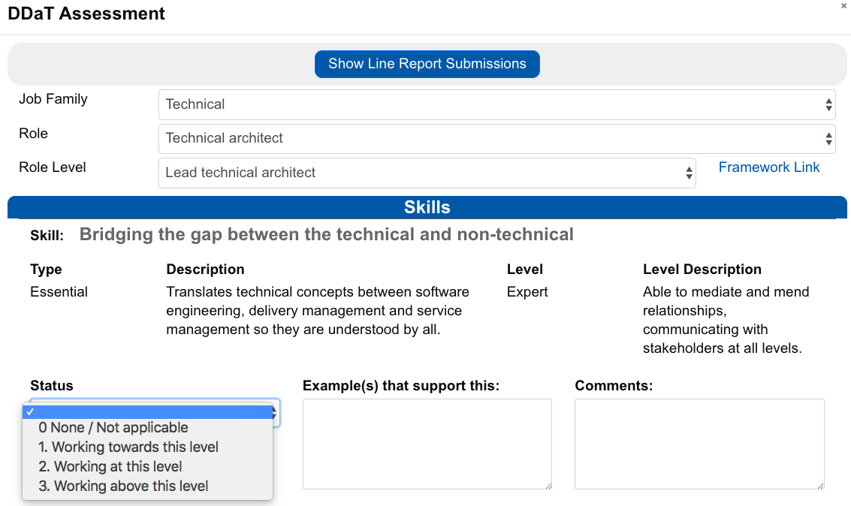

Each professional then has a conversation with their Line Manager about the skills assessment, so they can understand strengths and development areas. Staff can also consider where they stand against the career pathways, to understand their current position and future progression options.

Line Managers are required to validate the skills assessment within the tool after they had their conversation with their DDaT line reports. Further moderation is then enabled within Cabinet Office Business Units by either Communities of Practice or a bespoke panel.

The DDaT skills assessment data is centralised in the tool and stored according to the General Data Protection Regulation requirements. After a first round of assessments was complete in late 2019, anonymised data sets have been used to inform how the Cabinet Office could implement capability-based pay in 2020-21.

Our experience so far

Early learnings indicate that securing the right level of sponsorship for the programme and building strong engagement are critical enablers. We have consulted with Senior Leadership teams, Communities of Practices and Trade Unions. In parallel, we ran information sessions with DDaT Professionals and their Line Managers on the process and provided assistance with the assessment tool where required via a dedicated mailbox.

Still, due to the sensitive nature of both the assessment exercise and its links with pay, there is a feeling that we should have communicated even more. Phasing our communications throughout the assessment journey and adopting a distinctive narrative before, during and after the assessment would have proved useful.

The DDaT Capability Framework roles are standards across government. Therefore, a translation effort is often required at an organisational level to make them fully relevant to people’s day-to-day jobs. We experienced that we could have supported Line Managers and Communities with this where role families are less mature.

Adopting a fair scoring system and mapping it to the Pay levels has been a challenge. It prompted excellent conversations on where the consistency should lie and whether it is within a role, in a role family or within the whole Capability Framework. Averaged scores allow direct comparisons between roles. Nevertheless, since the number of skills and their levels between roles vary, we were keen to ensure that no DDaT professional would be at a disadvantage when matching their assessment scores to a pay level.

We are iterating our assessment moderation process and designing the governance around the implementation of the Pay Approach accordingly.

Useful advice <Break-out box>

We could not emphasise enough the need to anchor the process within a wider organisation transformation piece. Identifying a clear strategic anchor helps to gather the right stakeholders and eases communications going forward.

There is a need to articulate the links between the skills assessment and other HR interventions, whether these are related to Performance Management, Learning and Development, Compensation or Talent Management. A clear strategic anchor helps to clarify to everyone what is the problem we are trying to solve, what is the approach being implemented and how will we measure success going forward.

When we modelled the assessment data to inform our implementation plan for the Pay Approach, we built in other relevant factors into our analysis. The impact on the gender pay gap being one of them. This helped us to focus initiatives in our Gender Pay gap action plan on roles where we have a specific issue and provided wider consistency in all attraction and retention actions directed to DDaT professionals.

We would also strongly recommend to get User Researchers involved in the analysis of the quantitative and qualitative data collected during the assessment. A User Research perspective on the process and its tool is critical to make it work for a variety of users. It can be easily progressed using anonymised data sets.

Finally, we have to be conscious that professionals filing a self assessment are expecting a clear return on the time they invested. A couple of months could lapse before people see a tangible result from the assessment. We would advise to identify quick wins from the assessment process for all stakeholders involved as well as to inform them regularly. This is all the more critical if the assessment process is not meant to be a one off.

One last thing to think about around how we demonstrate expertise
People learn in different ways and in the DDaT Profession some of the technical skills and specific needs within departments may be better proven through specific means. By trying to achieve that in a mechanical way only - via a tick-box assessment in a spreadsheet for example, we may lose the energy in learning that we are trying to engender in our teams. So consider allowing people to demonstrate their newly found skills in a way that is meaningful to them… on a white board, in a demo or through a prototype. This is about balancing the intent of the exercise and the need for an objective assessment that has an auditable outcome, with the need to have an effective conversation that encourages individuals to invest time in their learning journey.

Centrally managed cross-profession skills assessment tool
We continue to collect feedback on the self-assessment tools and the process in order to be in a position to feedback what is working for our teams. This will help us also understand how we can improve the DDaT Capability Framework and skills assessment process across government.

At present we do not prescribe using an online for tool as standard because we recognise that some teams may not have the means to fund such an approach. However, we are working with other professions to determine the users needs for the potential deployment of a cross-profession skills assessment tool which we hope will be available as an option from 2021. Please contact ddatprofession@digital.cabinet-office.gov.uk if you would like more details or are considering procuring an online tool.

More about the tools, guidance and services currently available from the DDaT Profession team

The DDaT Capability Framework defines the roles in the DDaT Profession and describes the skills needed for each role level. It is publicly available on GOV.UK.

Together with strong communities of practice and opportunities for learning and development through the GDS Academy, the Capability Framework supports attraction, recruitment and retention of DDaT specialists.

Further materials to help with the implementation of the DDaT Capability Framework are available from the DDaT Profession team on Knowledge Hub:

- A brief overview of the Capability Framework provides an insight into its purpose, benefits and structure.
- Guidance for mapping roles
- Examples of jobs mapped to roles
- DDaT guidance on skills assessment
- Set of assessment templates - one for each role in the Capability Framework

Pay Approach materials and guidance are available upon request through your Pay and Reward Lead:

- DDaT Pay Approach guidance document describing the benchmarked pay ranges for each role and level and capability based pay

If you have any questions, please contact us at: ddatprofession@digital.cabinet-office.gov.uk

