Learning and Development – Trainer Guide
(Trainer Guides aim to provide a detailed instructional guide for the delivery of a Session, Course and / or Programme. This should be complimented with a basic Lesson Plan)

Activity: | Healthy Chats (Wellbeing and You)
Duration: | 2 Hours  (Timing may vary between 1.5 to 2 Hours depending on size of group and the learners’ background / experience).
Level: | Intermediate Knowledge and Skills
Aim: | This activity aims to equip learners with the knowledge and skills to hold a wellbeing conversation and signpost people to lifestyle support services that are of benefit.
Learning Outcome: | By the end of this activity, learners will be able to:  - Define what public health is and how the Healthy Chat approach supports this.  - Define what change is, why it occurs and how to respond.  - Describe how to structure and carry out a constructive wellbeing conversation.  - Define the benefits of healthy choices.  - Choose the appropriate information source about wellbeing topics.  - Implement effective wellbeing conversations and signpost people to appropriate services.
Version: | 1.1 – 06/2019

Time / Duration: | Section Title:
0 – 2 (2) | Healthy Chats (Wellbeing and You)

Time / Duration: | Sub-Section Title:
0 – 2 (2) | Healthy Chats (Wellbeing and You)

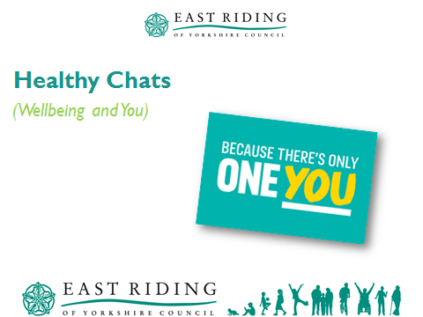
- Put 1 each of the 4 A3 printouts from the MECC Link website on tables.
- Slide 1

Prompt - advise the learners of:
- Health, Safety and Fire details for the venue.
- Location of toilets, etc.
- Mobile phones – preferably off, but as a minimum on silent.

Welcome to the Healthy Chats (Wellbeing and You) session, which enables you to learn more about the healthy chat initiative and how this supports the public health agenda.

Evidence suggests that adoption of the Making Every Contact Count (MECC) approaches across health and care could potentially have a significant impact on the health of our population.

This event last for up to 2 hours [Revise time based on the number of learners and their background / experience] and includes opportunities for you to get involved in discussions and share your ideas and thoughts.

We will start off by looking at what we are trying to achieve with this event by reviewing the Aim and Learning Outcomes.

Information
This symbol highlights information on a particular point, topic or area.
Key Point
This symbol highlights a key point on a particular topic or area.
Question
This symbol indicates a question.
Activity
This symbol indicates an activity.
Scenario
This symbol indicates a scenario or case study.
Tag
This symbol highlights where you can find more information, help, support or a resource.
Time / Duration: |  |  | Section Title:
2 – 3 (1) |  |  | About Healthy Chats (Wellbeing and You)

Time / Duration: | Sub-Section Title:
2 – 3 (1) | Aim and Learning Outcomes

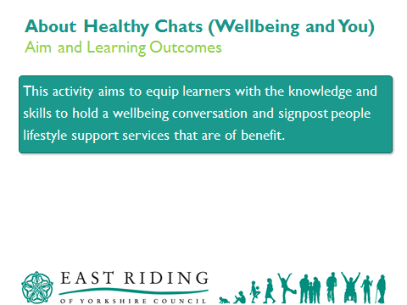
- Slide 2
This activity aims to equip learners with the knowledge and skills to hold a wellbeing conversation and signpost people to lifestyle support services that are of benefit.

Highlight / Key Point:
Depending on the audience, it may be of benefit to highlight the following:
This does not mean that we are seeking for you to become public health expert or a health trainer, but simply to enable you to provide support and signpost people that may benefit from lifestyle information.

Time / Duration: | Section Title:
4 – 5 (1) | About Healthy Chats (Wellbeing and You)

Time / Duration: | Sub-Section Title:
4 – 5 (1) | Aim and Learning Outcomes

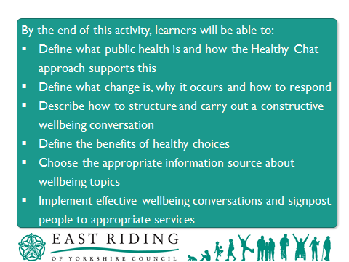
- Slide 3
By the end of this activity, learners will be able to:
- Define what public health is and how the Healthy Chat approach supports this.
- Define what change is, why it occurs and how to respond.
- Describe how to structure and carry out a constructive wellbeing conversation.
- Define the benefits of healthy choices.
- Choose the appropriate information source about wellbeing topics.
- Implement effective wellbeing conversations and signpost people to appropriate services.

Prompt - Take the opportunity to check that the learners understand the Learning Outcomes and identify if there are any other areas / topics they may wish to include, subject to agreement.

Time / Duration: | Section Title:
5 – 7 (2) | Public Health and You

Time / Duration: | Sub-Section Title:
5 – 7 (2) | What is Public Health?

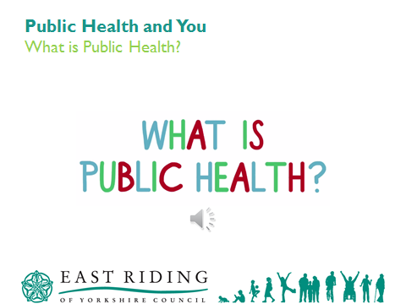

- Slide 4
- What is Public Health?
- Embedded Audio Clip – 40 seconds.

Highlight / Key Point:
Use the audio clip to open up the topic and set the scene for the following. The audio clip is embedded within the MS PowerPoint Presentation and requires the Trainer / Facilitator to click the play button for it to start.

Public health is about helping people to stay healthy and protecting them from threats to their health.

Sometimes public health activities involve helping individuals, at other times they involve dealing with wider factors that have an impact on the health of many people, for example an age-group, an ethnic group, a locality, or a country.

Address any queries the learners may have.

Time / Duration: | Section Title:
7 – 10 (3) | Making Every Contact Count

Time / Duration: | Sub-Section Title:
7 – 10 (3) | East Riding’s Healthy Chat Approach

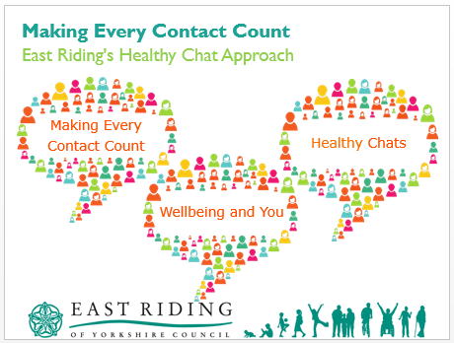

- Slide 5

Highlight / Key Point:
3 clicks to reveal slide content;
- Making Every Contact Count
- Healthy Chats
- Wellbeing and You

Making Every Contact Count (MECC) is a national programme that has been developed to encourage people to access health and wellbeing support services. MECC is not aimed at telling someone how to live their life, instead it encourages conversations based on behaviour change. This can be from brief advice, to encouraging people to access specific and / or specialist services, such as health trainers, etc.

MECC is an approach to behaviour change that uses the millions of day-to-day interactions that organisations and individuals have with other people to support them in making positive changes to their physical and mental health and wellbeing.
It supports the opportunistic delivery of consistent and concise healthy lifestyle information and enables individuals to engage in conversations about their health at scale across organisations and populations.

Making changes such as stopping smoking, improving diet, increasing physical activity, losing weight and reducing alcohol consumption can help people to reduce their risk of poor health significantly.
The goal is to empower people to make healthier lifestyle choices and improve their overall wellbeing.

Healthy chat is the East Riding’s approach to Making Every Contact Count and seeks to reduce the risk of poor health through the promotion of positive wellbeing conversations.

Time / Duration: | Section Title:
10 – 14 (4) | Making Every Contact Count

Time / Duration: | Sub-Section Title:
10 – 14 (4) | The Benefits…

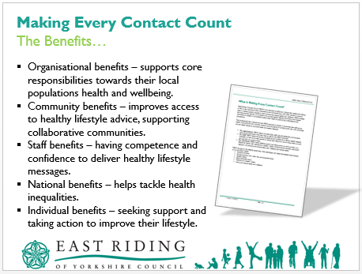
- Slide 6
- LR1 – What is MECC?
- LR2 – What are the benefits?
The slide appears with the image of LR1 showing.
Highlight / Key Point:
5 clicks to reveal slide content
- Organisational benefits – supports core responsibilities towards their local population’s health and wellbeing.
- Community benefits – improves access to healthy lifestyle advice, supporting collaborative communities.
- Staff benefits – having competence and confidence to deliver healthy lifestyle messages.
- National benefits – helps tackle health inequalities.
- Individual benefits – seeking support and taking action to improve their lifestyle.

There are clearly identified benefits in using MECC approaches at every available opportunity;

Organisational benefits:
Implementing MECC can support organisations in meeting their core responsibilities towards their local population’s health and wellbeing and to meet obligations within the NHS standard contract.
It can assist organisations in meeting responsibilities towards their workforces, for example by improving staff awareness of health and wellbeing issues; and in enhancing staff skills, confidence and motivation and potentially bring improvements to staff health and wellbeing.
MECC activity can be incorporated as part of existing health improvement or workforce improvement initiatives, for example, when tackling access to healthier food options.

Community and local health economy benefits:
The benefits of MECC can include improving access to healthy lifestyles advice improvement in morbidity and mortality risk factors within a local population; and cost savings for organisations and the local health economy.
It can also support health improvement activity within local communities, and provide an approach that reaches out to community members and groups. MECC can provide a lever to support communities in collaborating together.
Staff benefits:
For staff, MECC means having the competence and confidence to deliver healthy lifestyle messages and the encouragement for people to change their behaviour and to signpost to local services that can support them to change.

National/Population benefits:
It provides a means of maximising the benefit from existing resources for improving population health. For example, it can include advice on low or no-cost activity, such as persuading parents to walk their children to school; or, as part of physical activity advice, encouraging increased use of existing community resources such as leisure centres and swimming pools.
MECC can be effective in helping to tackle health inequalities and the impact of the wider determinants of health, through supporting individual behaviour change. For example, some local services are using the MECC plus approach to engage local populations in managing debt, action towards gaining employment or in tackling housing issues.
The population level approach of MECC can also help address equity of access, by engaging those who will not have otherwise engaged in a ‘healthy conversation’ or considered accessing specialised local support services, such as for weight management.

Individual benefits:
For individuals, MECC means seeking support and taking action to improve their own lifestyle by eating well, maintaining a healthy weight, drinking alcohol sensibly, exercising regularly, not smoking and looking after their wellbeing and mental health.

Time / Duration: | Section Title:
14 – 24 (10) | Change and You

Time / Duration: | Sub-Section Title:
14 – 24 (10) | Change and why it occurs

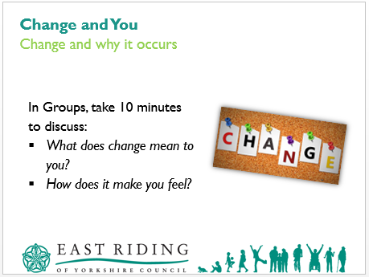

- Flip chart paper and pens
- Slide 7
We will now look at change and start by considering why it occurs.

First of all let us take a moment to consider the Oxford English Dictionary definition of change:

…make or become different…

Introduce the activity by reading out the learner instructions on the slide;

In Groups, take 10 minutes to discuss:
- What does change mean to you?
- How does it make you feel?
Delegates can either work in table groups or pairs.
The activity seeks to promote discussion and the generation of view, opinions, etc. from the learners about change. This should be considered within the context of:
- Learners as individuals
- Learners as professionals
- Others

Once the activity is complete, facilitate delegate feedback either by asking each table in turn to feedback or take feedback from the group as a whole.
The key points are:
Change means different things to different people.
Change can be positive and negative.
Change often generates an emotional response, which can be a barrier to moving forward unless it is addressed.
What may mean little to one person can be life changing for another.

Use Slide 8 to help facilitate the review of the findings.

Time / Duration: | Section Title:
24 – 26 (2) | Change and You

Time / Duration: | Sub-Section Title:
24 – 26 (2) | Change and why it occurs

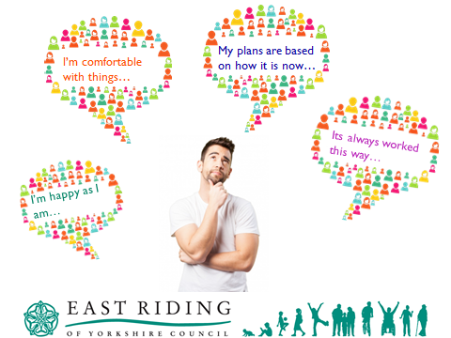
- Slide 8
Highlight / Key Point:
The slide animations will automatically trigger once the slide is active / opened.

Use this slide during the facilitated discussion following the group activity in Slide 7. You may wish to use Flipchart to collect and note responses from learners.

The key points are:
- Change means different things to different people.
- Change can be positive and negative.
- Change often generates an emotional response, which can be a barrier to moving forward unless it is addressed.
- What may mean little to one person can be life changing for another.

Discuss and respond to the learners responses.

Time / Duration: | Section Title:
26 – 28 (2) | Keep, Develop and Let Go

Time / Duration: | Sub-Section Title:
26 – 28 (2) | Considering Change…

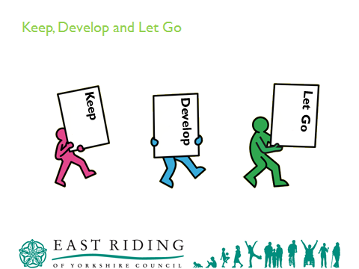
- Slide 9
We are now going to look at change a little more and introduce an approach you can adopt personally and with others.

This approach considers change and places into 3 distinct areas:
- Keep
- Develop
- Let Go

The areas help to look at change objectively and how we can overcome resistance and move forward.

Time / Duration: | Section Title:
28 – 29 (1) | Keep

Time / Duration: | Sub-Section Title:
28 – 29 (1) | Working well…Edna

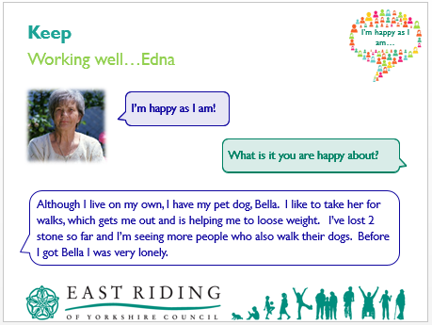
- Slide 10
Highlight / Key Point:
The slide appears with an image of ‘Edna’ with 2 speech bubbles;
- I’m happy as I am!
- What is it you are happy about?
A 3rd speech bubble automatically appears on the slide after a few seconds of the slide showing;
- Although I live on my own, I have my pet dog, Bella. I like to take her for walks, which gets me out and is helping me to lose weight. I’ve lost 2 stone so far and I’m seeing more people who also walk their dogs. Before I got Bella I was very lonely.

We should never become complacent and always consider that things could be done better, differently or not at all. However, the key is to consider and check that it is right, it works well and it does not need changing.

In some circumstances, something may not be perfect, but it is working well for now so it can be reviewed in the future.

We need to keep the things that are working well or those that do not need to change yet. These are mainly positive things that are achieving a good outcome.

This may be: where you live, where you work, personal relationships, social life, activities, hobbies, interests, etc.

Highlight / Key Point:
You may wish to add additional and / or specific examples that support the particular learners and their background / experience.

We will now look at a scenario to put this theory into practice.

Set the scene as follows:
We will now look at Edna, she has made some positive changes to her life that is improving her wellbeing;
- Managing weight
- Increased physical activity
- Improved mobility
- Reduced loneliness/isolation
Therefore Edna needs to Keep going out for walks with Bella as it is clearly improving her well-being in several ways.

Time / Duration: |  |  | Section Title:
29 – 30 (1) |  |  | Develop

Time / Duration: | Sub-Section Title:
29 – 30 (1) | Enhancing success…Peter

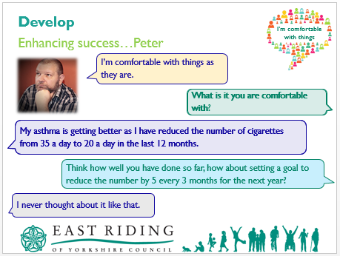

- Slide 11
Highlight / Key Point:
The slide appears with an image of ‘Peter’.
3 clicks to reveal slide content;
Click 1 – I’m comfortable with things as they are.
What is it you are comfortable with?
Click 2 – My asthma is getting better as I have reduced the number of cigarettes from 35 a day to 20 a day in the last 12 months.
Click 3 – Think how well you have done so far, how about setting a goal to reduce the number by 5 every 3 months for the rest of the year?
I never thought about it like that.

We have just looked the concept of keeping things that working well. We will now move on and look at the concept of develop.

We should never assume that just because something is not as good as it should be it has to be abandoned. Some things may be OK, but not perfect. So, we should consider:
- How can we may them better?
- If a small change has worked well, what would a bigger change do?

Develop seeks to celebrate what has worked well and look to continue this and make it even better.

Highlight / Key Point:
You may wish to add additional and / or specific examples that support the particular learners and their background / experience.

We will now look at a scenario to put this theory into practice.
The scenario is based around a simulated conversation.

Set the scene as follows:

Peter is a smoker and suffers from asthma. He has reduced the number of cigarettes he smokes each day.

Walkthrough the simulated conversation with the learners by reading out the content of the speech bubbles. Each stage of the conversation is revealed by a single click.

Address any questions or queries the learners may have.

Time / Duration: | Section Title:
30 – 32 (2) | Let Go

Time / Duration: | Sub-Section Title:
30 – 32 (2) | Moving forward…Betty

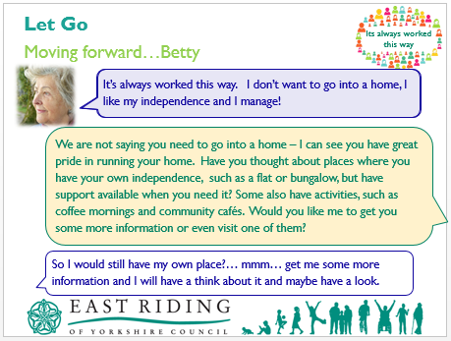
- Slide 12
Highlight / Key Point:
The slide appears with an image of ‘Betty’.
2 clicks to reveal slide content;
Click 1 – It’s always worked this way. I don’t want to go into a home, I like my independence and I manage!
Click 2 – We are not saying you need to go into a home – I can see you have great pride in running your home. Have you thought about places where you have your own independence, such as a flat or bungalow, but have support available when you need it? Some also have activities, such as coffee mornings and community cafes. Would you like me to get you some more information or even visit one of them?

Let us now consider the final concept of Let Go.

There are times when things are not working well or may be out of date. If this applies we should be looking to changing them. This could be: stopping, changing or replacing. Although this may sound easy and straight forward, as we have already discussed, change affects people in different ways. Therefore, it may not be easy for people to stop doing something, change the way things are done or replace them.

Let Go seeks to stop doing things that are not working well or out of date.

It is important that we address the anxiety or concerns people may have about letting go of something otherwise this could be a barrier to moving forward.

Highlight / Key Point:
You may wish to add additional and / or specific examples that support the particular learners and their background / experience.

We will now look at a scenario to put this theory into practice.
The scenario is based around a simulated conversation.

Set the scene as follows:

Betty is aged 66 and has limited mobility, but can walk with walking sticks. She doesn’t like to use a wheelchair or walker, as she is very proud and feel they are for old people. She has lived in her 3 bedroom Council house for the last 40 years. Her husband died 2 years ago and she has 2 children – 1 local, but doesn’t see them often due to their own health problems.

Betty’s house has some adaptations, but she has always been reluctant to make further changes.

Betty has not been eating well as she is struggling with the size of the house and moving around. She has also reduced the volume of fluid she is drinking as it takes time to get to the toilet, even when using her stair lift. Betty is very upset as she has stress incontinence and recently she has not been able to get to the toilet in time.

Walkthrough the simulated conversation with the learners by reading out the content of the speech bubbles.

Address any questions or queries the learners may have.

Time / Duration: | Section Title:
32 – 40 (8) | Keep, Develop and Let Go

Time / Duration: | Sub-Section Title:
32 – 40 (8) | Considering change…

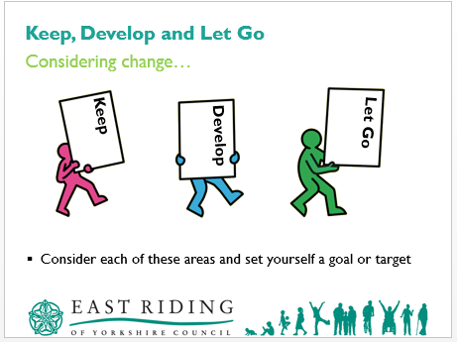
- LR3 – Keep, Develop, Let Go
- Slide 13
Introduce the activity by reading out the slide content;
Consider each of these areas (Keep, Develop, Let Go) and set yourself a goal or target.
Delegates to use LR3 for this activity.

Highlight / Key Point:
Advise delegates that this activity is personal to themselves and they will not be required to read out/share the content of their work with anyone else.

Taking the opportunity to undertake this activity within the session enables delegates to experience the application of this approach as well as provide them with further opportunity to see how it can be used.

Following completion of this activity, facilitate feedback from either each table in turn or from the group as a whole.

Time / Duration: | Section Title:
40 – 50 (10) | Conversations with You

Time / Duration: | Sub-Section Title:
40 – 50 (10) | What’s it all about?

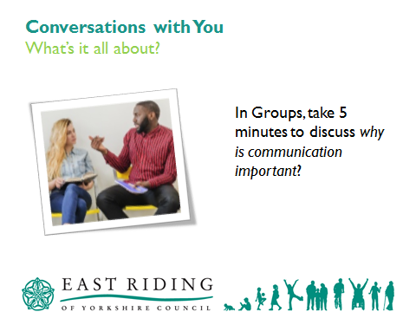
- Flipchart paper and pens
- Slide 14
We now move on a look at the knowledge and skills needed to communication well and have effective conversations.

Highlight / Key Point:
Depending on the learner’s background / experience, you may wish to adopt a different introduction to this area / topic.

Let us just take a moment to consider the Oxford English Dictionary definition of communication. Communication is defined as:

…the imparting or exchange of information by speaking, writing or using some other medium…

Effective communication is critical when we are working with others.

In Groups, take 5 minutes to discuss:
- Why is communication important?

The activity seeks to promote discussion and the generation of view, opinions, etc. from the learners.

Highlight / Key Point:
Key points to elicit are:
- To know and understand the person you are communicating with.
- To know what they want.
- To know what they do not want.
- To know what they already do.
- Fact finding.
- Building a relationship.
- To give appropriate responses.

Review and discuss the responses generated by the learners and address any concerns or queries.

Highlight that the key principle of a healthy chat is effective communication – the ability to provide information that is relevant and appropriate to the person. This is only known if when you involve the person.

Time / Duration: |  |  | Section Title:
50 – 54 (4) |  |  | Communication

Time / Duration: | Sub-Section Title:
50 – 54 (4) | Conversations

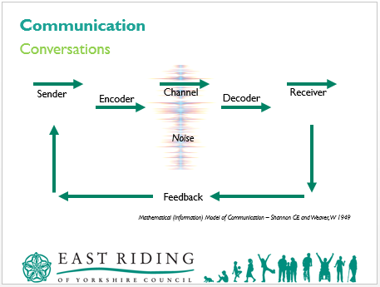
- Slide 15
Let us take a moment to consider communication and how it can be impacted.

Highlight / Key Point:
You may wish to introduce the diagram as a component of the Shannon and Weaver model of communication, which was created in 1940 by Claud Elwood Shannon and Warren Weaver.

Review the diagram and explain:

- Sender (Information Source)
The sender is person who creates the message, chooses the channel and sends it.

- Encoder (Transmitter)
The sender thinks about what the message is and then encodes it by choosing the words, letters, numbers, etc.

- Channel
This is the method used to send the message, e.g. Letter, email, telephone, face-to-face conversation, etc.

- Decoder (Receiver)
The person receiving the message needs to decode the words, letters, number, etc. sent to translate the message.

- Receiver (Destination)
The person receiving the message reviews the translated message and checks that they understand what it means, what needs to be done and if a response is needed.

- Noise
Noise can be physical disturbances like environment, people, etc. that prevent the message from being sent and received correctly.
It can also be judgements about others based on your own views and opinions, which prevent you from sending or receiving a message effectively.

Address any concerns or queries the learners may have.

Time / Duration: |  |  | Section Title:
54 – 1.09 (15) |  |  | About Healthy Chats (Wellbeing and You)

Time / Duration: | Sub-Section Title:
54 – 1.09 (15) | Aim and Learning Outcomes

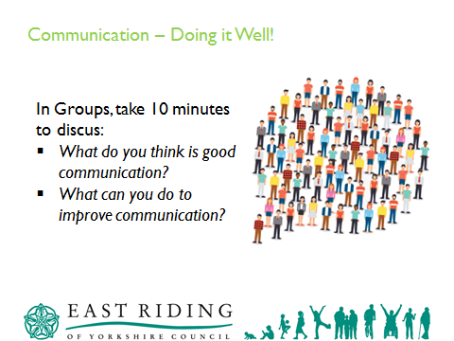
- Flipchart paper and pens.
- Slide 16
Let us now look at communication a little more and let us think about what is good and how we can make it better.

Introduce the group activity by explaining the learner instructions on the PowerPoint Slide

In Groups, take 10 minutes to discuss:
- What do you think is good communication?
- What can you do to improve communication?

Once the activity it complete, facilitate a discussion to review the learner’s findings. You may wish to note these on Flipchart to aid the discussion.

The feedback / review aspect of this activity will vary depending on the size of the group and their background / experience. Judge the approach to adopt and the guidelines / points below will assist in running the activity effectively.

Time / Duration: |  |  | Section Title:
1:09 – 1:12 (3) |  |  | Communication

Time / Duration: | Sub-Section Title:
1:09 – 1:12 (3) | Doing it Well!

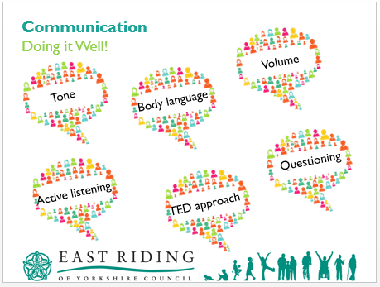
- Slide 17
The slide appears blank.
6 clicks to reveal the slide contents;
Click 1 – Tone
Click 2 – Volume
Click 3 – Body language
Click 4 – Active Listening
Click 5 – Questioning
Click 6 – TED approach

- How we speak

  - Tone - your voice should portray energy and enthusiasm when you speak, which provides a positive tone to a message.

A monotone voice does not keep attention for very long and often leads minds to drift off onto other things. A confident voice helps keep attention and people takes what they hear seriously.

  - Volume - we are less likely to listen or take a message seriously when a person speaks softly and can hardly be heard. On the other hand if a person speaks very loudly, we do listen – we have no choice – but we may be more aware of the volume than the content of the message.

People who speak very softly can find it hard to increase their volume. They believe they are shouting when in fact they are simply being heard clearly.

People who speak very loudly may be equally unaware of it. It may be that they have had to speak up to be heard, they may not hear very well, or they may find it a useful took to talk over others in an aggressive manner.

- Body Language

In order to create the right impression, you have to be aware of your body language, especially if you feel less than comfortable with the person or people you are interacting with. There are occasions when you may say positive words, even with a positive tone of voice, but your body language gives a very different message.

- When sitting, sit upright with your body against the back of the chair and feet flat on the floor. This gives the impression of taking up space and been confident.
  - Sitting with your feet flat on the floor in front of you also makes it more difficult to lean forward, which is some instances can appear aggressive.
  - Stand balanced equally on both feet gives the impression that you are taking up more space.
  - Be aware of personal space. If you notice someone moving back as you move forward, you may be too close.
  - Generally, woman feel more comfortable standing opposite the person they are talking to. Men feel more comfortable at an angle.
  - Use positive open hand movements.
  - Pointing with a finger or pen can appear aggressive.
  - Make eye contact. Some people feel unconfutable doing this because they think it is too much like staring. If you feel like this, simply look at the point between their eyebrows and they will still think you are looking straight at them.
  - One of the most effective body language techniques to build rapport is what is known as mirroring behaviour.

- Listening

People switch in and out of listening all of the time. Listening generally falls into 3 areas:
  - Passive
  - Surface / selective
  - Active

Active listening is the most effective and productive.
How do they feel when they are not listened to or interrupted or spoken over? Listening makes the other person feel good and gives them confidence in you – builds your relationship – more inclined to come to you. Techniques that reinforce active listening are: summarising and reflecting.

- Questioning

  - Open - what, who, where, when, how, why. Used to find out more detail. Be careful of why – ask them why not to over use ‘why’ – can sound accusatory.

  - Closed - did, is it, can? Used to check things out / confirm things / bring a conversation back on track.

  - Extending - these probe or invite further exploration.

  - Linking Questions - these pick up from a previous response to move on in a desired direction. They create a smooth, logical flow but depend on active listening and attention to the structure of the interview.

  - Clarifying Questions - these check your understanding.

Explain the TED approach to question formation, i.e. Tell, Explain, and Describe.

As you have conversations, be aware of their reaction to you – verbal and non-verbal – as well as your own reaction to them.

The impression you create is made up from what you say (the words), your tone of voice (the music), and your body language (the dance). Research shows that 55% of our impact on others comes from our body language, 38% from our tone of voice and only 7% from the words we use!

Time / Duration: |  |  | Section Title:
1:12 – 1:17 (5) |  |  | Wellbeing

Time / Duration: | Sub-Section Title:
1:12 – 1:17 (5) | Health and Wellbeing East Riding

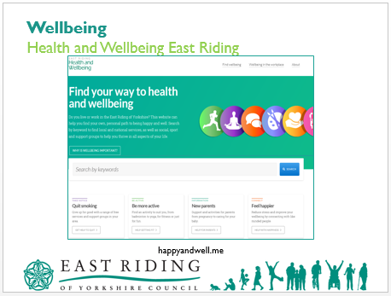
- East Riding Public Health materials and any other resources identified as appropriate by the Trainer / Presenter in line with the national One You imitative.
- Slide 18

Highlight / Key Point:
This area / topic of the training enables discussion and review of healthy choices and the various sources of information / resources available.

Depending on the facilities / resources available within the delivery venue, the Trainer / Presenter will determine the approach adopted with this area / topic.

Where possible, have access to the Internet to show the learners the Health and Wellbeing East Riding Website: happyandwell.me
Also consider accessing other Public Health resources as required.

If no internet is available, simply work from the slide to give an outline of the website explaining that the website has been created by the East Riding of Yorkshire Council Public Health team to support the social prescribing project and make sure everyone has access to reliable wellbeing information and local services.

Find your way to health and wellbeing.
This website has been created by the East Riding of Yorkshire Council Public Health team to support the social prescribing project and make sure everyone has access to reliable wellbeing information and local services. The categories used include be active, take notice, connect, learn and give, taken from the Five Ways to Wellbeing created by Mind.

Do you live or work in the East Riding of Yorkshire? This website can help you find your own, personal path to being happy and well. Search by keyword to find local and national services, as well as social, sport and support groups to help you thrive in all aspects of your life.

Are you looking to improve your wellbeing to feel happier and more productive? Do you want to find like-minded people and services that can support your physical health and mental wellbeing? Then this website is for you! East Riding Health and Wellbeing is a directory of local health services and social groups. It has plenty of information on self-care and where to get help, from quitting smoking to mental health, and parent support to being less lonely.

What is social prescribing?
Social prescribing is about linking residents with local community groups and services that offer support and advice to help them, improving self-care and tackling the social causes of ill health and wellbeing. Following a successful trial in early 2018, social prescribing has been rolled out across all GP Practices in the East Riding.

The pilot found a number of people regularly visiting their GP had underlying non-medical issues that, if dealt with, could reduce reliance on medical interventions and help those with existing long-term or complex conditions to better manage them.

Link workers, based in GP practices, can spend more time getting to the cause of the issues unlike GP's who have an allotted rather than a GP who has an allotted time. Together, you and your link worker will co-design and agree a personalised plan of action.

Social Prescribing does not replace medical services but instead works with them and the patient to identify and deal with underlying issues that hinder the person's quality of life and health and wellbeing.

East Riding of Yorkshire Council is one of many organisations involved in the social prescribing service locally. Others include:
Humber NHS Foundation Trust
HEY MIND
East Riding GP
HEY Smile Foundation

Time / Duration: |  |  | Section Title:
1:17 – 1:25 (8) |  |  | Wellbeing

Time / Duration: | Sub-Section Title:
1:17 – 1:25 (8) | Healthy choices – MECC Link

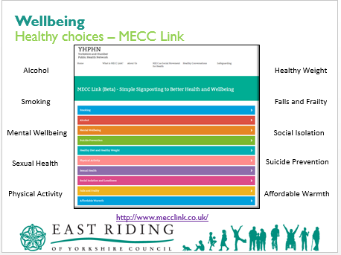
- A3 print outs from this website on tables
- Trainer table information
- Slide 19
The slide appears with an image of a screenshot from the MECC Link website along with several topic areas on this site.

Highlight / Key Point:
This area / topic of the training enables discussion and review of healthy choices and the various sources of information / resources available. It may be useful to refer to the Yorkshire and Humber Public Health Network MECCLink site available on http://www.mecclink.co.uk/.

Base information is provided by East Riding Public Health to assist in the discussions. However, Trainers / Presentations may wish to review the timings to allow greater emphasis on particular topics that may be of a higher priority or prominence for the learners.

It is recommended that between 3 to 10 minutes is allowed for each topic as time allows.

Information on the A3 sheets of paper placed on each table contains information taken directly from the Ask, Assist, and Act model detailed within this website.
Delegates are to review each of the 4 resources on their tables.
These topics can be tailored to suit specific needs of the learners.

MECC Link - Simple Signposting to Better Health and Wellbeing
What is MECC Link?
MECC Link is a simple but flexible online tool that has been carefully designed to support an approach to positive behaviour change called 'Making Every Contact Count' (MECC). MECC Link helps you to raise awareness, motivate and signpost people to help them to improve their health and wellbeing. MECC Link gives you access a full range of signposting information for health improvement, including self-care and national and local support services...and it does this all in one place by providing:
- Easily accessible information on key healthy lifestyle topics
- Suggested open questions using the Ask, Assist, Act model
- Information on a range of primary Self-care tools and resources
- Signposting to recommended national and local support services.

How does MECC Link work?
MECC Link a mobile/tablet enabled website designed in recognition that MECC conversations are often opportunistic. Once you have selected 'Your Region' you can then access a full list of positive actions that people can take to improve their health and wellbeing. You can use the ASK, ASSIST and ACT section to help support your conversations or at the touch of button you can go direct to range of primary signposting information on self-care, national and local support services.

Smoking – Alcohol – Mental Wellbeing – Suicide Prevention – Healthy Diet and Healthy Weight – Physical Activity – Sexual Health – Social Isolation and Loneliness – Falls and Frailty – Affordable Warmth – Problem Gambling – Fire Safety and Prevention – Oral Health

Time / Duration: | Section Title:
1:25 – 1:28 (3) | Wellbeing

Time / Duration: | Sub-Section Title:
1:25 – 1:28 (3) | Healthy choices – stopping smoking example

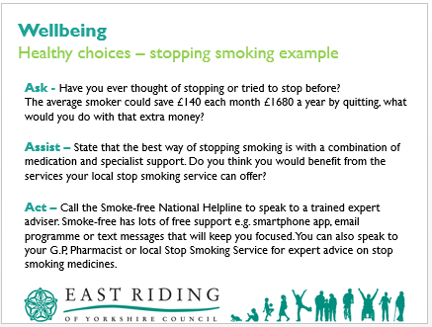
- Slide 20
The slide appears blank.
This is an example of the Ask, Assist and Act model can be used for a healthy chat in relation to stopping smoking and is taken from the MECC Link Website.
3 clicks to reveal the slide contents;
Click 1 – Ask – Have you ever thought of stopping or tried to stop before?
The average smoker could save £140 each month, £1680 a year by quitting, what would you do with that extra money?
Click 2 – Assist – State that the best way of stopping smoking is with a combination of medication and specialist support. Do you think you would benefit from the services your local stop smoking service can offer?
Click 3 – Call the Smoke-Free National Helpline to speak to a trained expert advisor. Smoke-Free has lots of free support e.g. smart phone app, email programme or text messages that will keep you focused. You can also speak to your G.P, Pharmacist or local Stop Smoking Service for expert advice on stop smoking medications.

Did you know giving up smoking significantly increase your chances of living a longer healthier lifestyle, even if you have smoked for 40 years!
It is never to late to think about stopping, it will make a drastic improvement to your lifestyle and health in ways you might not expect.

Benefits of quitting
After 20 minutes your blood pressure and pulse return to normal
After 24 hours your lungs start to clear
After two days your body is nicotine-free and your sense of taste and smell improve
After three days you can breathe more easily, and your energy increases.

Ask - Have you ever thought of stopping or tried to stop before?
The average smoker could save £140 each month (£1680 per year) by quitting, what would you do with that extra money?
Remember to personalise the benefits. Is the person saving for a holiday, or a new home? Do they have children or grandchildren they would like to run around with?
Assist - State that the best way of stopping smoking is with a combination of medication and specialist support.
Studies show that you are four times more likely to quit smoking if you do it through a specialist support service.
Services are free and they provide one to one support.
Local stop smoking services staffed by expert advisers provide a range of proven methods to help you quit.
Do you think you would benefit from the services your local stop smoking service can offer?

Act - Call the free Smokefree National Helpline to speak to a trained, expert adviser on 0300 123 1044. All lines are open Monday to Friday 9am to 8pm and Saturday and Sunday 11am to 4pm*.
Smokefree has lots of free support this includes a smartphone app, email programme or text messages that will keep you focused wherever you are.
You can also speak to your doctor, pharmacy team or local Stop Smoking Service for expert advice on stop smoking medicines.

Self-care
Download the NHS Smokefree app from iTunes or google play
Get further information from the National Health Service www.nhs.uk/quit
Consider using e-cigarettes to stop smoking
Millions have used Smokefree support to help them stop smoking. Choose from an app, email, SMS and face-to-face guidance.

Emphasise that quitting will the best thing they will ever do and the NHS Smokefree service can provide the friendly and helpful support they need to quit for good.

Time / Duration: |  |  | Section Title:
1:28 – 1:31 (3) |  |  | Healthy Chat

Time / Duration: | Sub-Section Title:
1:28 – 1:31 (3) | Ask, Assist and Act

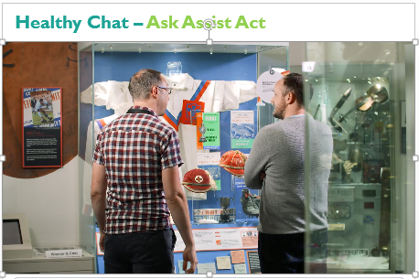
- Embedded video clip – 1:38 seconds
- Slide 21
The video plays once the play icon is pressed.
The video is a demonstration of a healthy chat taking place using the Ask, Assist and Act model as detailed within the MECC Link website.

Facilitate a whole group discussion following this video.

Highlight / Key Point:
Other videos could be used to tailor the session to the needs of the delegates.

Time / Duration: | Section Title:
1:31 – 1:34 (3) | Healthy Chat

Time / Duration: | Sub-Section Title:
1:31 – 1:34 (3) | Ask, Assist and Act

- Embedded video clip – 2:22 seconds
- Slide 22
The video plays once the play icon is pressed.
The video is a demonstration of a healthy chat taking place using the Ask, Assist and Act model as detailed within the MECC Link website.

Facilitate a whole group discussion following this video.

Highlight / Key Point:
Other videos could be used to tailor the session to the needs of the delegates.

Time / Duration: | Section Title:
1:34 – 1:35 (1) | Wellbeing Conversations

Time / Duration: | Sub-Section Title:
1:34 – 1:35 (1) | Applying the skills

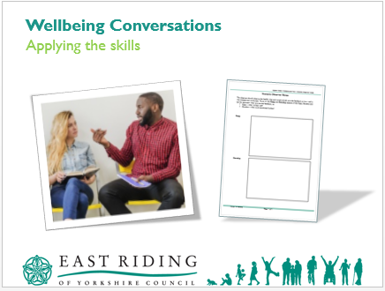
- LR4 – Scenario Observer Notes
- Slide 23
You are now going to be given a scenario which requires you to work in groups of 3 to undertake a health chat in response to this scenario.
Consider what has been covered within this session, e.g. active listening skills, communication skills, body language etc. and have a healthy chat.

1 person undertakes the role of Elsie, 1 as Sharon the befriender and the 3rd person as the observer.

There is 5 minutes allocated for each person to undertake each role with constructive feedback being given by as part of the observer role.
The observer role focuses on the Keep and Develop aspects of the healthy chat.

The scenario is over the following 3 slides.

Highlight / Key Point:
The trainer has flexibility to determine the approach taken with the applying the skills part of this course. Slides 24 to 26 deal with a scenario which can be:
Reviewed and managed as a collective group discussion.
Reviewed as a group and then allow learners to role play. This may or may not include the option of having 1 learner take on the role of observer whilst 2 others carry out the role play.
The scenario can be tailored to suit the needs of the delegates.

Time / Duration: | Section Title:
1:35 – 1:36 (1) | Healthy Chat

Time / Duration: | Sub-Section Title:
1:35 – 1:36 (1) | Elsie

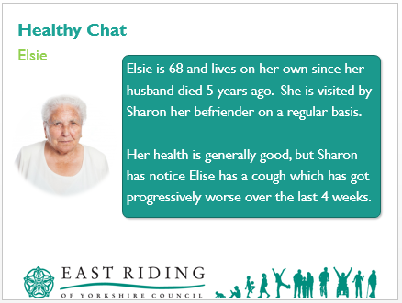
- Slide 24
Elsie is 68 and lives on her own since her husband died 5 years ago. She is visited by Sharon her befriender on a regular basis.

Her health is generally good, but Sharon has noticed Elsie has a cough which has got progressively worse over the last 4 weeks.
Time / Duration: |  |  | Section Title:
1:36 – 1:37 (1) |  |  | Healthy Chat

Time / Duration: | Sub-Section Title:
1:36 – 1:37 (1) | Elsie

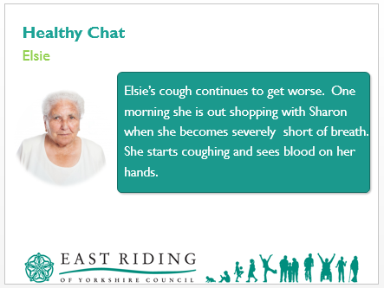
- Slide 25
Elsie’s cough continues to get worse. One morning she is out shopping with Sharon when she becomes severely short of breath. She starts coughing and sees blood on her hands.
Time / Duration: |  |  | Section Title:
1:37 – 1:55 (18) |  |  | Healthy Chat

Time / Duration: | Sub-Section Title:
1:37 – 1:55 (18) | Elsie

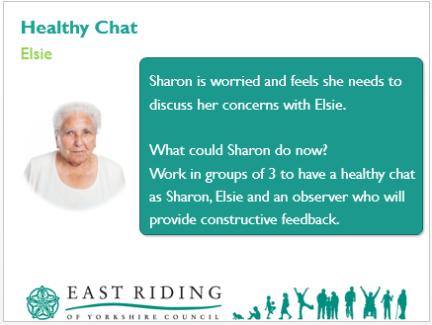
- Slide 26
Sharon is worried and feels she needs to discuss her concerns with Elsie. What could Sharon do now?
Work in groups of 3 to have a healthy chat as Sharon, Elsie and an observer who will provide constructive feedback.

Facilitate whole group feedback on how the healthy chats went and the constructive feedback from an observer’s perspective.
Time / Duration: |  |  | Section Title:
1:55 – 1:56 (1) |  |  | Healthy Chats…

Time / Duration: | Sub-Section Title:
1:55 – 1:56 (1) | Simple sign posting to better health and wellbeing

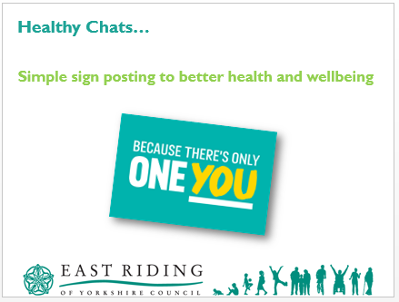
- Slide 27
Healthy Chats, simple sign posting to better health and wellbeing, because there’s only one you.
Time / Duration: |  |  | Section Title:
1:56 – 2:00 (4) |  |  | Healthy Chats

Time / Duration: | Sub-Section Title:
1:56 – 2:00 (4) | Learning outcomes recap

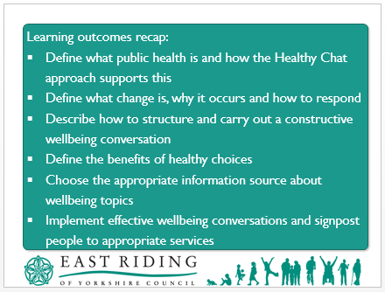
- Slide 28
That brings us to the end of the session, let us recap on the learning outcomes set out at the start.

Learning outcomes recap:
- Define what public health is and how the Healthy Chat approach supports this.
- Define what change is, why it occurs and how to respond
- Describe how to structure and carry out a constructive wellbeing conversation
- Define the benefits of healthy choices
- Choose the appropriate information source about wellbeing topics
- Implement effective wellbeing conversations and signpost people to appropriate services.

Are there any questions?

