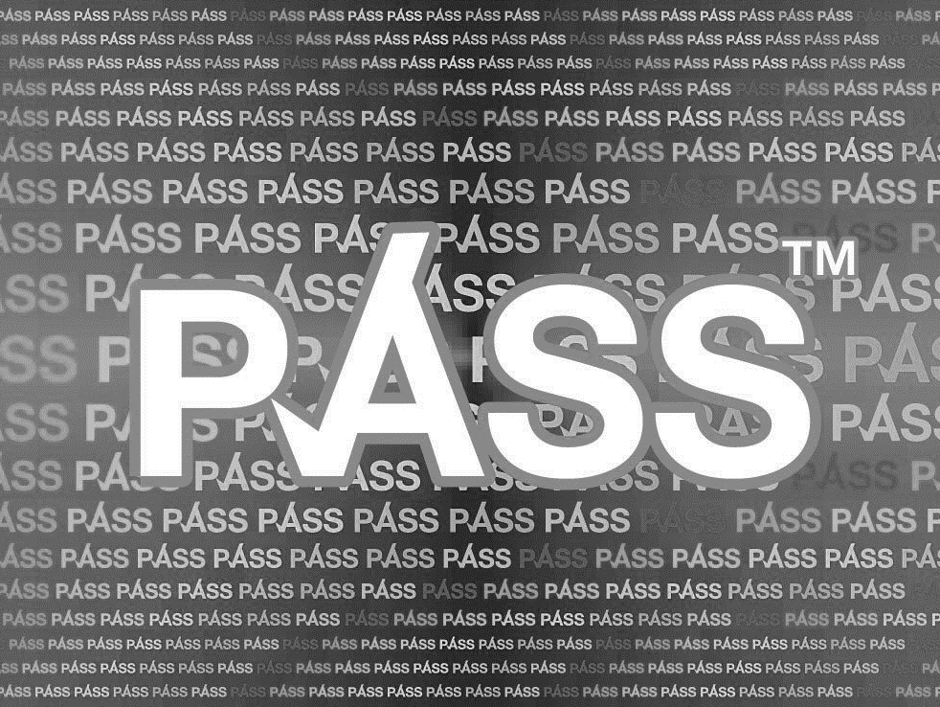

Proof of Age Standards Scheme

Consultation on PASS Proposal to Develop UK Standards for the

Physical Presentation of Digital Proof of Age (DPoA)

1 Introduction

  - PASS (the Proof of Age Standards Scheme) accredits card schemes based on agreed standards for verification of identity and the rigour of the card issuing process, meaning that those accepting these cards can be confident these are valid documents.

  - A growing number of people want to prove their age through a digital system on their phone rather than or as well as using physical proof of age cards. The purpose of this consultation is to seek views on whether or not PASS should extend its remit to cover the use of Digital Proof of Age (DPoA) as well as physical forms of Proof of Age.

1.3 The consultation proposes a new PASS Standard to enable any number of Accredited Digital Suppliers (ADSs) to operate via a single open-source DPoA Retail Validation Interface (RVI).

1.4 The consultation will run until Thursday 30th April 2020 and the PASS Board welcomes views from all interested parties. All responses will be considered before PASS decides whether and how to proceed with the proposal at its meeting in July 2020.

1.5 If the Board decides to proceed, suppliers would be invited to apply for accreditation as an ADS in July 2020 and it is envisaged that the RVI would be made available to retailers & DPoA acceptors from October 2020.

1.6 If you have any queries about the consultation, then please get in touch with Katharine Walters at: PASSdigitalconsultation@gmail.com

1.7 To respond to the consultation, visit: https://www.surveymonkey.co.uk/r/PASSDPoAConsultation.

1.8 Please note that ACS (the Association of Convenience Stores) is using its SurveyMonkey account to support the administration of the consultation process. The information that you provide will go directly to PASS and will be analysed by them. ACS will not use the information you provide for any purpose, however your response will be accessible through ACS’ SurveyMonkey account.

2 Rationale

2.1 Retailers of age-restricted goods and services currently rely on checks of approved forms of physical PoA such as passports, photo driving licences, PASS cards, military ID and national identity cards.

2.2 Thousands of UK users are attempting to use DPoA to prove their age at retail outlets, however, there are no industry-wide standards relating to its use to ensure that retailers can verify that it is a legitimate DPoA.

2.3 It has become apparent that many of the existing rules governing PoA, in particular the Home Office’s Mandatory Licensing Conditions (MLCs) pertaining to alcohol sales and access to licensed premises in England & Wales, do not permit use of any form of DPoA. In Scotland the use of DPoA is not sanctioned in any legislation, statutory guidance or regulations.

2.4 To support retailers in verifying DPoA, PASS proposes developing a single Retail Validation Interface (RVI) which would assure retailers of the validity of the DPoA and allow them to refuse sales where spoof or fraudulent DPoA is presented. The RVI would automatically record that a refusal or successful check has taken place. It would not store any personal data. DPoA providers would be invited to apply to PASS to become an Accredited Digital Supplier (ADS). The operation of these schemes in respect of verifying applicants would be subject to the current PASS Standards.

2.5 Under this proposal any number of ADSs can enter the UK market for the supply of DPoA. The RVI would be open-source, meaning that it would validate any legitimate DPoA rather than having to integrate separately with multiple DPoA suppliers using different validation methods.

2.6 To become an ADS, providers would need to display their DPoA to a common visual standard on customers’ mobile phones so that staff can check that the person presenting the DPoA is the person to whom the DPoA pertains.

2.7 The remit of this proposal is limited to customers using their mobile phones to prove their age in retail environments where a member of staff is responsible for determining that the DPoA is legitimate and pertains to the person presenting it. The proposal does not relate to automated (non-human) validation of PoA nor to age estimation.

Questions

Q1. Do you support the need for a collective approach to be developed for the physical presentation of DPoA?

Q2. Do you support the following key principles of the proposal:
- Facilitate the introduction of legitimate DPoA in the UK
- DPoA can be provided by any number of suppliers
- Ensure that the RVI allows for open-source validation

Q3. Are you aware of any industry standards in other countries that have been developed for the physical presentation of DPoA? If so, what learnings should we take from those schemes.

3 Basis for Physical Presentation of DPoA

3.1 The existing MLCs for age verification related to alcohol sales require acceptable PoA cards to display the holder’s photo, date of birth and either a holographic mark or ultraviolet (UV) feature. It is therefore implicit that to comply with the MLCs retail staff are required to undertake three specific actions:

- check that the customer presenting the PoA is the person in the photo;

- check from the date of birth or age band (eg. ‘18+’) that the customer is at least 18 years old;

- check for holographic or UV features to confirm visually that the PoA appears to be genuine.

3.2 The precedent from the existing MLCs is that staff should be capable of determining a person’s age by assessing that person against the PoA that they present, in other words, without any technical validation of the PoA presented. Even where, for example, ID scanning equipment exists the law requires the member of staff manually to check the PoA presented against the person presenting it.

  - The PASS standards for DPoA should therefore logically match the functional aspects of Physical PoA:

- the person’s image to confirm likeness

- the person’s date of birth to confirm customer’s age (and provide staff with the opportunity to ask the customer to state their DoB)

- visual (manual) validation to confirm that the presented DPoA pertains to the person presenting it

  - Two of the existing PASS requirements for physical PoA should also be included:

- an age band indicating that the customer is, for example, 16+ or 18+ (so that staff do not need to calculate age from the DoB)

- visual endorsements on the DPoA from government and enforcement agencies (such as NPCC and SIA logos)

3.5 To ensure that staff can be confident that the DPoA is legitimate ie. from an ADS and not a spoof, an open-source RVI would be developed. This would offer any member of staff the ability to use their mobile phone to validate the DPoA presented. At the most basic level, this would be done through the retailer or staff member downloading a free app with this functionality. Retailers would also be able, at their cost, to programme the RVI into their EPOS or other systems.

Questions

Q4 Do you agree that the proposals should build upon the existing legal requirements where retailers and staff must verify proof of age manually, comparing the photo with the person presenting the DPoA?

4 Retailer Verification Interface (RVI)

4.1 Under PASS’ proposals, customers using an accredited DPoA would initially present their mobile phone to the retailer. The retailer would determine whether the DPoA is legitimate using the RVI (either by using the retailer or staff member’s Retail App or through the retailer’s EPOS). Only when the Retail App or retailer EPOS validates the QR Code is the customer’s DPoA revealed:

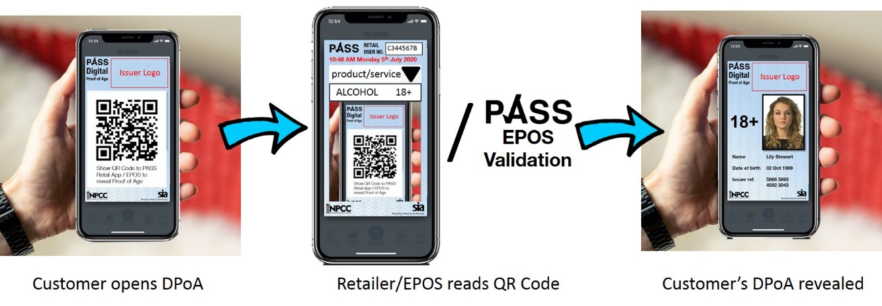

4.2 Retailers would also confirm that the image on the DPoA pertains to the person presenting the phone.

4.3 To use the free Retail App, the retailer would need to initally register their details including the premises address, and they are assigned a unique retailer reference number.

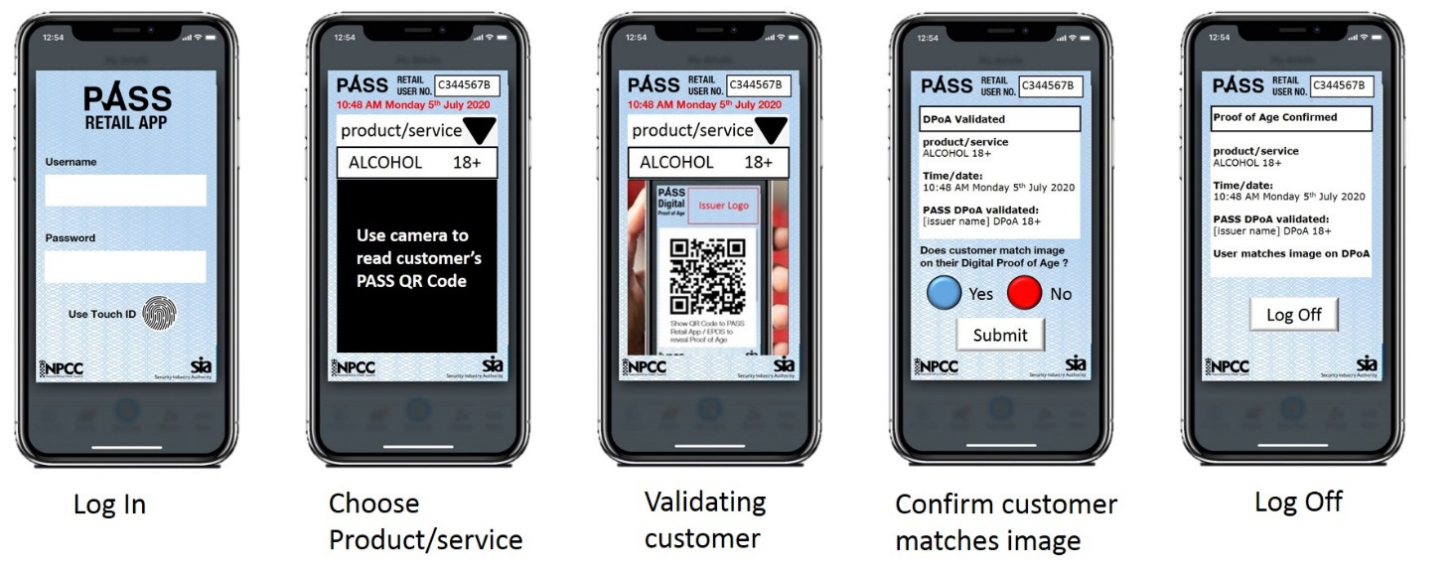

4.4 Instead of (or in addition to) using the Retail App, retailer’ EPOS or other systems (such as payment or lottery terminals) could also be programmed to validate legitimate DPoA.

Questions

Q5. Should a free Retail App be made available to all retailers to maximise the accessibility of DPoA?

Q6. Do you agree with proposed steps in the Retail App for how a retailer would verify a legitimate DPoA?

Q7. Do you think the Retail App should log the details of the staff member using the app and the premises the app is used at?

Q8. Do you agree that the customer’s DPoA should not be revealed on their phone unless electronically validated either by the Retail App or retail EPOS, to deter the use of spoofed DPoA ?

Q9. Do you agree that retailers wishing to integrate the RVI into their EPOS or other systems should cover the cost of that integration?

5 Accredited Digital Suppliers (ADSs)

5.1 Any organisation would be able to apply to be an ADS. They would need to demonstrate compliance with the existing PASS Standards for verification of an applicant’s identity.

5.2 In addition, a prospective ADS would need to demonstrate compliance with the new PASS digital standards that include the requirement to comply with a new Visual DPoA Standard and requirement to integrate with the RVI.

5.3 Prospective ADSs would be audited against the standards prior to accreditation as an ADS. Once accredited, ADSs would be further audited prior to commencement (specifically the point at which their userbase would be linked to the RVI).

5.4 ADSs would pay an annual Digital Licence Fee which would enable them to link their userbase securely to the RVI. The cost of the audits would be a fixed fee and the licence fee would relate to the size of userbase. PASS propose that the full cost of the process is met by ADSs (other than the cost incurred by retailers who wish to integrate the RVI into their EPOS or other systems).

Questions

Q10. Do you support, in principle, a single UK accreditation process for DPoA providers?

Q11. Should ADSs be required to be audited against agreed PASS verification and digital standards?

Q12. Do you agree that the proposed accreditation process should be funded by ADSs paying an annual licence fee related to size of their userbase?

6 Retailers and other DPoA Acceptors

6.1 For this proposal to succeed the vast majority of UK retailers & other DPoA acceptors would need to commit to supporting the proposed standards. Retailers are not expected to incur any costs from accepting DPoA, but they are expected to agree to recognise PASS DPoA as a valid means of customers proving age.

6.2 Specifically, retailers should commit to training their staff either in use of the Retail App (provided free of charge to retailers) and if they have EPoS, integrating RVI technology.

6.3 DPoA is not intended to replace the requirement on staff to check age. Retailers would still need to be trained in how to determine if a DPoA presented is legitimate and prompted to check that the DPoA pertains to the person presenting it.

Questions

Q13. Do you agree that retailers should not be required to financially contribute to the DPoA standards or pay to accept legitimate DPoA (unless they wish to integrate RVI)?

Q14. Under this proposal, are there any challenges for retailers and other potential DPoA acceptors to verify legitimate DPoA? If there are challenges, how could these be overcome?

Q15. Do you believe that the introduction of an open-source RVI would encourage retailers to accept DPoA in-store?

7 Regulatory endorsement

7.1 A single open-source DPoA solution would need endorsement from governmental, regulatory and enforcement bodies to be successful. Although new legislation would not be required to permit the use of DPoA, revised Home Office guidance would be helpful to encourage wider DPoA acceptance by retailers, underpinned by appropriate training by retail employers for staff on in-store approval processes, and to confirm if it is an acceptable form of due diligence. Legislation would need to be amended in Scotland.

7.2 The NPCC (National Police Chiefs’ Council) and SIA (Home Office’s Security Industry Authority) logos are reproduced on physical PASS cards. PASS propose that these logos, and potentially others such as Scottish equivalent organisations, appear on the common PASS DPoA standard design.

Questions

Q16. Do you agree that the standards should only be introduced if government departments including the Home Office, as well as the Scottish Government, police and trading standards, have provided some indication of their intention to support the solution? Should support be sought from any other organisations?

Q17. Do you agree that the proposed DPoA standard design should, if possible, include NPCC, SIA and potentially other endorsements as is the case with physical PASS cards?

Q18. Do you believe that the introduction of an open-source UK DPoA solution such as that proposed would facilitate retailer compliance in ensuring that age restricted products are not sold to persons underage?

8 Data Privacy

8.1 The proposed standards would maintain the privacy of users at all times. Only ADSs would have access to their users’ personal information and they would be required to obtain the user’s consent to the creation of the users’ DPoA on the ADS’s app.

8.2 The user would be required by the ADS to consent to Terms & Conditions that explain clearly that the user’s DPoA would only be revealed on their phone if the user chooses to allow the RVI to validate their DPoA either via a staff member using the Retail App or via the user tapping their phone at the retailer’s EPOS.

8.3 None of the user’s personal details are transferred via the RVI to the Retail App or EPOS system. The retailer or other DPoA acceptor would only receive confirmation that the DPoA is legitimate, the name of the ADS, and that the user is the required age.

  - Registered users of the Retail App and/or the retail EPOS systems would receive an audit trail of the checks made including details of the product/service type and the date & time the check was made. The ADS would also be able to access the audit trail of checks made.

  - Aggregated information on number of checks performed for different product/service types and date & time details could be made available to retail trade organisations and may be shared with government and regulatory organisations for the purpose of monitoring the success or otherwise of the standards. Usage information on individual members of staff or on individual premises would only be made available to the relevant operator.

Questions

Q19. Do you agree that DPoA users’ personal information must not be communicated under any circumstances by the ADS?

Q20. Do you agree that the RVI must not itself contain any personal information (beyond an electronic token supplied by the ADS via the user’s QR code) to enable the RVI to open up the user’s DPoA on their phone?

Q21. Do you agree that anonymised aggregated information on usage of the DPoA standards can and should be shared with trade, government and regulatory organisations?

Q22. Do you have any other comments about PASS’ proposal to Develop UK Standards for the Physical Presentation of Digital Proof of Age (DPoA)?

