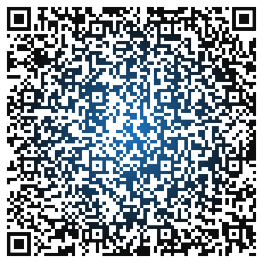A picture containing clipart

Description generated with high confidence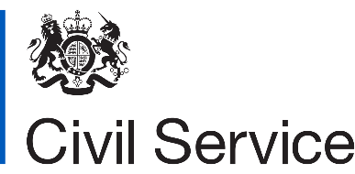

**Five easy steps to register on Knowledge Hub:**

1. Access Knowledge Hub at <https://khub.net/> or scan the barcode.

2. Go to sign-up on the top-right corner.

3. Register and review the confirmation email.

4. Search for ‘CSMN’ under the ‘Groups’ tab.

5. Request to Join the group and start to explore, collaborate and network.

*Assalamu Alaikum (peace be with you),*

**We would like to invite colleagues, regardless of their faith and belief or none, to join the Civil Service Muslim Network (CSMN) Knowledge Hub platform.**

This platform is a one stop site to keep you updated with the latest news, events, blogs, webinars and other resources. It’s free to join, set up an account today to access the page. Let’s all contribute to achieve our shared aim of making the Civil Service the most inclusive employer in the UK.

You can also reach us at [csmn@hmrc.gov.uk](mailto:csmn@hmrc.gov.uk) if you have any registration difficulties or via our new Twitter handle [(@CivilServiceMN](https://twitter.com/CivilServiceMN?s=03)).

**Civil Service Muslim Network**

**Knowledge Hub**