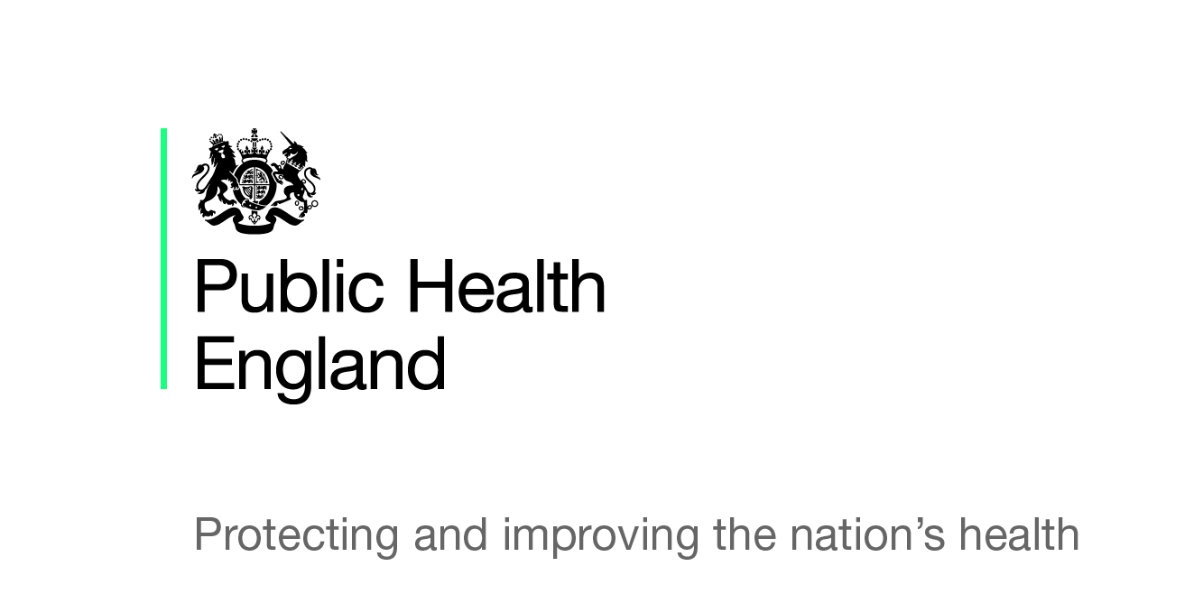

Cardiovascular Disease

Briefing produced by Public Health England’s East of England Health & Wellbeing Team – Feb 2020 (V1.06)

This briefing paper has been produced by Public Health England’s East of England Health and Wellbeing Team. It is designed to provide easy access to key reference points and useful resources around the cardiovascular disease agenda and will be updated on a regular basis as new information becomes available. The information in each section is presented chronologically, with the most recent first.

What is Cardiovascular Disease (CVD)?

Cardiovascular disease (CVD) is a general term for conditions which affect the heart or blood vessels caused by atherosclerosis. Atherosclerosis particularly results in coronary heart disease, stroke and peripheral arterial disease but it also covers other conditions such as vascular dementia and cardiac arrhythmias It is one of the main causes of mortality and morbidity in the UK and is one of the conditions most closely associated with health inequalities.

Many of the risk factors associated with CVD are behavioural risk factors such as poor diet and are modifiable i.e. disease can be prevented, or its progress slowed. Risk factors such as smoking, physical inactivity and obesity are more common in lower socioeconomic groups and the burden of CVD is experienced disproportionately more by the most deprived communities.

This briefing document focuses on three of the six high risk conditions which are part of the PHE CVD Prevention Programme: High blood pressure (hypertension), high cholesterol (hypercholesterolaemia / familial hypercholesterolaemia) and abnormal heart rhythm (atrial fibrillation). The three conditions not included in this briefing are: Chronic kidney disease, ‘pre-diabetes’ (non-diabetic hyperglycaemia) and diabetes.

National policy and reports

The 10-year CVD Ambitions for England – One Year On
This Public Health Matters blog (February 2020) details several promising areas of work and initiatives, led by members of the National CVD Prevention System Leadership Forum, that have been addressing the ABC ambitions (atrial fibrillation, blood pressure, cholesterol) since their launch in February 2019.

NHS Long Term Plan
The NHS Long Term Plan (NHSLTP, January 2019) includes a major ambition to prevent 150,000 strokes, heart attacks and dementia cases over the next 10 years, through improved detection and treatment of the high-risk conditions: atrial fibrillation; high blood pressure and high cholesterol.

To complement the NHSLTP, the National CVD Prevention System Leadership Forum has agreed specific ambitions for detection and management of the high-risk conditions. This Health Matters blog (February 2019) sets out these ambitions and challenges.

PHE Cardiovascular Disease Prevention Initiatives, 2018-2019
This document (November 2018) details some of the key CVD prevention initiatives that PHE is delivering in the 2018 to 2019 financial year, addressing CVD at a population, community and individual level.

High Blood Pressure: Action Plan
In January 2018, PHE published an updated high blood pressure action plan detailing achievements that have been made since the establishment of the Blood Pressure System Leadership Board and the initial action plan which was published in November 2014. This update also outlines further commitments and opportunities for collaboration for stakeholders. It details how everyone can contribute to tackling high blood pressure.

Cardiovascular Disease Prevention Pathway
This NHS RightCare evidence-based pathway (November 2016) supports local commissioners and healthcare professionals in the development of their case for change; best practice pathway for individual conditions and best practice case studies for different parts of the pathway which demonstrate what can be changed, how to change it and a scale of improvement. There is accompanying information detailing how to use the prevention pathway.

Data, guidance, infographics and toolkits

Cardiovascular Disease Fingertips Profiles
This tool produced by PHE (updated regularly), provides an overview of data on cardiovascular and cardiovascular related conditions such as heart disease and stroke. Data presented includes mortality, hospital admissions and disease management and aims to support local commissioners and healthcare professionals when assessing the impact of cardiovascular disease on their local population to make decisions about services in their areas. Additionally, narrative profile reports regarding cardiovascular related conditions are available to download for each clinical commissioning group in England.

All Our Health
The PHE All Our Health framework is a framework of evidence to help healthcare professionals in England understand and maximise the impact on improving health outcomes and reducing health inequalities. Since the publication of this framework, PHE has published a resource about the framework and another piece of guidance around applying ‘All Our Health’ in relation to cardiovascular disease prevention (updated December 2019). This guidance explains the need for promoting CVD prevention; actions providers can take; understanding local needs; measuring impact and other useful resources.

Quality and Outcomes Framework: Achievement, Prevalence and Exceptions Data
In October 2019, NHS Digital published this achievements, prevalence and exceptions data for the April 2018 to March 2019 reporting period. Data for cardiovascular group conditions, including atrial fibrillation and hypertension are available at a national, regional and local (STP, CCG and GP Practice) level.

Atrial Fibrillation High Impact Intervention Tool
NHS RightCare in collaboration with Imperial College Health Partners developed this tool (September 2019) to support local health systems to measure the value of identifying and treating patients with Atrial Fibrillation, including the impact of screening and treatment-based interventions. A user guide for this tool is also available.

What Good Cardiovascular Disease Prevention Looks Like
This publication (September 2019) represents the practical translation of the core guiding principles and features of what a good quality Cardiovascular Disease prevention programme looks like in any defined place. It was developed collaboratively through the synthesis of existing evidence, examples of best practice, practitioners’ experiences and consensus expert opinions. It is intended to serve as a guide and will be iterative with regular reviews and updates when new evidence and insights emerge.

Cardiovascular Disease Primary Care Intelligence Packs
These PHE produced CCG level data intelligence packs (updated May 2019) enable healthcare professionals and commissioners to understand the prevalence, variation and the treatment of cardiovascular conditions in their local areas. It uses GP practice level data on prevention, detection and management of various cardiovascular conditions and can help with the planning, commissioning and improvement of services.

National Cardiovascular Disease Prevention Packs
These packs (March 2019) aim to provide information for hypertension and atrial fibrillation and are produced for each STP/ICS area in East of England. Information is included at STP, CCG and practice level and compare local diagnosis and treatment figures in relation to the national PHE CVD ambitions. These can be used alongside other resources such as the NHS RightCare CVD packs.
- Cambridgeshire and Peterborough
- Hertfordshire and West Essex
- Mid and South Essex
- Milton Keynes, Bedfordshire and Luton
- Norfolk and Waveney
- Suffolk and North East Essex

Physical Ill-health and CVD Prevention in People with Severe Mental Illness
NHS RightCare have published a toolkit (March 2019) which defines the core components of an optimal service for people with SMI who are at risk of developing CVD and provides a set of resources to support local health systems concentrate their efforts on improving where this is the greatest opportunity to address variation and improve population health.

CVD Prevention: Cost-Effective Commissioning
This PHE return on investment tool (October 2018) has been published to support commissioners in providing cost-effective interventions to prevent CVD in individuals with associated risk factors. Accompanying the tool itself is some guidance and press release with the background to the tool. You can access a PHE produced webinar on the tool here (November 2018).

Global Burden of Disease Study
New analysis of data from the GBD study (October 2018) details the leading causes of morbidity and mortality in the UK and for the first time, includes data at local authority level in England. This development was due to an international collaboration involving PHE, University of East Anglia (UEA), University of Washington and many other partners. UEA also developed a data visualisation tool for years of life lost alongside the GBD data visualisation tool. This data shows that cardiovascular diseases in the East of England is a leading cause of death and disability and that more than half of early deaths in the East of England are associated with potentially preventable risk factors.

Atrial Fibrillation: How can we do better?
PHE in partnership with others created the ‘how can we do better?’ documents (Updated February 2018). These documents use the data from various data sources and the documents detail the state of atrial fibrillation care in England and each of the CCGs. NHS England has developed a pilot project to target patients who have been diagnosed with atrial fibrillation but are not receiving optimal treatment, to ensure that they are receiving appropriate treatment to reduce the risk of stroke.

Blood Pressure: How can we do better?
British Heart Foundation, PHE and partners produced these ‘how can we do better?’ documents (Updated February 2018). These documents provide data and resources to help improve the detection and management of high blood pressure in the local and the documents are outlined at CCG level, with a separate document for England as a whole.

Local Health and Care Planning: Menu of Preventative Interventions
This PHE document (updated February 2018) was published to help those involved in the planning and commissioning of health services, including STPs. This document details evidence-based public health interventions and includes a discrete section on CVD secondary prevention detailing steps that can be taken to improve atrial fibrillation, hypertension familial hypercholesterolaemia management.

Using the NHS Health Check Programme to Prevent CVD
This PHE guidance (January 2018) explains how the NHS Health Check is playing an important role in the prevention and in the early detection of CVD. It also has a section around “call to action” which explains what the different parts of the health and social care sector can do to increase uptake.

NHS RightCare Focus Packs
In April 2016, NHS RightCare produced focus packs for the CVD family of conditions, providing more information on the wider range of outcomes measures and information on the most common procedures and diagnoses for the condition in question. The focus packs are produced at CCG level. Alongside these focus packs, there is an atlas tool which produces a chart showing where the CCG ranks nationally for any particular indicator in the pack.

NICE Guidelines and Quality Standards

Below are the following pathways relating to CVD. NICE pathways allow users to navigate the breadth and depth of NICE recommendations on a given subject through topic-based diagrams, linking to the tools and resources that NICE has produced to support the implementation of the guidance. For each topic area, there are NICE guidelines, – clinical and/or public health – and their related quality standards:
- Cardiovascular disease prevention
- Cardiovascular disease: Identifying and supporting people most at risk of dying early
- Atrial fibrillation
- Hypertension (high blood pressure)
- Hypertension in pregnancy (high blood pressure in pregnancy)
- Familial hypercholesterolaemia

Under the familial hypercholesterolaemia pathway, there is the clinical guideline: ‘Familial hypercholesterolaemia: Identification and Management’ (last updated in November 2017). PHE has produced a guide (August 2018) providing additional information to support the implementation of this NICE guideline and it includes best practice case studies, recommendations and outline of key policy documents.
Initiatives and Campaigns

NHS Diabetes Prevention Programme
The Healthier You: NHS Diabetes Prevention Programme was launched in 2016 and is a joint commitment from NHS England, Public Health England and Diabetes UK. Its aim is to support individuals who are at high risk of developing Type 2 diabetes. Those who are referred onto the programme get tailored help and support including education on lifestyle choices, healthier eating and physical activity programmes and their benefits. An annual Diabetes Prevention Week campaign runs in April to raise awareness of the programme and of the causes of Type 2 diabetes. Free promotional materials are available from the PHE resources hub.

NHS Health Check
This national programme from the age of 40-74 years old measures a range of risk factors that are known to increase the risk of developing CVD in the next 10 years. It offers everyone having the check to know their risk early, support to change lifestyle behaviours and early detection and management of conditions. Since April 2013, over 6 million people have had a check and recent evidence suggests it is reaching the most deprived communities.

PHE One You - Social Marketing Programme
Launched in March 2016, ‘One You’ encourages adults to take part in an online health quiz, called ‘How Are You?’, which helps them reassess their lifestyle choices. After completing the quiz, individuals can receive email reminders and resources to motivate them to make changes to lead a healthier lifestyle. ‘One You’ has its own website with a range of resources and free apps. In the first year of its launch, there were 1.34 million completions of the quiz. Promotional materials can be downloaded and ordered for free from the PHE resource hub.

Under the banner of ‘One You’, PHE has launched several campaigns covering different lifestyle choices and changes that can be made, including:
Drink free days – PHE in association with Drinkaware, launched this campaign in September 2018 to help people, particularly 45-64-year olds, cut down on the amount of alcohol they are regularly drinking and to highlight that having more drink free days can reduce risks of serious conditions like CVD and improve their health.
Active 10 – Initially launched in March 2017 and re-launched in June 2018, this PHE campaign aims to combat physical inactivity and lower the risks of serious illnesses such as heart disease, by encouraging adults to incorporate more physical activity into their daily lives, by going for a brisk ten-minute walk (or more) each day.

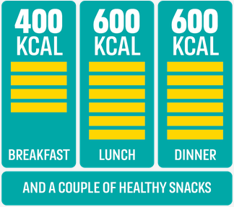
400-600-600 – Adults are consuming on average an extra 200-300 calories per day. This ‘calorie creep’ contributes to two thirds of adults being overweight or obese, which can in turn lead to serious CVD conditions. This PHE campaign was launched in March 2018, to help adults manage the ‘calorie creep’ by providing simple tips to help them make healthier choices whilst on the go. The aim is around 400 calories for breakfast, 600 for lunch and 600 for dinner, plus a couple of healthier snacks and drinks in-between.
Stoptober – Originally launched in October 2012, this PHE 28-day stop smoking challenge, encourages and supports smokers across England towards quitting for good. There are lots of ways to quit and Stoptober can help people choose what works for them and provides free support along the way.
Heart Age Test – This tool is a collaboration between NHS, PHE, the British Heart Foundation and UCL. It was relaunched in September 2018 and is an ‘always-on’ campaign. This simple online test helps individuals compare their heart age to their real age and explains the importance of knowing their blood pressure and cholesterol numbers. The test can still be completed if these numbers are not known. As part of the results, it also provides individuals with advice on how to lower their heart age and reduce their risk of heart attack and stroke.

Training opportunities

All Our Health
PHE in partnership with Health Education England have launched a series of e-learning sessions, with one covering CVD. The sessions have been developed to provide a bite-sized introduction to CVD including useful sources of evidence, guidance and support.

Blood Pressure (BP) Training for Pharmacists
This webinar, funded by Health Education England and delivered with the support of PHE and NHSE across the Midlands and East areas, aims to develop BP risk awareness and measurement technique and is available to pharmacy colleagues. It will ensure consistency in measuring a patients BP appropriately and will support knowledge development on the lifestyle behaviours that can contribute to high BP and the brief interventions that may support people to reduce their risk.
Other briefing documents in this series

There are several briefing documents in this series which relate to cardiovascular disease and will be updated on a regular basis. These include:
- Dementia and Healthy Ageing
- Making Every Contact Count
- Obesity Prevention
- Physical Activity
You can click on the links above to download each document or visit the PHE East of England Group on the KHub to view all the documents in the series and other useful resources.

For any further questions, please contact Fennie Gibbs, Health and Wellbeing Support Officer, PHE East of England on fennie.gibbs@phe.gov.uk.

