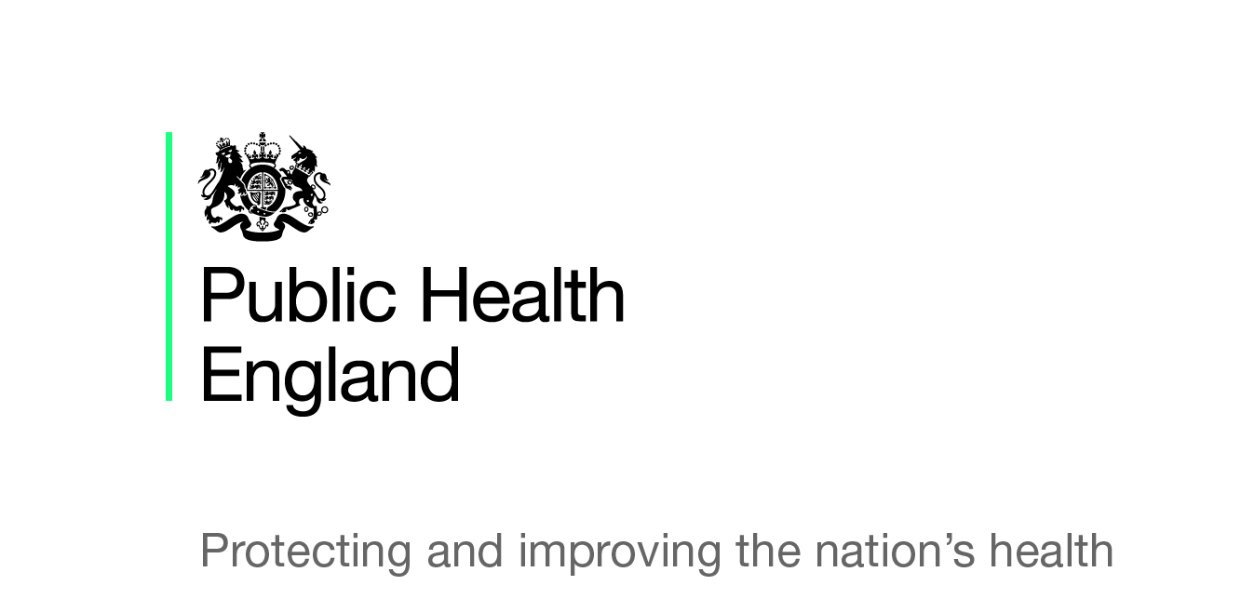

Obesity

Briefing produced by Public Health England’s East of England Health & Wellbeing Team – Oct 2019 (V1.05)

This briefing paper has been produced by Public Health England’s East of England Health and Wellbeing Team. It is designed to provide easy access to key reference points and useful resources around the obesity agenda and will be updated on a regular basis as new information becomes available. The information in each section is presented chronologically, with the most recent first.

National policy and reports

Time to Solve Childhood Obesity: CMO Special Report
An independent report by former Chief Medical Officer (October 2019), sets out a range of recommendations for the government, which are supported by 10 principles and builds on the work the government has already done.

Healthier Weight Conversations: Consensus Statement
This document (September 2019) has been co-produced with a number of professional organisations, outlining the shared commitment to support the public health workforce in working together to have healthier weight conversations.

Sugar Reduction Programme
Following the 2016 ‘Childhood Obesity: A Plan for Action’ and their commitment for PHE to oversee a sugar reduction programme, in March 2017 PHE published ‘Sugar Reduction: Achieving the 20%’ which included guidelines of how to achieve this ambition. In May 2018, a progress report was published assessing the progress that has been made. In January 2019, a supplementary report on fermented drinks was published covering yoghurts and fromage frais category of the sugar reduction programme. Most recently, there has been a summary of progress: 2015 to 2018 report published (September 2019), giving a detailed assessment of progress towards the 20% reduction ambition by 2020.

Childhood Obesity: A Plan for Action
The government’s plan for action (August 2016) to significantly reduce childhood obesity by encouraging industry to cut the amount of sugar in food and drinks and primary school children to eat more healthily and stay active. Chapter 2 (June 2018) of the plan for action followed and outlined what has been done since the plan was first introduced; key actions the Government is hoping to take and many examples of good practice.

An impact assessment document (updated September 2018) addresses the policy intentions set out by the Government in Chapter 2, and the effects on those people with protected characteristics.

Government published Chapter 3 of the childhood obesity plan as part of the Advancing Our Health: Prevention in the 2020s green paper (July 2019, p30). It sets out plans for: infant feeding, clear labelling, food reformulation improving the nutritional contents of foods, and support for individuals to achieve and maintain a healthier weight.

What Good Healthy Weight Looks Like
This PHE and ADPH publication (July 2019) aims to provide a high-level framework for what a good quality, local approach to promoting healthy weight looks like. It is designed to promote a coordinated approach to tackling obesity across the whole system and provides examples of best practice, signposts to a range of guidance and includes a self-assessment matrix to support sector-led improvement.

All Our Health
The PHE All Our Health framework (first published 2015, but evolving with latest updates in May 2019) is a framework of evidence to help healthcare professionals in England understand and maximise the impact on improving health outcomes and reducing health inequalities. Since the publication of this framework, PHE has published a resource about the framework, and two other pieces of guidance, specifically around obesity: Childhood Obesity – Applying ‘All Our Health’ (updated August 2019) and Adult Obesity – Applying ‘All Our Health’ (updated June 2019). These pieces of guidance explain the issues around obesity in adults and children, practical actions and interventions, understanding local needs, measuring outcomes and further guidance and resources of relevance.

Obesity, Healthy Eating and Physical Activity in Primary Schools
Following on from the 2016 ‘Childhood Obesity: A Plan for Action’, Ofsted were commissioned to conduct a thematic review into what actions schools are taking to reduce childhood obesity (July 2018).

Healthy Weight, Healthy Futures
The Local Government Association published this updated document in June 2018 which showcases the variety of ways local authorities and other partners are working to tackle childhood obesity. It comes after the first published document of the same name in 2016.

Childhood Obesity: Follow-up
The House of Commons Health Select Committee published this report (March 2017) following the childhood obesity plan release in August 2016. The Government then responded to the conclusions and recommendations made, in its own report (January 2018).

Working Together to Reduce Childhood Obesity
This document (May 2017) from the National Children’s Bureau explores local activity in the context of national policy with the aim to inform schools, early year’s settings, local authorities, voluntary organisations and others, to plan and deliver joined-up and effective initiatives.

Drug and Alcohol Addiction, and Obesity: Effects on Employment Outcomes
Dame Carol Black conducted this independent review (December 2016) which in its own distinct part of the review, she explores obesity, employment outcomes and the benefits system.

Childhood Obesity: Brave and bold action
In November 2015, the House of Commons Health Select Committee published this report around childhood obesity detailing recommendations for change. Following this report, the Government responded to the conclusions and recommendations in their own report (September 2016).

Dental Caries and Obesity: Their Relationship in Children
This PHE produced evidence summary (October 2015) reviews what is currently known about the relationship between dental caries and obesity in children using existing literature and public health monitoring data. It aims is to support the public health and obesity teams who may need to explain the relationship between these two outcomes.
Adult Obesity and Type 2 Diabetes
This PHE paper (July 2014) provides an overview of the relationship between obesity and type 2 diabetes among adults, utilising the latest available data and evidence around prevalence trends at a national and local level. It also details the potential implications around health consequences, inequalities and cost and other relevant policy and guidance documents.
Obesity and the Environment: Regulating the Growth of Fast Food Outlets
PHE published this briefing in conjunction with the Local Government Association and the Chartered Institute of Environmental Health (March 2014). Its aim is to address the opportunities to limit the number of fast food outlets, predominantly hot food takeaways, especially near schools and ways in which fast food options can be made healthier.

Data, guidance, infographics and toolkits

Fingertips Profiles
PHE has produced profiles displaying data for indicators across a range of health and wellbeing themes, with the aim of supporting commissioning to improve health and wellbeing and reduce inequalities. As obesity cuts across many themes, related indicators are available in many profiles. Once you follow the link to the Public Health Profiles main page, there is a search bar where you can enter indicator keywords. Enter ‘obesity’ here and the indicators across all profiles will display and data is available at a local level alongside data for England.

NCMP and Child Obesity Fingertips Profile
The National Child Measurement Programme (NCMP) measures the height and weight of children who are 4-5 and 10-11 years old, in primary schools in England. This data helps to increase understanding of the patterns in underweight, healthy weight, overweight and obesity among the population of children. The data in this tool is presented at a local level alongside the data for England for the different indicators.

Encouraging Healthier ‘Out of Home’ Food Provision
This toolkit (updated September 2019) aims to help local authorities and businesses to provide and promote healthier options for food eaten out of the home.

Healthy Schools Rating Scheme: Guidance for Schools
This self-assessment tool (July 2019) is aimed at schools to help them to recognise their contribution to and improve the health and wellbeing of their pupils. Schools will be able to determine how well they are doing and how they might improve their healthy living policies and awards for performance are given and can be utilised to show how well they are doing.

National Child Measurement Programme (NCMP) Guidance for Local Authorities: Collection
This link is to a collection of PHE publications which offers guidance for local authorities around the implementation of NCMP. In its most recent updates, an NCMP: Conversation Framework document (April 2019) and NCMP and Child Obesity profile data (May 2019) were added. In September 2019, updated information for schools and operational guidance was published.

Whole Systems Approach to Obesity
PHE has produced a guide and set of resources (July 2019) to support local authorities and partners including the NHS, with implementing a whole systems approach to address obesity (WSO) and promote a healthy weight. The guide covers the role of local authorities; the benefits of taking a WSO and the 6-phase process with practical support.

Statistics on Obesity, Physical Activity and Diet
This statistical report presents information on obesity, physical activity and diet which was published by NHS Digital in May 2019 and relates to a reporting period of 01 April 2017 to 31 December 2018. It includes intelligence around adult and childhood obesity prevalence among other topics areas and there are links to the data tables and a data visualisation tool.

Patterns and Trends in Adult Obesity
PHE has produced this presentation of the latest data on adult obesity which was published in March 2019. It covers overweight and obesity data, BMI status and waist circumference including prevalence and trends in relation to age, sex, location, income, education, deprivation and ethnicity.

Patterns and Trends in Child Obesity
PHE has produced this presentation of the latest data on childhood obesity which was published in February 2019. It covers the prevalence and trends of excess weight and obesity and BMI status in relation to age, sex, ethnicity and deprivation.

Differences in Child Obesity by Ethnicity
This PHE publication (January 2019) presents National Child Measurement Programme data analyses and shows how child obesity prevalence varies by ethnicity, after adjustment for other explanatory variables.

KPIs: Tier 2 Weight Management Services for Children
This document published in January 2019, sets out the recommended key performance indicators for child and family weight management services which should be used in line with the guidance around commissioning and providing services (detailed below, October 2017).

Promoting Healthy Weight in Children, Young People and Families
This resource, published in October 2018, is made up of briefings and practice examples to promote healthy weight for children, young people and families as part of a whole systems approach.

Obesity and the Environment: Density of Fast Food Outlets
These documents (June 2018) show the density of fast food outlets in England by local authority area on a map and an accompanying chart to show the relationship between the density of fast food outlets and deprivation by local authority. The data table document presents at local authority and ward level.

Weight Management Interventions: Standard Evaluation Framework
The PHE guidance (March 2018) is an update of the ‘Standard Evaluation Framework for weight management interventions’ (2009), originally published by the National Obesity Observatory and is now widely used across the country. It has been updated following practitioner feedback and to provide support for the collection of weight management guidance for commissioners and providers.

Adult Weight Management: Key Performance Indicators
This PHE guidance document (November 2017) details the key performance indicators recommended for tier 2 adult weight management services, which should be used in line with the evidence-based guidance on commissioning and providing services for adults (June 2017) detailed below.

Child Weight Management Services: Systematic Review
PHE commissioned this independent systematic review (October 2017) which identifies the characteristics and/or combination of characteristics that feature in successful tier 2 child (0-11 years) weight management programmes.

Weight Management Services: Collect and Record Data
These PHE guidance tools are aimed at service providers to enable them to collect and record data around tier 2 weight management services, consistently, for adults (June 2017) and for children (October 2017), respectively.

Weight Management: Commission and Provide Services
PHE produced two evidence-based documents to support commissioners, practitioners and providers of tier 2 weight management services. They offer recommendations, considerations and resources to implement this guidance into practice for adults (June 2017) and for children and their families (October 2017).

Let’s Talk About Weight
PHE produced two written documents to provide practical advice for health and care professionals around conversations they should be having about weight management for adults (June 2017) and for children and their families (September 2017). Accompanying these step-by-step guides are one-page infographics detailing the steps to follow when talking to adults and to children and their families.

Adult Weight Management: Changing Behaviour Techniques
This PHE evidence-based guidance document (June 2017) recommends behaviour change techniques to be used in adult tier 2 weight management services.

Local Authority Declaration on Healthy Weight Toolkit
Food Active designed this declaration to support local government to exercise their responsibility in developing and implementing policies which promote healthy weight. The aim of this support pack (June 2017) is to provide local authorities with a step-by-step guide to adopting the declaration.

Weight Management Services: Insights into User Experiences
PHE commissioned this independent report (June 2017) to understand the experiences of tier 2 and tier 3 weight management services for children, families and adults from the perspectives of the service users, providers and commissioners.

Obesity in Mental Health Secure Units
This review was published by PHE in February 2017 and summarises the latest evidence around obesity in secure adult mental health settings. The aim of this guidance document is to support NHS England and the future commissioning of these services.

NICE Guidelines and Quality Standards for Obesity

Obesity: Clinical Assessment and Management (Last reviewed August 2019) – This quality standard covers the assessment and management of obesity in children and young people and adults, including referral for specialist care and weight loss surgery. It also covers people who are obese and have or are at risk of other medical conditions. There are tools and resources to help with implementation and improvement.

Obesity in Adults: Prevention and Lifestyle Weight Management Programmes (Last reviewed August 2019) – This quality standard covers preventing those over 18 years old from becoming overweight or obese. It also includes lifestyle weight management programmes for adults and strategies around increasing physical activity and promoting a healthy diet. There are tools and resources to help to implement this quality standard.

Obesity in Children and Young People: Prevention and Lifestyle Weight Management Programmes (Last reviewed August 2019) – Much like the quality standard above for adults, this one focuses on children and young people covering preventing them from becoming overweight and obese, including ways to increase levels of physical activity and a healthy diet. It also details lifestyle weight management programmes for those who are overweight or obese.

Obesity: Identification, Assessment and Management (Last reviewed May 2018)
This clinical guideline covers children (2 years old and over), young people and adults and identifying, assessing and managing obesity. It aims to improve the use of very low calorie diets and bariatric surgery to help people who are obese to reduce their weight. To note: After the May review, recommendations on identification and classification of overweight and obesity, assessment, pharmacological interventions and physical activity will be updated.

Obesity: Working with Local Communities (Last reviewed June 2017) – This public health guideline covers obesity prevention and weight loss within local communities, with the support of local organisations and networks. It aims to support sustainable and community-wide action to achieve this. Tools and resources are included to help with implementing this guidance.

Obesity Prevention (Last reviewed, March 2017) – This clinical guideline looks at preventing all ages from becoming overweight or obese. It details how local authorities, the NHS, educational settings and workplaces can increase physical activity and promote healthy diets among their target groups. This guideline includes recommendations, tools and resources to help with implementation.

Preventing Weight Gain (Last reviewed March 2017)
This NICE guideline aims to prevent a range of diseases and conditions including cardiovascular disease and type 2 diabetes and improve mental wellbeing. It covers behaviours such as physical activity and diet to help children; young people and adults maintain a healthy weight and prevent excess weight gain.

Training opportunities

All Our Health
PHE in partnership with Health Education England have launched a series of e-learning sessions, with one covering adult obesity. The sessions have been developed to provide a bite-sized introduction to adult obesity including useful sources of evidence, guidance and support.

Initiatives and Campaigns

Change4Life Programme
This programme is to encourage and help families eat well and move more and is PHE’s flagship programme for preventing obesity in children. As part of the programme, Change4Life has run targeted campaigns around nutrition and physical activity (10 minute shake ups).

NHS Diabetes Prevention Programme
The Healthier You: NHS Diabetes Prevention Programme was launched in 2016 and is a joint commitment from NHS England, Public Health England and Diabetes UK. Its aim is to support individuals who are at high risk of developing Type 2 diabetes. Those who are referred onto the programme get tailored help and support including education on lifestyle choices, healthier eating and physical activity programmes and their benefits. An annual Diabetes Prevention Week campaign runs in April to raise awareness of the programme and of the causes of Type 2 diabetes. Free promotional materials are available from the PHE resources hub.

parkrun Practices
The Royal College of GPs and parkrun UK are launching a new initiative where patients could be ‘prescribed’ outdoor physical activity, in order to improve health and wellbeing. GP practices will be able to become certified ‘parkrun practices’, establishing closer links with their local parkrun, enabling healthcare professionals to signpost their patients and carers to parkrun, especially those who have long-term conditions and/or are inactive.

PHE One You - Social Marketing Programme
Launched in March 2016, ‘One You’ has an online ‘How are you?’ health quiz which helps adults reassess their lifestyle choices. After completing the quiz, individuals can receive email reminders and resources to motivate them to make changes to lead a healthier lifestyle. ‘One You’ has its own website with a range of resources and free apps. In the first year of its launch, there were 1.34 million completions of the quiz. Promotional materials for One You and associated campaigns can be downloaded and ordered for free from the PHE resource hub.

Under the banner of ‘One You’, PHE has launched several campaigns covering different lifestyle choices and changes that can be made. For example:

Drink free days – PHE along with with Drinkaware launched this campaign in September 2018 to help people, particularly 45-64 year olds, cut down on the amount of alcohol they are regularly drinking and to highlight that having more drink free days can reduce risks of serious conditions and improve their health.

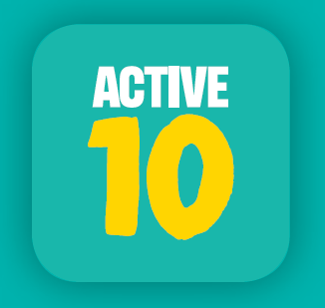
Active 10 – Initially launched in March 2017 and re-launched in June 2018, this PHE campaign aims to combat physical inactivity and lower the risks of serious illnesses such as heart disease, by encouraging adults to incorporate more physical activity into their daily lives, by going for a brisk ten-minute walk (or more) each day.

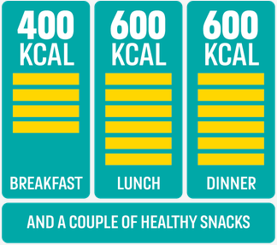
400-600-600 – Adults are consuming on average an extra 200-300 calories per day. This ‘calorie creep’ contributes to two thirds of adults being overweight or obese, which can in turn lead to serious CVD conditions. This PHE campaign was launched in March 2018, to help adults manage the ‘calorie creep’ by providing simple tips to help them make healthier choices whilst on the go. The aim is around 400 calories for breakfast, 600 for lunch and 600 for dinner, plus a couple of healthier snacks and drinks in-between.

Other briefings in the series

There are several briefing documents in this series which relate to physical activity and will be updated on a regular basis. These include:
- Dementia and Healthy Ageing
- Making Every Contact Count
- Musculoskeletal Health
- Physical Activity
You can click on the links above to download each document or visit the PHE East of England Group on the KHub to view all the documents in the series (East of England Policy Briefings) and other useful resources.

For any further questions, please contact Fennie Gibbs, Health and Wellbeing Support Officer, PHE East of England on fennie.gibbs@phe.gov.uk.

