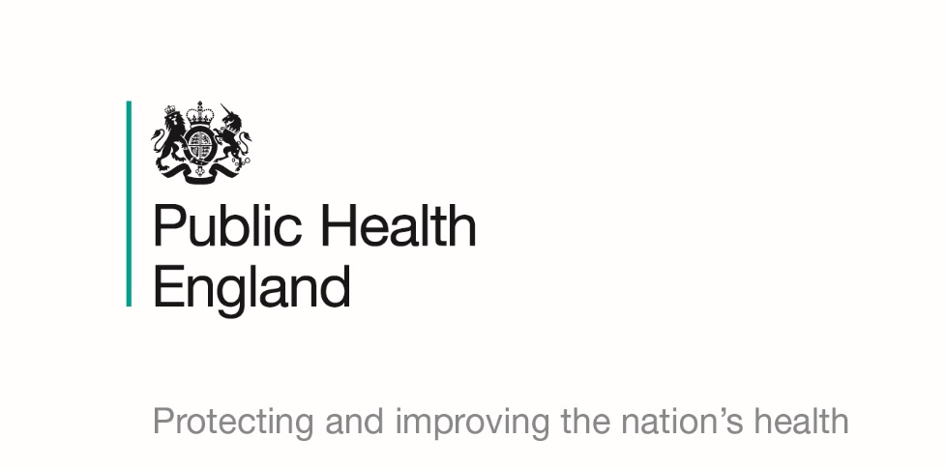

Healthy Weight in Pregnancy

Briefing produced by Public Health England East of England’s Health & Wellbeing Team – June 2020 (V1.01)
This briefing paper has been produced by Public Health England’s East of England Health and Wellbeing Team. It is designed to provide easy access to key reference points and useful resources around the healthy weight in pregnancy agenda and will be updated on a regular basis as new information becomes available. The information in each section is presented chronologically, with the most recent first.

National policy and reports

MBRRACE-UK: Saving Lives, Improving Mothers Care
This report (November 2019), the MBRRACE-UK annual report of the Confidential Enquiries into Maternal Deaths and Morbidity, includes surveillance data on women who died during or up to one year after pregnancy between 2015 and 2017 in the UK. One of the key messages is that cardiovascular disease remains the leading cause of women’s deaths during or after pregnancy in the UK (obesity being a risk factor for heart disease).

Healthier Weight Conversations: Consensus Statement
This document (updated October 2019) has been co-produced with a number of professional organisations, outlining the shared commitment to support the public health workforce in working together to have healthier weight conversations.

What Good Healthy Weight Looks Like
This PHE and Association of Directors of Public Health publication (July 2019) aims to provide a high-level framework for what a good quality, local approach to promoting healthy weight looks like. It is designed to promote a coordinated approach to tackling obesity across the whole system and provides examples of best practice, signposts to a range of guidance and includes a self-assessment matrix to support sector-led improvement.

Making the Case for Preconception Care
This PHE document (July 2018) brings together information on the impact of preconception health and ways to improve birth outcomes, address inequalities and upgrade prevention through embedding preconception care. It links to specific evidence, guidance and best practice advice is provided throughout.

Better Births: Improving Outcomes of Maternity Services in England – A Five-Year Forward View for Maternity Care
This report (updated August 2017) sets out the vision for the planning, design and safe delivery of maternity services; how women, babies and families will be able to get the care they want and how staff will be supported.
Data, guidance, infographics and toolkits

All Our Health
The PHE All Our Health framework (first published 2015, but evolving with latest updates in February 2020) is a framework of evidence to help healthcare professionals in England understand and maximise the impact on improving health outcomes and reducing health inequalities. Since the publication of this framework, PHE has published a resource about the framework, guidance around Healthy Beginnings – Applying ‘All Our Health’ (June 2019), including encouraging a healthy pregnancy, and two other pieces of guidance, specifically around obesity: Adult Obesity – Applying ‘All Our Health’ (updated June 2019) and Childhood Obesity – Applying ‘All Our Health’ (updated May 2020). These pieces of guidance explain the issues, practical actions and interventions, understanding local needs, measuring outcomes and further guidance and resources of relevance.

Statistics on Obesity, Physical Activity and Diet
This statistical report presents information on obesity, physical activity and diet which was published by NHS Digital in May 2020 and relates to a reporting period of 01 April 2018 to 31 December 2019. It includes intelligence around adult and childhood obesity prevalence among other topics areas and there are links to the data tables and a data visualisation tool.

Promoting a Healthier Weight: Consistent Messaging
These training tools (updated December 2019) aim to support health and social care professionals to deliver brief conversations, with a core set of healthy weight messages for preconception and maternity.

Health of Women Before and During Pregnancy: Health Behaviours, Risk Factors and Inequalities
The PHE report (November 2019) gives an updated analysis of the maternity services dataset, including a detailed picture of the distribution of risk factors present when a woman attends her first appointment with a midwife (booking appointment). Accompanying this report is a demographic and risk factor investigation tool.

NHS Maternity Statistics, England 2018-2019
This publication (October 2019) is on maternity activity in English NHS hospitals and data is included from both the Hospital Episodes Statistics data and the Maternity Services Data Set. The summary report refers to data around proportion of deliveries by mother’s BMI group.

Physical Activity Guidelines: Infographics
This infographic (September 2019) explains the type and amount of physical activity needed for general health benefits in pregnant women.

Whole Systems Approach to Obesity
PHE has produced a guide and set of resources (July 2019) to support local authorities and partners including the NHS, with implementing a whole systems approach to address obesity (WSO) and promote a healthy weight. The guide covers the role of local authorities; the benefits of taking a WSO and the 6-phase process with practical support.

Patterns and Trends in Adult Obesity
PHE has produced this presentation of the latest data on adult obesity (March 2019). It covers overweight and obesity data, BMI status and waist circumference including prevalence and trends in relation to age, sex, location, income, education, deprivation and ethnicity.

Being Overweight During Pregnancy and After Birth
This patient-facing information sheet (November 2018) is based on the Royal College of Obstetricians and Gynaecologists (RCOG) Green-top Guideline, as detailed below (Care of Women with Obesity in Pregnancy) and the NICE Public Health guideline (PH27). It covers BMI; risks of high BMI during pregnancy; how to reduce the risks and what to expect in labour, birth and after.

Care of Women with Obesity in Pregnancy
This RCOG guideline (November 2018) is NICE accredited and covers interventions prior to conception, and during and after pregnancy when caring for women with obesity.

Promoting Healthy Weight in Children, Young People and Families
This resource, published in October 2018, is made up of briefings and practice examples to promote healthy weight for children, young people and families as part of a whole systems approach.

Weight Management Interventions: Standard Evaluation Framework
The PHE guidance (March 2018) is an update of the ‘Standard Evaluation Framework for weight management interventions’ (2009), originally published by the National Obesity Observatory and is now widely used across the country. It has been updated following practitioner feedback and to provide support for the collection of weight management guidance for commissioners and providers.

Pregnant Women with a Raised BMI: Best Practice Standards of Care
The Maternity Clinical Network High Risk Pregnancy Group with support from East Midlands Strategic Clinical Network developed a local set of quality and clinical standards (June 2015) for the care of women with a raised BMI, to support local service to use best practice and help to reduce variations in care across the area. Recommendations for consideration to support the implementation of the standards were also made.

The Royal College of Midwives: Webinar
This RCM have produced a webinar on ‘maternal obesity: supporting women to change’ which discusses the scale, costs and risks of maternal obesity and the opportunities for midwives to support women to manage their weight.

NICE Guidelines and Quality Standards

Antenatal Care for Uncomplicated Pregnancies [CG62] (Last updated February 2019) – This clinical guideline covers the care that healthy women and their babies should be offered during pregnancy. It aims to ensure that pregnant women are offered regular check-ups, information and support.

Diabetes in Pregnancy: Management from Preconception to the Postnatal Period [NG3] (Last checked July 2018, due to be updated) – Care of women with diabetes which is commonly associated with obesity is covered in this NICE guideline. It covers managing diabetes and aims to improve the diagnosis of gestational diabetes and help women with diabetes to self-manage their blood glucose levels before and during pregnancy.

Maternal and child nutrition [PH11] (Last checked December 2017, due to be updated) – This public health guideline covers the nutrition of pregnant women, including those planning to become pregnant, mothers and other carers of children under 5 and their children. It includes recommendations on diet in pregnancy and obesity.

Weight Management Before, During and After Pregnancy [PH27] (Last checked March 2017, due to be updated) – This public health guideline covers how to assess and monitor body weight and how to prevent someone from becoming overweight or obese before, during or after pregnancy.

Maternal and child nutrition [QS98] (Published July 2015) – This quality standard covers improving nutrition for pregnant women, those planning to become pregnant and babies and children under 5 and their mothers and carers. It focuses on low-income and disadvantaged families and describes high-quality care in priority areas for improvement.

Training Opportunities

NHS Health Education England (HEE): E-Learning for Healthcare
- All our Health: You can access a series of e-learning sessions around All Our Health, with one covering adult obesity, one covering childhood obesity and one covering best start in life. The sessions have been developed to provide a bite-sized introduction, including useful sources of evidence, guidance and support.
- Obesity: PHE in partnership with HEE have launched an obesity e-learning programme for practitioners in the NHS and local authorities working in weight management. There are several modules with ones more relevant to healthy weight in pregnancy (01_03 and 01_04).
- Healthy Child Programme: This e-learning programme for all healthcare professionals working with pregnancy and the first five years of life. It covers a range of topics related to child health and health promotion. There is a module on Growth & Nutrition which is particularly relevant to healthy weight in pregnancy (module 8).

Initiatives and Campaigns

PHE One You - Social Marketing Programme
Launched in March 2016, ‘One You’ has an online ‘How are you?’ health quiz which helps adults reassess their lifestyle choices. After completing the quiz, individuals can receive email reminders and resources to motivate them to make changes to lead a healthier lifestyle. ‘One You’ has its own website with a range of resources and free apps. In the first year of its launch, there were 1.34 million completions of the quiz. Promotional materials for One You and associated campaigns can be downloaded and ordered for free from the PHE resource hub.

Under the banner of ‘One You’, PHE has launched several campaigns covering different lifestyle choices and changes that can be made. For example:

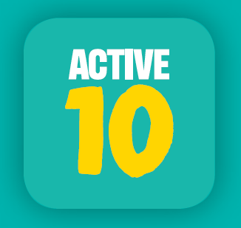
Active 10 – Initially launched in March 2017 and re-launched in June 2018, this PHE campaign aims to combat physical inactivity and lower the risks of serious illnesses such as heart disease, by encouraging adults to incorporate more physical activity into their daily lives, by going for a brisk ten-minute walk (or more) each day.

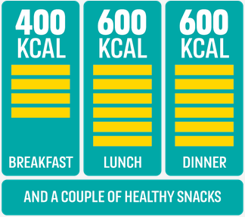
400-600-600 – Adults are consuming on average an extra 200-300 calories per day. This ‘calorie creep’ contributes to two thirds of adults being overweight or obese, which can in turn lead to serious CVD conditions. This PHE campaign was launched in March 2018, to help adults manage the ‘calorie creep’ by providing simple tips to help them make healthier choices whilst on the go. The aim is around 400 calories for breakfast, 600 for lunch and 600 for dinner, plus a couple of healthier snacks and drinks in-between.

Start4Life
This is PHE’s national programmes that delivers NHS advice and practical guidance to parents-to-be and families with babies and young children. It helps parents to understand the importance of the first 1,000 days of life and provides expert advice and tangible support to help them adopt healthy behaviours and build parenting skills. Information and support is provided through the Start4Life website and you can download associated promotional materials from the PHE resource hub.

Tommy’s
Tommy’s is a charity providing accredited midwife-led pregnancy health information for parents-to-be. They have dedicated pages on their website around weight management in pregnancy and also provide free pregnancy resources to order or download including materials around staying active during pregnancy, healthy weight during pregnancy and weight management and exercise goal plans.

Other briefings in the series…

There are several briefing documents in this series which may be relevant to healthy weight in pregnancy and will be updated on a regular basis. These include:
- Making Every Contact Count
- Obesity Prevention
- Physical Activity
You can click on the links above to download each document or visit the PHE East of England Group on the KHub to view all the documents in the series and other useful resources.

For any further questions, please contact Fennie Gibbs, Health and Wellbeing Support Officer, PHE East of England on fennie.gibbs@phe.gov.uk.

