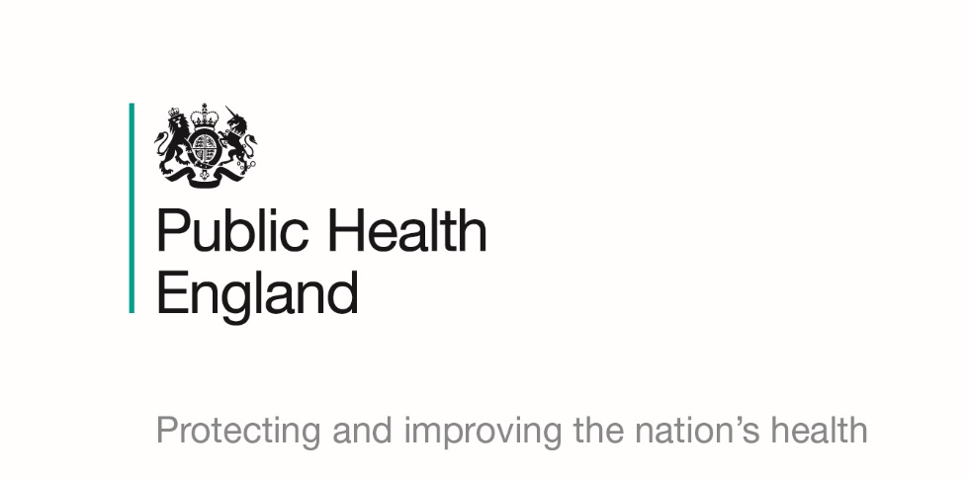

Musculoskeletal Health

Briefing produced by Public Health England’s East of England Health & Wellbeing Team – Sept 2019 (V0.01)
This briefing paper has been produced by Public Health England’s East of England Health and Wellbeing Team. It is designed to provide easy access to key reference points and useful resources around the musculoskeletal (MSK) health agenda and will be updated on a regular basis as new information becomes available. The information in each section is presented chronologically, with the most recent first.

National policy and reports

State of Musculoskeletal Health 2019
In July 2019, Versus Arthritis (formerly Arthritis Research UK) published their annual State of MSK Health report which is a resource for health professionals, policy makers, public health leads and anyone else interested in MSK health. It details the scale of the problem; key factors affecting MSK health; the impact and the economic benefits of MSK research.

Developing Partnerships and a Whole-System Approach for the Prevention of MSK Conditions in England
This case study and lessons learnt was published in Public Health Panorama (September 2018) and includes PHE as an author. The case study reviews experience in England of developing and implementing a public health approach to the prevention of and early intervention in MSK conditions.

Musculoskeletal Conditions and Multimorbidity Report
This policy report (June 2017) by Versus Arthritis explores the link between arthritis and many long-term conditions. It details key observations and sets out seven recommendations for change at a national and local level.

Providing Physical Activity Interventions for People with Musculoskeletal Conditions
This jointly produced report by Versus Arthritis, the Department of Health, PHE and NHS England (March 2017) reviews the benefits of physical activity for both those with MSK conditions and the wider society, and provides a framework that supports a tiered approach to intervention. It’s intended for those commissioning and providing local services and other interested parties such as health and fitness professionals and leisure and sports facilities providers.

Data, guidance, infographics and toolkits

MSK Calculator
Versus Arthritis and Imperial College London have developed an MSK calculator which is a prevalence modelling tool for MSK conditions.

MSK Conditions Fingertips Profile
PHE has produced the musculoskeletal condition profile (updated regularly) to provide meaningful data, on a single platform, to enable commissioners to understand the health needs of their local populations and commission high value services.

Musculoskeletal Health: 5 Year Prevention Strategic Framework
PHE, jointly with NHSE, Versus Arthritis and partners, published the strategic framework (June 2019), which sets out a statement of commitments to promote MSK health and prevent MSK conditions. The framework is underpinned by key objectives, deliverables, outcomes and desired impact by 2023, providing a strategic programme overview of MSK prevention for England.

All Our Health
The PHE All Our Health framework (first published 2015, but evolving with latest updates in May 2019) is a framework of evidence to help healthcare professionals in England understand and maximise the impact on improving health outcomes and reducing health inequalities. Since the publication of this framework, PHE has published a resource about the framework and another piece of guidance around applying ‘All Our Health’ in relation to MSK health (January 2019). This guidance explains the need for promoting MSK health; interventions that can prevent the onset of MSK; actions that can be taken; measuring impact and other useful resources.

Musculoskeletal Core Capabilities Framework
This framework (July 2018) for first point of contact practitioners has been published in partnership by PHE, NHSE, Health Education England, Skills for Health and the Arthritis and Musculoskeletal Alliance. It aims to ensure that people with MSK problems get rapid access to diagnosis and early management advice. It sets out a standard for consistent, safe, effective practice across a range of settings.

Productive Healthy Ageing and MSK Health
This PHE guidance (December 2017) is aimed at health professionals and local authorities and makes the case for action to support healthy productive ageing. The guidance includes background data and impact of poor MSK health as well at interventions to prevent the onset of MSK problems and a call to action for healthcare professionals, local authorities, commissioners and the voluntary and private sectors.

Return on Investment of Interventions for the Prevention and Treatment of MSK Conditions
This PHE tool (December 2017) is to help local commissioners provide cost-effective interventions for the prevention and treatment of MSK conditions. The tool allows results to be tailored to local situation based on the knowledge of the user. Accompanying the tool itself is a report and a literature review.

Transforming MSK and Orthopaedic Elective Care Services
This NHSE handbook (December 2017) has been produced to support local health and care systems to work together to better manage rising demand for elective care services; improve patient experience and access to care and provide more integrated, person-centred care.

MSK Health in the Workplace: A Toolkit for Employers
Business in the Community in partnership with PHE have produced a suite of toolkits to health organisations support the mental and physical health and wellbeing of its employees. These are free to access for all employers, irrespective of size or sector. In particular there is a MSK health in the workplace toolkit (March 2017).

NHS RightCare Focus Packs
These NHS RightCare produced data packs (May 2016) allow local health systems to consider information from across patient pathways to identify the greatest potential improvements in spend and outcomes. These packs are CCG focused with one specifically for MSK.

NICE Guidelines and Quality Standards

NICE pathways allow users to navigate the breadth and depth of NICE recommendations on a given subject through topic-based flowcharts. For each topic area, there are NICE guidelines, – clinical and/or public health – and their related quality standards. Each of the guidelines and quality standards will link to the tools and resources that NICE has produced to support the implementation of the guidance and improvement of practice.

This musculoskeletal conditions interactive pathway includes arthritis, bone and joint conditions, congenital conditions, maxillofacial conditions, soft tissue conditions and spinal and back conditions. It also links to the interactive flowcharts on low back pain and sciatica, osteoarthritis, osteoporosis and rheumatoid arthritis.

Initiatives and Campaigns

PHE One You - Social Marketing Programme
Launched in March 2016, ‘One You’ encourages adults to take part in an online health quiz, called ‘How Are You?’, which helps them reassess their lifestyle choices. After completing the quiz, individuals can receive email reminders and resources to motivate them to make changes to lead a healthier lifestyle. ‘One You’ has its own website with a range of resources and free apps. In the first year of its launch, there were 1.34 million completions of the quiz. Promotional materials can be downloaded and ordered for free from the PHE resource hub.

Under the banner of ‘One You’, PHE has launched several campaigns covering different lifestyle choices and changes that can be made:
Drink free days – PHE in association with Drinkaware, launched this campaign in September 2018 to help people, particularly 45-64-year olds, cut down on the amount of alcohol they are regularly drinking and to highlight that having more drink free days can reduce risks of serious conditions like CVD and improve their health.
Active 10 – Initially launched in March 2017 and re-launched in June 2018, this PHE campaign aims to combat physical inactivity and lower the risks of serious illnesses such as heart disease, by encouraging adults to incorporate more physical activity into their daily lives, by going for a brisk ten-minute walk (or more) each day.
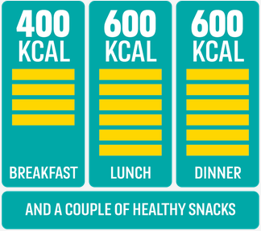
400-600-600 – Adults are consuming on average an extra 200-300 calories per day. This ‘calorie creep’ contributes to two thirds of adults being overweight or obese, which can in turn lead to serious CVD conditions. This PHE campaign was launched in March 2018, to help adults manage the ‘calorie creep’ by providing simple tips to help them make healthier choices whilst on the go. The aim is around 400 calories for breakfast, 600 for lunch and 600 for dinner, plus a couple of healthier snacks and drinks in-between.
Stoptober – Originally launched in October 2012, this PHE 28-day stop smoking challenge, encourages and supports smokers across England towards quitting for good. There are lots of ways to quit and Stoptober can help people choose what works for them and provides free support along the way.
Heart Age Test – This tool is a collaboration between NHS, PHE, the British Heart Foundation and UCL. It was relaunched in September 2018 and is an ‘always-on’ campaign. This simple online test helps individuals compare their heart age to their real age and explains the importance of knowing their blood pressure and cholesterol numbers. The test can still be completed if these numbers are not known. As part of the results, it also provides individuals with advice on how to lower their heart age and reduce their risk of heart attack and stroke.

We Are Undefeatable
This national campaign launched in August 2019 aims to support and empower the 15 million people who live with one or more long-term health condition, in England, to be more active. The campaign is led by a collaboration of 15 health and social care charities (Richmond Group of Charities) and Sport England. To help support the campaign locally, you can download and order a range of materials from the PHE campaign resource hub.

Training opportunities and sharing knowledge

Musculoskeletal Primary Care Programme
This e-learning programme consists of 8 sessions and has been developed by Health Education England to support the musculoskeletal core capabilities framework in primary care. It is therefore aimed at supporting clinicians who are working in primary care and first contact practitioners.

PHE Musculoskeletal Health Knowledge Hub Group
This Khub group is an open group for those interested in MSK health and wellbeing. You can join the group to share knowledge and keep up-to-date with the latest news, events and information.

Other briefings in the series

There are several briefing documents in this series which relate to MSK health and will be updated on a regular basis. These include:
- Dementia and Healthy Ageing
- Making Every Contact Count
- Obesity Prevention
- Physical Activity
You can click on the links above to download each document or visit the PHE East of England Group on the KHub to view all the documents in the series and other useful resources.

For any further questions, please contact Fennie Gibbs, Health and Wellbeing Support Officer, PHE East of England on fennie.gibbs@phe.gov.uk.

