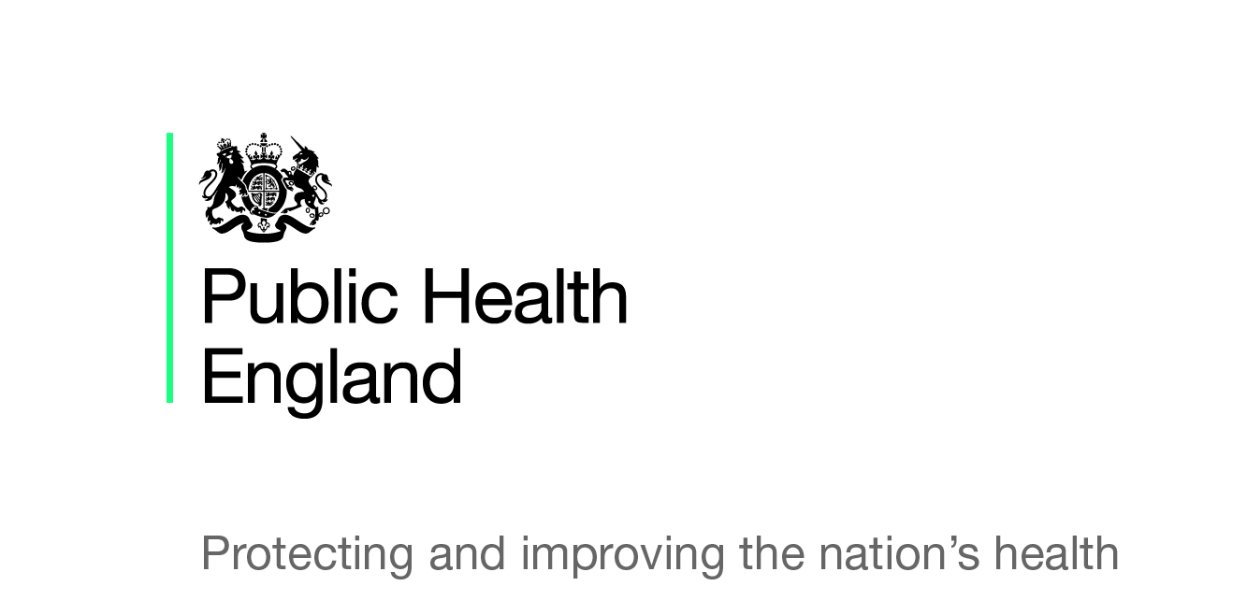

Sexual Health

Briefing produced by Public Health England and the PHE East of England Centre – September 2019 (V1.01)
This briefing paper has been produced by PHE and the PHE East of England Health and Wellbeing Team. It is designed to provide easy access to key reference points and useful resources around the sexual health, reproductive health and HIV prevention agenda and will be updated on a regular basis as new information becomes available. The information in each section is presented chronologically, with the most recent first.

National policy and reports

Syphilis: PHE Action Plan
This PHE published action plan (June 2019) focuses on the main affected population and aimed at clinicians, public health specialist specialty societies and commissioners of specialist sexual health services. It aims to address the increase in syphilis in England through strengthening public health measures to reduce transmission of syphilis.

A Consensus Statement: Reproductive Health is a Public Health Issue
Views about what reproductive health means, its breadth, and key target populations vary widely between individual users, stakeholders and organisations. This consensus statement (June 2018), has brought the different stakeholders together with the ambition to reach an agreed scope and vision for reproductive health. This is expressed as a set of shared values and on which to base future models of care that works for the user across the whole reproductive life-course. It is one of three documents that together form the basis of PHE strategy for improving reproductive health of the population.

What Do Women Say? Reproductive Health is a Public Health Issue
This document (June 2018) presents the findings from a survey of more than 7,500 women and focus group discussions to find out how women experience reproductive health issues and some of the choices they make. It is one of three documents that together form the basis of PHE strategy for improving reproductive health of the population.

All Our Health
The PHE All Our Health framework is a framework of evidence to help healthcare professionals in England understand and maximise the impact on improving health outcomes and reducing health inequalities. Since the publication of this framework, PHE has published a resource about the framework and another piece of guidance around applying ‘All Our Health’ in relation to sexual health, reproductive health and HIV (January 2018). This guidance explains the need for promoting good sexual health; interventions, measuring outcomes, and examples of good practice.

Sexual and Reproductive Health and HIV: Strategic Action Plan
This action plan (December 2015) sets out the priorities for health promotion for sexual and reproductive health and HIV from 2016 to 2019. It focuses on four key areas for action, to reduce: incidence of HIV; rates of STIs; unplanned pregnancies and rates of under-16 and under-18 conceptions.

A Framework for Sexual Health Improvement in England
This framework (March 2013), sets out the government’s ambitions for improving sexual health. The document aims to aims to provide the information, evidence base and support tools to enable those involved in sexual health improvement to work together effectively. It should ensure that accessible high quality services and support are available to everyone

Data, guidance, infographics and toolkits

Sexual and Reproductive Health Fingertips Profiles
PHE has produced these profiles, providing local data alongside national comparisons to support local authorities and other interested parties to monitor the sexual and reproductive health of their population. The profiles include interactive maps, charts and tables, providing trends across a range of topics including teenage pregnancy, abortions, contraception, HIV, STI’s and sexual offences.

HIV in the United Kingdom
These PHE reports (updated July 2019) about HIV testing, diagnosis and care in the UK. The report is updated annually and provides the latest epidemiological data around HIV.

National Chlamydia Screening Programme (NCSP)
This is a collection of resources (updated April 2019) relating to the NCSP. It includes links to relevant information, data, commissioning and provider guidance, quality assurance, programme materials and pilots and studies.

Teenage Mothers and Young Fathers: Support Framework
This framework (last updated April 2019) is for local commissioners and service providers to use as a multi-agency self-assessment tool to review local services. It helps to identify gaps in provision and likely impact and effectiveness of each aspect of local support.

Pharmacy Offer for Sexual Health, Reproductive Health and HIV
This guidance (March 2019) discussed the capacity and capability of pharmacy teams, to provide consistent and high quality sexual and reproductive health services. It aims to help commissioners and providers further embed pharmacy into key workstreams but recognises that commissioners will only commission services that are appropriate for local need and not all pharmacies will deliver all the public health interventions discussed in this resource.

Female Genital Mutilation: Resource Pack
This resource pack (updated February 2019) was developed in response to requests for clearer direction from central government about the safeguarding responsibilities of local authorities. It includes an overview, legislation, case studies highlighting effective practice, questions for local areas to consider and signposting of further resources around this.

Sexual and Reproductive Health in England: Local and National Data
This guidance (updated January 2019) is to help commissioners and providers understand the sexual health data available across England and how data can be accessed. It includes information available on STIs, HIV, contraception, conception and abortion and where to access it.

Multi-Agency Statutory Guidance on Female Genital Mutilation
This guidance (updated October 2018) is for all persons and bodies in England and Wales who are under statutory duties to safeguard and promote the welfare of children and vulnerable adults.
Sexually Transmitted Infections (STIs): East of England Data
This research and analysis (last updated September 2018) presents epidemiological data since 2015 for STIs in the East of England.

Public Health Services Non-Mandatory Contract
These documents (last updated August 2018) are for use by local authorities in public health commissioning services including sexual health. There is also a specific document titled ‘integrated sexual health services: a suggested national service specification’ to help local authorities and can be used alongside the non-mandatory contract.

Sexual Health, Reproductive Health and HIV Services: Evaluation Resources
These documents (June 2018) are for practitioners, to support them to undertake evaluations of interventions or projects in sexual health, reproductive health and HIV services. The documents include an introductory guide, evaluation workbook with guidance and a list of standards and metrics.

What Does the Data Tell Us? Women’s Reproductive Health is a Public Health Issue
The presentation (June 2018) provides a national overview of the current status of reproductive health based on routine and survey data. It is one of three documents that together form the basis of PHE strategy for improving reproductive health of the population.

Commissioning Services to Meet the Needs of Women and Girls with Female Genital Mutilation (FGM)
This NHS guidance (April 2018) makes recommendations for commissioners to ensure services meet the needs of women and girls with FGM and to safeguard those at risk.

Female Genital Mutilation: Standards for Training Healthcare Professionals
These NHS training standards (April 2018) support NHS organisations to understand what their staff need to know about FGM, to support the development of local training strategies as part of workforce development.

Public Health Functions to be Exercised by NHSE – Service Specification: Sexual Assault Referral Centres
This service specification (April 2018) outlines the public health functions to be exercised by NHS England in regards to the commissioning of Sexual Assault Referral Centres.

Sexual and Reproductive Health: Spend and Outcome Tool
This guidance (January 2018) is a step-by-step on how to use the Spend and Outcome Tool for local authorities to compare spend data on sexual and reproductive health, with sexual and reproductive health outcomes.

Teenage Pregnancy Prevention Framework
This framework (January 2018) endeavours to help local areas assess their teenage prevention programmes to identify any gaps; see what is working well and to take a multi-agency whole-system approach, to prevent unplanned pregnancies and support young people to develop healthy relationships.

Sexual Health, Reproductive Health and HIV: Commissioning Review
This PHE document (August 2017) shares the findings and the action plan from a survey carried out nationally, to understand the commissioning arrangements for sexual health, reproductive health and HIV. The findings form the basis the action plan detailed within the document.

Promoting the Health and Wellbeing of Gay, Bisexual and Other Men Who Have Sex with Men
These PHE documents (last updated May 2016) details the evidence base and action plan, which determines plans for the next 18 months around developing data, reducing inequalities in local areas and addressing wider causes.

Making it Work: A Guide to Whole System Commissioning for Sexual Health, Reproductive Health and HIV
This guide (March 2015) looks at how to pull the whole commissioning system together, focusing on: interfaces in commissioning responsibility, including how commissioning bodies need to work together to ensure that the individual experiences seamless delivery of services to meet their needs.
It also focuses on addressing the wider determinants of health, illustrating examples of how local areas are taking a wider view to address an area of need.

Commissioning Sexual Health Services and Interventions: Best Practice Guidance for Local Authorities
This guidance (March 2013) aims to support local authorities commission high quality sexual health services for their local areas and included the legal requirements, examples of best practice and other resources that may be useful.

NICE Guidelines and Quality Standards

Long-Acting Reversible Contraception [CG30] (updated July 2019) - It refers to long-acting reversible contraception (LARC). It offers best-practice advice for all women of reproductive age who may wish to regulate their fertility using LARC methods.

NICE Impact Sexual Health (February 2019) - This report considers how NICE’s evidence-based guidance contributes to improvements in sexual health. Includes information on contraception, STIs and HIV.

Sexual Health [QS178] (February 2019) – This quality standard covers sexual health, with a focus on STIs. It does not cover harmful sexual behaviour or contraception.

Contraceptive Services for Under 25s [PH51] (March 2014, reviewed in October 2017, no updates) - This PH guideline aims to ensure all under-25 are given advice and information on all types of contraception, including additional tailored support to meet the particular needs and choices of those who are socially disadvantaged or who may find it difficult to use these services.

HIV Testing: Encouraging Uptake [QS157] (September 2017) - This quality standard covers interventions to improve the uptake of HIV testing among people who may have undiagnosed HIV. It focuses on increasing testing to reduce undiagnosed infection in people at increased risk of exposure. It describes high-quality care in priority areas for improvement.

Sexually Transmitted Infections: Condom Distribution Schemes [NG68] (April 2017) – This NICE guideline covers condom distribution schemes. The aim is to reduce the risk of STIs and can provide a good introduction to broader sexual and reproductive health services, especially for younger people, and help prevent unplanned pregnancies.

HIV Testing: Increasing Uptake Among People Who May Have Undiagnosed HIV [NG60] (December 2016) - This NICE guideline covers how to increase the uptake of HIV testing in primary and secondary care, specialist sexual health services and the community. It describes how to plan and deliver services that are tailored to the local prevalence of HIV, promote awareness of HIV testing and increase opportunities to offer testing.

Contraception [QS219] (September 2016) - This quality standard covers contraception for women, including emergency contraception. It does not cover sexual health and preventing STIs.

Harmful Sexual Behaviour Among Children and Young People [NG55] (September 2016) - This NICE guideline covers children and young people who display harmful sexual behaviour, including those on remand or serving community or custodial sentences. It aims to ensure these problems don’t escalate and possibly lead to them being charged with a sexual offence. It also aims to ensure no-one is unnecessarily referred to specialist services.

Sexually Transmitted Infections and Under-18 Conceptions: Prevention [PH3]
(February 2007, reviewed in December 2018 and due to be updated) – This PH guideline covers one-to-one interventions to prevent STIs and under-18 conceptions. It is aimed at professionals who are responsible for, or who work in, sexual health services. This includes GPs and those working in contraceptive services, genitourinary medicine and school clinics.

Campaigns and initiatives

Brook’s Sexual Health Week (16-22 September 2019)
Previously run by the Family Planning Association, this year Brook will be running the Sexual Health Week campaign. The theme for this year is sex, relationships and disability. Brook believes that every young person should have equal access to quality relationships and sex education, sexual health services and wellbeing support. Sex and disability isn’t talked about enough and this means that lots of young people are missing out on valuable education, information and support. You can access a range of campaign resources and content on their website.

East of England Syphilis Campaign - This regional campaign is a collaboration between the East of England local authorities, PHE and Terrence Higgins Trust and was launched in February 2019. It is particularly targeted at men who have sex with men and aims to increase awareness and call to action to get tested for syphilis.

It Starts With Me (ISWM) - An award-winning social marketing campaign aiming to cut new HIV transmissions in England. It promotes testing and prevention messages and behaviours amongst the communities who have the highest prevalence and new diagnoses rates of HIV in the UK, particularly men who have sex with men (MSM) and black Africans (BA). The main campaign delivery is through National HIV Testing Week each November, but each Summer the campaign emphasises other prevention methods, such as condoms and Treatment as Prevention.
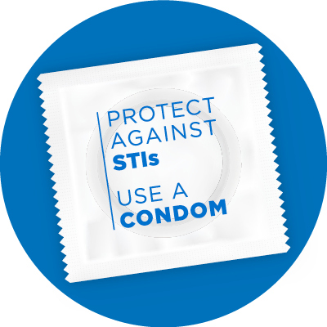
Protect Against STIs: Use a Condom - In December 2017, PHE launched a new sexual health campaign. The aim of the campaign is to reduce rates of STIs among 16-24-year-olds, through condom usage. The campaign is the first government sexual health campaign in almost 10 years. You can find resources to order or download in the PHE Campaign Resource Hub.

Sexwise – Part of the Family Planning Association’s (FPA) programme, to deliver sexual and reproductive health information, as commissioned by PHE. This programme was developed to offer inclusive, evidence-based information on contraception, pregnancy, STIs and sexual pleasure and wellbeing to young people, as well as health professionals. Resources can be downloaded from the website and more information about FPA’s health promotion programme can be found here.

PHE Reproductive Health, Sexual Health and HIV Innovation Fund
PHE’s Innovation Fund for 2019-20, will help support projects that offer new and innovative ways of improving reproductive health and sexual health (including STI prevention), as well as HIV. to help develop innovative ways of preventing HIV. Proposals will be accepted from voluntary sector organisations to deliver projects of up to 12 months in duration of a cost of between £25,000 and £100,000.

HIV Prevention England
HIV Prevention England (HPE) is the national HIV prevention programme for England. It delivers a nationally co-ordinated programme of HIV prevention work with UK-based black African people and with gay men/men who have sex with men (MSM). It brings together campaigns, online services, local work and policy work. It works closely with black African, gay, and faith communities, NHS clinics, local authorities and PHE. HPE is a nationally funded programme, funded by PHE, designed to complement locally commissioned prevention in areas of higher prevalence.

National HIV Self-Sampling Service
PHE and local authorities co-commissioned the national HIV self-sampling service to provide a cost efficient and clinically robust remote HIV self-sampling service for sexually active individuals aged 16 years and over. The service aims to increase HIV testing among the most at-risk groups, including: men who have sex with men (MSM), black African communities, and other individuals at increased risk of HIV

