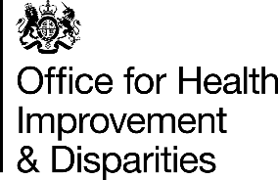

Nov 2021 Edition
Monthly newsletter – Physical Activity Clinical Champions
Welcome to the monthly PACC activity newsletter. The newsletter captures updates from PHE and partners on Physical Activity and the PACC network. The aim of the bulletin is to provide you with a regular update.

Message from Casey Bodman, PACC Project Manager
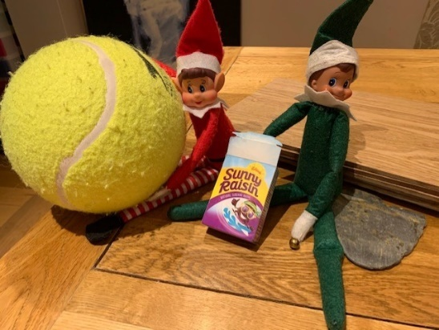
As we approach the Christmas break, I want to say a big thank for all your hard work over the year.
This week (W/C - 06 December) I presented the PACC programme to the MHPP advisory board group (the group which represents a number of prominent key academics and healthcare professionals engaged in the physical activity field).
The board were really impressed with the continued PACC session delivery each month despite the pressures on both primary and secondary care which other areas are feeling. So again, a big thank you as I know this is down to your determination and commitment.
As a national team, we are working hard too on PACC behind the scenes, and we continue to work on the transition to DHSC, as well as thinking about how the PACCs and the programme can help tackle the demand that Active Hospitals may have on the programme. We are also working with the Midlands on how PACC can become part of the legacy for the Commonwealth Games.
I wanted to also thank the Lead PACCs for all their time and support this year, we have had a very busy year! We recruited and onboarded 15 new PACCs, transitioned to a new organisation and rebranded and moved to a new hybrid online and F2F model.
I hope you all have a good festive break, I will be using the time to spend time with my family and particularly my two boys (5 and 8) to visit Santa, watch the xmas panto and I will be cooking dinner for 10 on Christmas Day! (wish me luck!). Picture shows the elf on the shelf antics in our house!

Key Updates for PACC
Transition to DHSC: Thank you for completing your DHSC Payroll forms, these have now been sent to DHSC to be processed. DHSC will contact you directly with your unique staff numbers. We will contact you if we need more information.
Timesheets: Please submit timesheets this month no later than 14th December, for processing before the Festive break. Please use the new template on SharePoint: PACC Expenses Form.xlsx (phe.gov.uk). Please look out for our timesheet reminder email, which will contain important information on completing your timesheets.

Staff Recognition
Sarah Dewhurst would like to commend Angela Penny (AHP PACC) who had a Desert Island Discs style radio interview and spent a good 10 minutes talking about the PACC programme alongside her speech and language role - brilliant promotion on radio Bradford. Angela is also our spotlight PACC today.
A slightly late congratulations to Pebz on her recent nuptials in October. We would like to wish her a happy married life.

Latest PACC figures
Month Total | No. of sessions | No. of people trained
October | 22 | 462
November | 25 | 478

Nov Breakdown | No. of sessions | No. of people trained
AHP | 11 | 229
Nurse/Midwife | 5 | 142
Medic | 9 | 107

Policy and campaign updates
Make your Move – physical activity videos from the Richmond Group
Make Your Move is a series of short physical activity videos, to help you get active in the way that works for you, from the charities behind We Are Undefeatable. These videos have been created especially for people with long term health conditions, who may experience the common symptoms associated with these, such as pain, stiffness and fatigue.
The Make Your Move series of physical activity videos from the Richmond Group of Charities is now ready on the We Are Undefeatable playlist.

What you can do now:
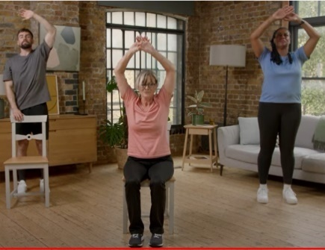
- Use the hashtag #MakeYourMove along with #WeAreUndefeatable to share the social media assets on any channels
- Look out for any social media posts from We Are Undefeatable and the Richmond Group of Charities, and share them
- Send out the video content to your audiences via any channel

A full suite of assets here should you wish to use them, including social media clips, key messages, newsletter copy and images: All the external facing assets on google drive

Please share this content with your external and internal audiences and stakeholders.

White paper - COVID-19: wider impacts on people aged 65 and over

The White Paper on Social Care that was published last week announced investment to tackle physical activity, deconditioning and falls prevention. It follows on from the recommendations made in the PHE Wider Impacts of COVID report, in particular targets people from more deprived backgrounds.

Sport England – Active Mums campaign
Sport England’s New campaign promotes activity to pregnant women and new mums. Active Mums Start With You is designed to help equip healthcare professionals with the resources they need to speak about physical activity with pregnant women and new mums.

https://www.sportengland.org/news/new-campaign-promotes-activity-pregnant-women-and-new-mums
These resources include training developed as part of the This Mum Moves project, and Sport England’s head of activation, Frances Drury, believes they could be key in giving pregnant women and new mums the confidence to be active.

Spotlight on Angela Penny, AHP
Angela is one of our newer PACCs who joined the Clinical Champions in August 2021. She has been really busy promoting the training and has trained 48 people so far. Great work Angela!
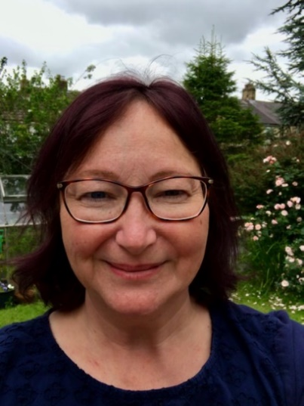
Email: angela.penny@phe.gov.uk
Location & Region: Yorkshire & the Humber

Profession: Speech & Language Therapist
Clinical Speciality: Adult Neurological disorders

Job title and Locations:
- Highly Specialist SLT
- Airedale NHS Foundation Trust
- Bank Specialist SLT Mersey Care NHS Foundation Trust

Particular interests/connections:
MND, dysphagia, Adult Learning Disabilities, MEd (Clinical Education), volunteer with Speech Therapy Cambodia

NICE are seeking several early members for the ‘Falls in Older People: assessing risk and prevention’ Guideline Committee.
This is a great opportunity to support the initial stages of the guideline development.
Deadline for applications Friday 17th December at 5pm:
Candidates should include practicing healthcare professionals with demonstrable relevant experience and clinical knowledge in the field of falls in older people, we are seeking the following early members to support the scoping stage of the guideline:
- A physician with an interest in the assessment and prevention of falls, for example specialising in care of the elderly
- A physiotherapist
- A practice nurse or advanced nurse practitioner

Time commitment: 2 years
Further details could be found at the following link: https://www.nice.org.uk/get-involved/our-committees/join-a-committee/member--falls-in-older-people-guideline-committee.
Advertising for wider committee membership will take place during the public consultation on the scope, in early 2022. Contact Tamara Diaz at Tamara.Diaz@rcp.ac.uk or 020 3075 1276 for more information.

Sharing good practice – ways to promote PACC

Sport England has launched the next part of our ten-year strategy, Uniting the Movement.

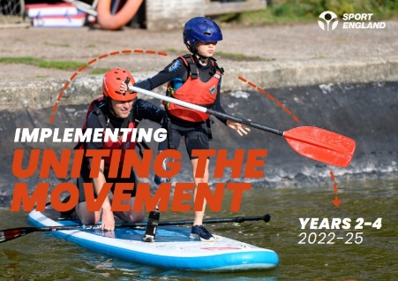
It details how Sport England will work over the next three years (2022-2025) to support the mission to transform lives and communities through sport and physical activity.

The full plan (which can be found here) builds on the lessons learned from throughout the pandemic and extensive consultation with thousands of partners who are passionate about making sport and physical activity a normal part of life for everyone in England; and reinforces our commitment to target investment, resources, and energy where it is needed most and will have greatest impact.

Sport England - collective ambitions for 2025

The three-year plan outlines the collective action and outcomes needed by 2025 in order to make progress with the big issues and catalysts for change that are prioritised and detailed in our Uniting the Movement strategy. These are shared ambitions where our movement can make progress together and include:

- Increasing investment and resources for communities with the greatest need.
- Listening to and involving people less likely to be active.
- Increasing diversity of leaders, volunteers and professionals across sport and related sectors.
- Creating positive experiences for children and young people.
- Giving talented athletes from every background the chance to reach the top.
In the first instance please visit www.unitingthemovement.org to read more and find out about how the movement will evolve, and the part you could play in it.

Sport England role in the movement

Tackling inequalities sits at the heart of the strategy to help level up communities across the country and support our sector’s delivery of key policy priorities like improved health and wellbeing, education and skills and net zero.

Organized under three roles: Building the Movement, Meeting People Where They’re At, and Being the Change.

These commitments include:

- Focus investment and resources on communities most in need.
- Continue to deliver our Covid-19 recovery and reinvention package.
- Convene and collaborate with the sports sector to join up and advocate around the big issues, such as supporting children and young people, connecting communities and integrating into health.
- Make it easier to access our open funding.
- Develop the sector’s presence across government to embed sport and activity and champion the critical role that we and our partners can play.
- Ensure good governance, safeguarding, integrity and inclusion is embedded in all we do, including through our revised Code for Sports Governance.

Mr Motivator Club in primary care – 12 week online resource for GPs
This month, Emma Pimlott, Medic PACC introduced Darryl Jashek to the PA Team. Darryl is a GP at Tynemouth Medical Practice, who has been actively promoting physical activity in his GP surgery.
He is working on a programme to give healthcare professionals and primary care receptionist the opportunity to signpost sedentary patients with chronic health conditions to a fun, inclusive 12-week online resource, free of charge. Darryl has been working with Mr Motivator and One You Haringey referring patients to The Motivation Club: https://mrmotivatorsclub.com/ since June 2021.
The Motivation club provides pre-recorded videos for all abilities, with live zoom sessions 3 times a week. This includes chair-based exercises.
Healthcare professionals (and reception staff) will be able to send patients a GP referral link directly (e.g. using AccuRx). At registration the patient will select their CCG so we can give feedback to each area.
The final changes are being made and the link will be ready to share and promote before Christmas in time for the new year.
For further information about this initiative, please contact Darryl directly on: darryl.jashek@nhs.net

Yorkshire and Humber – physical activity resource for schools
Please see details of the new resource for schools to support delivery of physical activity launched in YH last week. This is a piece of work completed by the COI school physical activity task & finish group.
The material is now ready to utilise across the region and can be accessed here: Children and Adolescents (CA) (yhphnetwork.co.uk).
It includes:

1: The ‘One minute guide’ itself – This has 3 versions, one for each Active Partnership geographical area, so please utilise the version for your locality

2: A template cover letter – Feel free to amend and use as you see fit

3: An informative case study which can go alongside the ‘One minute guide’ if needed

4: A template PowerPoint presentation – Feel free to utilise where you need (Let me know if you need an editable version)

Yorkshire and Humber hope that the new resource can help engage schools, add value to local programmes (such as Creating Active Schools) and further support the increase in physical activity linked to the COVID pandemic.
If you have any questions about the resource, Please contact: nicola.corrigan@dhsc.gov.uk or timothy.howells@phe.gov.uk

Research and useful information
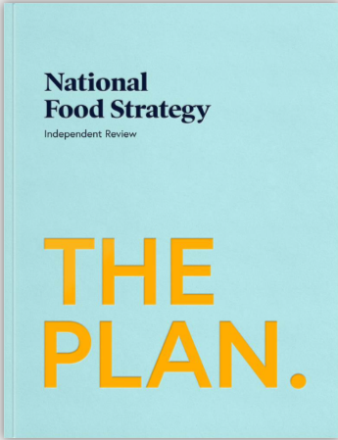
National Food Strategy
Part two of the National Food strategy is now ready to view: https://www.nationalfoodstrategy.org/.
It takes a closer look at how the food system really works, the damage is doing to our bodies and our ecosystem and the interventions we could make to prevent these harms.

SACN – risk assessment on lower carbohydrate diets for adults with type 2 diabetes (T2D)
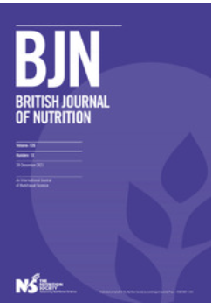
In May 2021, the Scientific Advisory Committee on Nutrition (SACN) published a risk assessment on lower carbohydrate diets for adults with type 2 diabetes (T2D). The purpose of the report was to review the evidence on ‘low’-carbohydrate diets compared with the current UK government advice on carbohydrate intake for adults with T2D.
You may be interested to know that a summary paper of the SACN report Lower Carbohydrate Diets for Adults with Type 2 Diabetes has been published in the British Journal of Nutrition.
You can access it here: Lower carbohydrate diets for adults with type 2 diabetes | British Journal of Nutrition | Cambridge Core

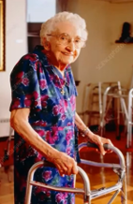
Presentation on Frailty and Falls by Prof. Dawn Skelton
Dawn Skelton, professor of Ageing and Health at Glasgow Caledonian University outlines the link between physical activity and ageing well.
Viewed via the YouTube link:
Frailty & Falls - Prof. Dawn Skelton - YouTube

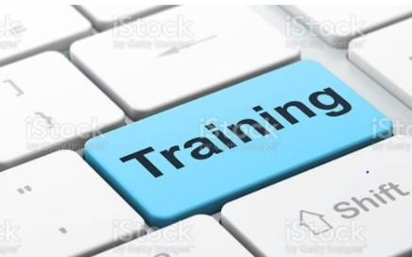
F2F training session: Lead PACCs delivered a F2F training session to help those of you who are engaging a blended model of delivery.
A recording of the session held on 2 Nov, is available for you to view on SharePoint. It is 1.5 hour long and can be viewed within your admin allowance (admin hours per month – max 4 hours)
Link: Videos - All Supporting Documents (phe.gov.uk)
The training slides have also been updated: Training Slides 2020-2021 - All Supporting Documents (phe.gov.uk)

Feedback - We want to make sure this newsletter continues to provide helpful and useful snippets into your inbox weekly. If you have any suggestions for future content, please let us know by emailing Rav or Casey at: PhysicalActivity@phe.gov.uk
And of course, if you’d rather not receive this email, please let us know and we can remove you from the distribution list.

