Data Insight: ORR Passenger Station Entries and Exits
The latest station passenger entry and exit data from the Office for Rail and Road comes with a lag of several months and reflect the position at an earlier stage in the post-COVID recovery of rail demand. However, they provide important insights into the scale of change the rail market has seen, whilst demonstrating the continued importance of rail to the North of England post-COVID.
It also reflects how leisure and tourism drove the initial recovery of the rail market, which has however begun to change in recent months with the return of international tourism and some recovery in office working.
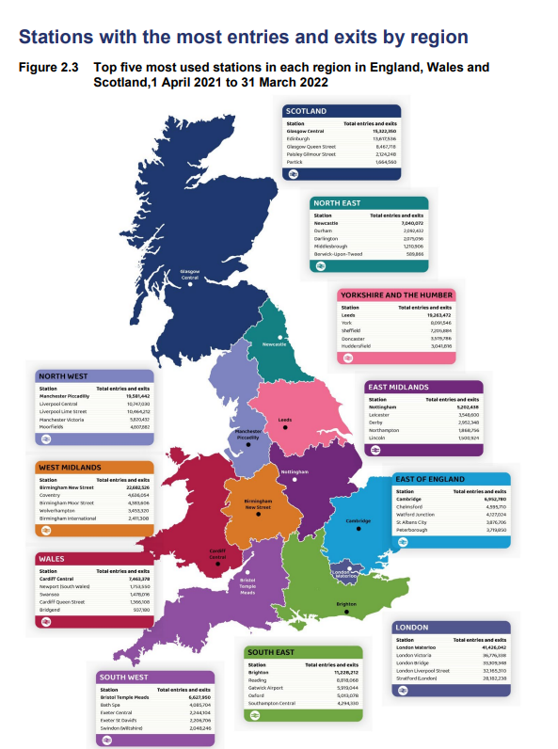
It showed Manchester Piccadilly to be the once again the North’s busiest train station, followed closely by Leeds. Both stations had almost 20 million entries & exits. This is still below a peak of over 30 million for both stations in 2019-20.
Overall, the North still has most of the busiest stations in England outside London, reflecting the scale of commuter and leisure traffic to the North’s major cities. The top 10 across England remains dominated by London stations, however. This suggests that northern cities continues to have a long way to go to reach the scale of labour market agglomeration and rail commuting that London has.

On the other hand, it is not the North’s major cities that led the recovery of rail passengers in the region. Some of the biggest winners were visitor economy destinations, including coastal towns and the North’s National Parks. In fact, Oxenholme in the Lake District saw passenger numbers surpassing pre-COVID-19 levels, reflecting the domestic tourism boom that resulted from foreign travel restrictions.

Some of the weakest growth in passenger numbers came unsurprisingly to Manchester Airport, but also commuter towns in the North West and West Yorkshire.

At the North’s busiest stations, the picture was also varied, with rail commuting hubs in Manchester, Liverpool and Leeds seeing a slower rate of passenger growth, but Newcastle and York reaching close to pre-pandemic levels.

However, it is encouraging how across all stations in the North, the increase in passenger numbers from the lows see in 2019 is signifiantly ahead of the rest of England outside London. This may reflect the lower rate of remote working among commuters in the North, as well as the imporrtance of the leisure market.

