Our Community Groups are there to be enjoyed by anyone living with dementia or experiencing difficulties with their memory, including their families and friends. All are welcome; people who can attend independently and/or, for those unable to do so should come with a companion who can provide any support for them. We are unable to transport for these groups and therefore it is your responsibility to get to and from this community activity, safely. Please speak to us, so we can support you to explore other transport options.
We are also here for you with a warm drink, food and company. We will be providing more coffee catch ups, or just pop in for a warm drink. Please see below for more details.
If you are unsure, or have questions about any of the groups, or have an idea for a new group, please let us know. All contact details are below.
In Person Group
Friday 1st of December | Pantomime at the regal in Bathgate  First come first served, limited availability | 4PM – 7PM
Monday 4th of December | Bathgate Memory café  Rosemount gardens, mid street, Bathgate EH48 1QW | 2:30PM – 4PM
Thursday 7th of December | Bloom and Blether  Alzheimer’s Scotland unit 1, Grampian court, Livingston, EH54 6QF | 1PM- 2:30PM
Monday 11th of December | Redbrick café (under 65)  Alzheimer Scotland Unit 1, Grampian Court, Livingston, EH54 6QF | 11AM – 12:30PM
Tuesday 12th of December | Under 65s Christmas Party  Alzheimer’s Scotland unit 1, Grampian court, Livingston, EH54 6QF | 6PM – 8PM
Wednesday 13th of December | Livingston memory café,  Alzheimer’s Scotland unit 1, Grampian court, Livingston, EH54 6QF | 1PM – 2:30PM
Thursday 14th of December | Christmas party  Alzheimer’s Scotland unit 1, Grampian court, Livingston, EH54 6US | 1PM – 3PM
Friday 15th of December | The Memory Café Armadale  The Community Centre, North Street, Armadale, EH48 3QB | 11AM – 1PM
Monday 18th of December | Whitburn/Blackburn Memory Café  Blackburn United Football Club, Ashgrove, Blackburn,  EH47 7LL | 12:30PM – 2PM
Wednesday 20th of December | The Caring Café  Queen Margaret Hall, 53 Blackness Road, Linlithgow, EH49 7JA | 10:30AM – 12PM
Thursday 21st of December | Bloom and Blether  Alzheimer’s Scotland unit 1, Grampian court, Livingston, EH54 6QF | 1PM -2:30PM

For those times when you cannot make it into the centre, or wish to attend some groups in person, and some online.
Please contact the person listed below the activity and they will send you the link to join.
Online Group
Wednesday 4th of December | Evening Carers Group  Support for those caring for a person living with dementia  Email westlothianservices@alzscot.org to gain access | 7.00pm – 8.00pm

Contact details for groups:

Email: westlothianservices@alzscot.org Tel: 01506 533108

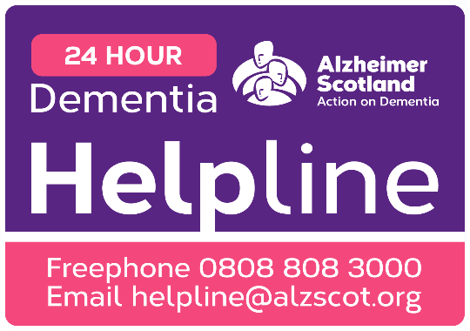
Our support and activities are only possible thanks to the donations we gratefully receive. There are many ways to support our groups, please speak to any member of staff detailed above for more details. To make a donation, please consider donating to our local Just Giving page
https://www.justgiving.com/fundraising/alzscot-fundraising-edinburgh-mid-east-lothian

