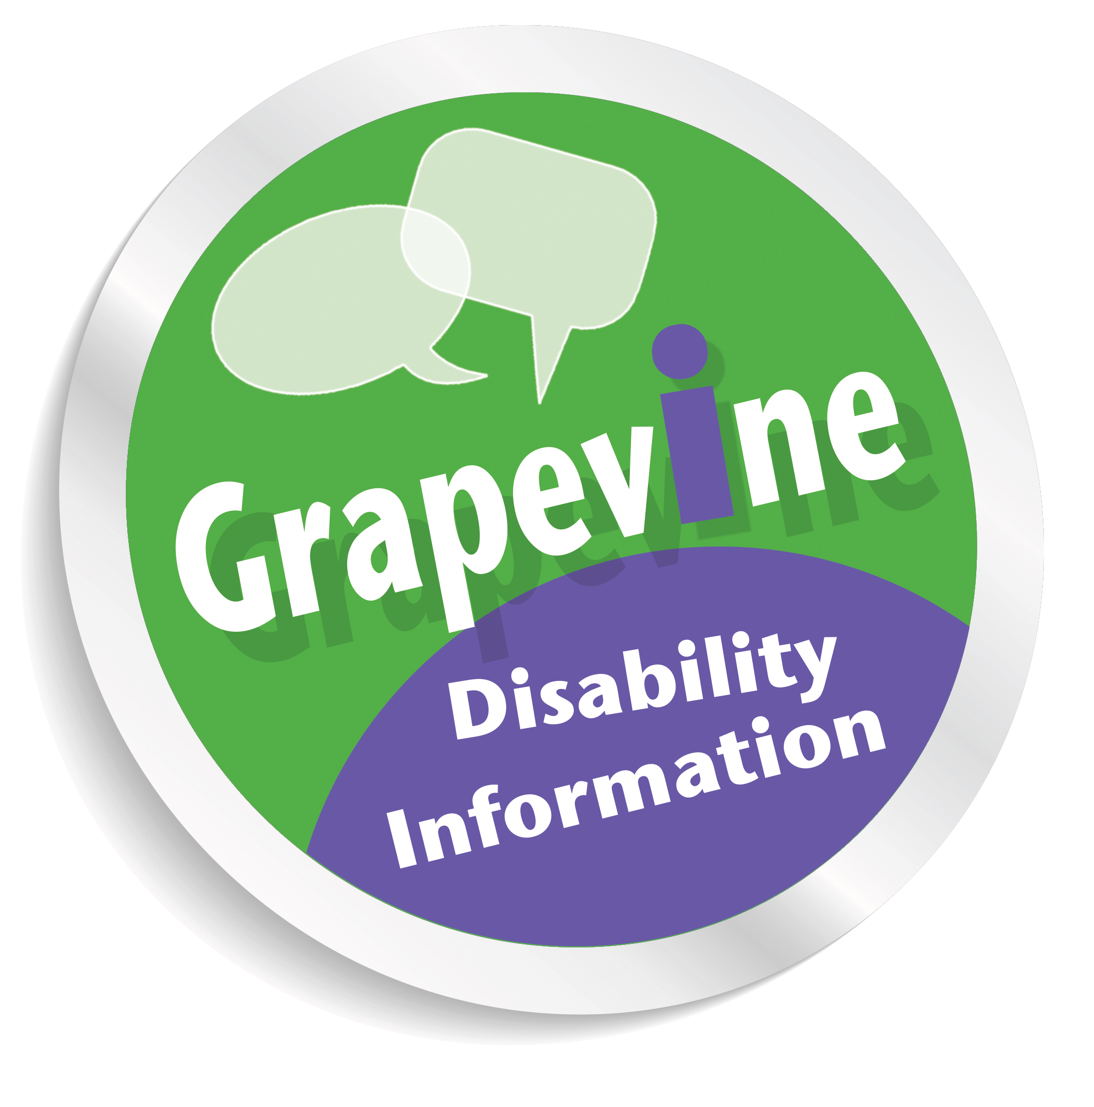

Lothian Centre for Inclusive Living (LCiL)

GRAPEVINE’S
COMMUNITY RESPIRATORY SUPPORT SERVICE
Disability Information Service for People affected with Respiratory Conditions:
LCiL is a registered charity working specifically with disabled people, people with long-term conditions and older people across Edinburgh and the Lothians. We take a person-centred approach in supporting people to take control of their own lives, participate fully in society, to be more in control and to live more independently. LCiL are working in partnership with Edinburgh Health and Social Care Partnership to provide this service.
LCiL’s Grapevine Community Respiratory Support Service provides local disability information and advice free, on a confidential and independent basis in Edinburgh. Our Grapevine service is dedicated to supporting people affected by Chronic Obstructive Pulmonary Disease (COPD) and other respiratory conditions in Edinburgh, including people who have developed long COVID 19 symptoms.
IMPORTANT NOTE: Support is normally provided as a home visit, however due to the present COVID 19 situation, support is currently provided by telephone, online video calls, email and post.
How can we support?
We can assist and provide information on the following:
Disability Benefits:

For people of working age (16-65) we provide information on how to claim disability benefits, including reassessments, entitlement conditions and passported benefits (other benefits to which people may be entitled) for: Personal Independence Payment (PIP), Disability Living Allowance (DLA), Disability Premiums, Employment and Support Allowance (ESA) and the Work Capability Assessment.
For people aged 65 and above we can explore benefit entitlement to Attendance Allowance, State Pension, Pension Credits etc.

Assistance is available to complete Personal Independence Payment and Attendance Allowance forms. We will also assist with mandatory reconsiderations and appeals should a person need to challenge a decision if they are unsuccessful with a benefit claim and we have supported them with completing the original form.

In addition, we can advise and provide information on the following:

- Financial grants and money (e.g. grants and trust searches for aids/equipment).

- Transport and Travel (e.g. Blue Badges, Taxi and Travel Concessions).

- Housing (e.g. applying for social housing, renting, buying and supported accommodation, support with domestic tasks).

- Community Care and Self-Directed Support (e.g. Self-Directed Support Options including Direct Payment, Community Care Assessments and further support from LCiL’s Independent Living Team).

- Employment and education: (e.g. rights at work, Access to Work, educational and training opportunities including LCiL’s training programmes).

- Holidays and Leisure (e.g. accessing respite and short breaks, accessible leisure opportunities).

- Access issues (e.g. accessing the internet and technology for disabled people, access to venues; we can also provide RADAR keys at the standard fee of £4 or £4.50 (incl. P&P). Please call to arrange in advance).

- Disability Equality and the law (e.g. rights of disabled people under the Equality Act and information on where to get further advice if you feel that you have been discriminated against).

- Health and Personal Issues (e.g. signposting/referring to specialist services, including mental health services, befriending and self-management courses).
LCiL’s Grapevine Community Respiratory Support Service is only accessible via healthcare and social care practitioners, no self-referral is accepted. Please contact Grapevine for further information here: loth.grapevine@nhslothian.scot.nhs.uk
Looking forward to supporting you!

