Pasda Listening Ears Project

Pasda’s Listening Ear project is open to all Parents and Carers of Autistic Adults across Lothian.
We have a team of 6 trained callers, 5 of which have an autistic family member to call carers for s series of calls or just a one of call.
It is up to the person who would like to be called to decide what they would like help with. The Listening Ears team can help with information and resources about local services relating to Caring and/or Autism. Or they may just fancy a blether to pass some time.

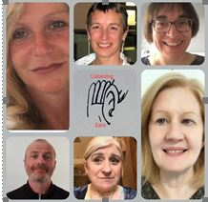

Please contact us if you are interested.
Info@pasda.org.uk
0131 475 2416

