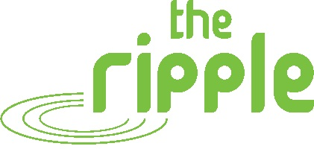

A 1ST and 2ND FOR LOCHEND RESTALRIG AND CRAIGENTINNY
Saturday the 16th of October and Sunday the 17th sees a 2 day open house for all local people at The Ripple Project with a focus on what you can do for yourself to and what you can do for others.
___________________________________________________________________
Saturday 16th October
THE RIPPLE WELLBEING DAY
This is our second annual wellbeing day, put together by our wellbeing co-ordinator Cat Robertson. She has organised a menu of activities that people can come and join in with ALL FOR FREE.
Available on the day
Silent Disco
Sing in The City
Capoeira
Drumming
Group Mindfulness
Creative writing
Art Workshop
Hypno/reiki
Reiki
Massage
Reflexology
Kinetic Chain Release

NO NEED TO BOOK – turn up from 9am til 4pm – The Ripple, Lochend and Restalrig Community Hub, 198 Restalrig Road South, EH6 6DZ – for further information email catriona.robertson@theripple.org.uk or call 0131 554 0422

___________________________________________________________________

Sunday 17th October
LCR STANDS UP – VOTING DAY
LCR Stands Up is an opportunity for people to decide, by voting, which local projects should receive money through what’s known as Participatory Budgeting (PB).

Everybody aged 8 and above who lives, works, volunteers, or studies in Restalrig, Lochend and Craigentinny can vote.
A total of £16,000 is available from a number of different funders who believe that local people should make decisions about money that is spent in their area.
PB comes in all shapes and sizes, but basically it looks like this:-

1) People think of ideas of what would make the lives of local people better
2) People who live and work in the area vote for the idea they would like to see happen
3) The ideas with the most votes get funded

You can find out more about the applications to vote for after the 19th September here https://www.rippleproject.co.uk/lcr-stands-up
TO VOTE – turn up from 10am til 4pm – The Ripple, Lochend and Restalrig Community Hub, 198 Restalrig Road South, EH6 6DZ
If you want to find out more please contact Tristan Green at The Ripple on:-
Mobile – 07547 794 604
Email – Tristan.green@theripple.org.uk
The Ripple – 0131 554 0422
