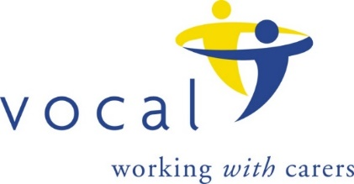

**Carer Involvement Event**

**Are you or have you been an unpaid carer for a family member, partner or friend who uses mental health services in Edinburgh?**

**Would you like to get involved in helping us help mental health services to develop their carer involvement practice?**

**To find out more come along to the Carer Involvement event at:**

**The Eric Liddle Community, Morningside Road, Edinburgh**

**Wednesday 4 May 2022**

**10 am until 12 noon.**

VOCAL – Voice of Carers across Lothian - is the largest provider of unpaid carer support in Edinburgh. We are working with Thrive Edinburgh and Mental Health services across Edinburgh to develop and improve how they involve carers in their services, but we need your help with this.

There are many different ways you can get involved: helping us gather the views of carers involved with mental health services, bringing the carer perspective to working processes and practices within services, coming along to events and sharing your many skills and experiences. Involvement in the project can be as short as a few hours or can become ongoing just whatever fits your available time and interests.

If you have experience as an unpaid carer, for an adult with mental ill health and you are interested in meeting and helping other carers why not come along and find out more. We look forward to seeing you!

**To register:**

Please Email: [**involve@vocal.org.uk**](mailto:involve@vocal.org.uk)

OR

Phone Fiona Barrett, project lead on: 07984 498870 / 0131 622 6666