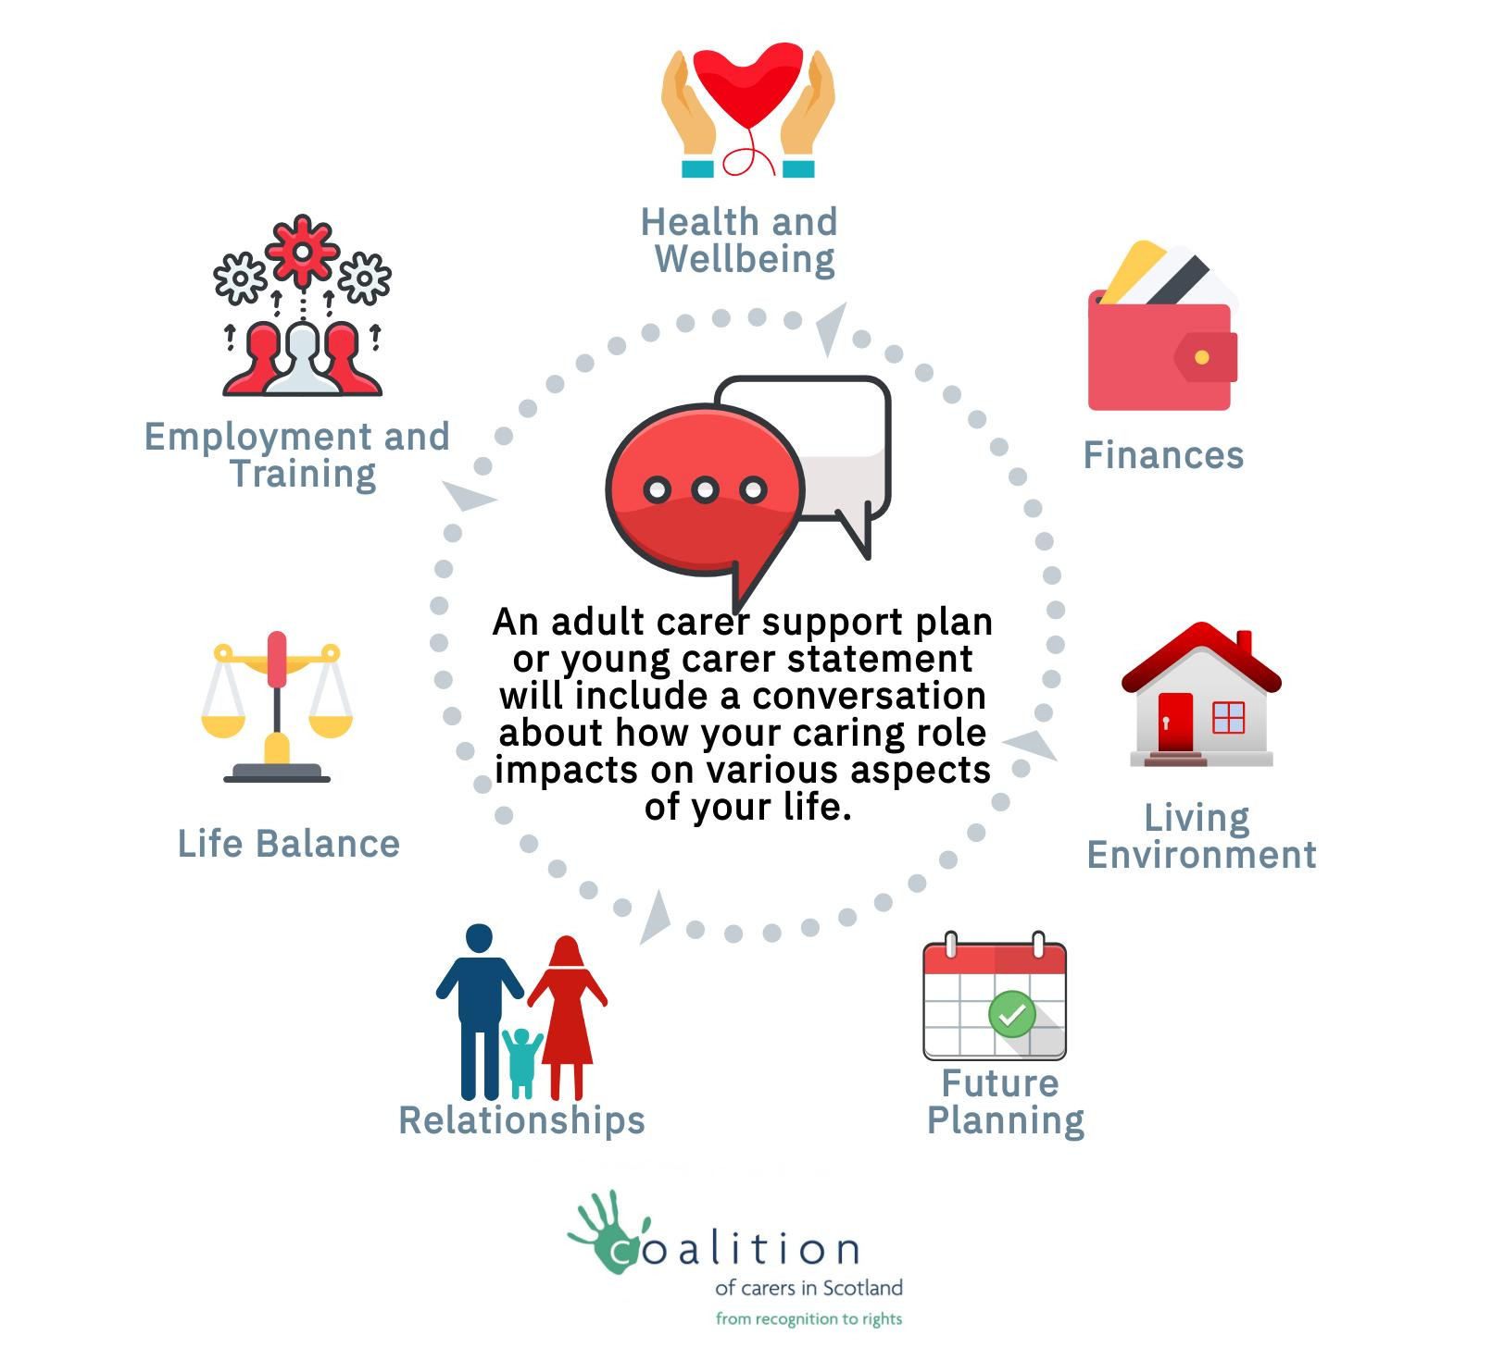
Am I a carer?
You are a 'carer' if you provide (or intend to provide) care for another person – but not :-
- if this is only because of that person's age (where they are under 18); or
- if you are caring because you have a contract or as voluntary work.
The previous definition for being identified as a 'carer' does not apply. You can be caring for someone for any number of hours. You do not need to be providing a substantial amount of care for someone on a regular basis.
Meaning of young carer: You are a 'young carer' if you are a carer (as above) and are also under the age of 18; or 18 or over, but still attending school.
Meaning of adult carer: You are an 'adult carer' if you meet the criteria for a carer above and are aged 18 or over, and not attending school.
Kinship carers: A kinship carer (usually a relative or close friend looking after a child in place of their parents) can be a carer under the Act, even where they have a kinship carer agreement with the local authority. This is only for kinship carers who meet the other requirements of the meaning of 'carer' above, so not where the care is simply because of the child's age.

