Key Facts- The Carers (Scotland Act) 2016
From 1 April 2018, the following will apply as a result of the Carers Act taking effect:

- Adult Carer Support Plans/Young Carer Statements: Carers have the right to be offered or request an Adult Carer Support Plan (ACSP) or Young Carer Statement (YCS), setting out their personal outcomes and identified needs.
- Information and advice: Local authorities are required to establish and maintain an information and advice service for carers. They must also publish and keep under review a Short Breaks Services Statement*. This statement must be published by 31st December 2018.
- Support to carers: Local authorities have a duty to provide support to carers, based on the carer’s needs which meet local eligibility criteria. Local authorities also have powers to enable them to provide support to carers who do not meet local eligibility criteria.
- Breaks from caring: Local authorities are required to consider whether any support provided should include, or take the form of, a break from caring. They must also have regard to the desirability of breaks being provided on a planned basis.
- Hospital discharge: Health boards have a duty to inform the carer and to invite their views before a cared-for person is discharged from hospital. These must be taken into account before the discharge of the cared-for person.
- Carers Charter: Scottish Government have published a Carers’ Charter which sets out the rights of carers in or under the Act.

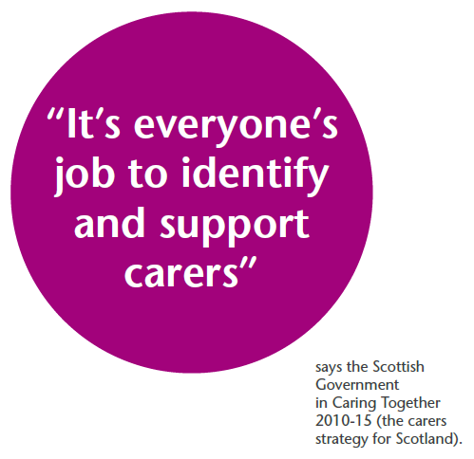 0131-536-3371

