Resources guide: Community-centred approaches
Purpose: Evidence and guidance to support the adoption and scaling of community-centred approaches and system working as part of action to reduce health disparities, promote health, prevent major conditions and level-up communities.
Audience: OHID teams for use in programme, policy and partnership delivery and development.
Content:
Why do communities matter for health?
What are community-centred approaches?
How can approaches be systematised to have greater impact?
What is the role of the VCSE?
What are the implications for workforce development?
What was learnt from the COVID-19 pandemic?
OHID Contacts

Why do communities matter for health?

Community life, social connections and having a voice in local decisions are all factors that contribute to improving health and reducing health inequalities. Levels of trust, community belonging, and cohesion also contribute to community resilience and population health. These community-level determinants build control and resilience that can help buffer against illness and influence health-related behaviour.
Involving and empowering local communities, particularly disadvantaged groups, is central to action to improving health and reducing health inequalities. Participatory approaches can directly address marginalisation and powerlessness that underpin inequities.
Blog, infographics and slides: Health matters: community-centred approaches for health and wellbeing
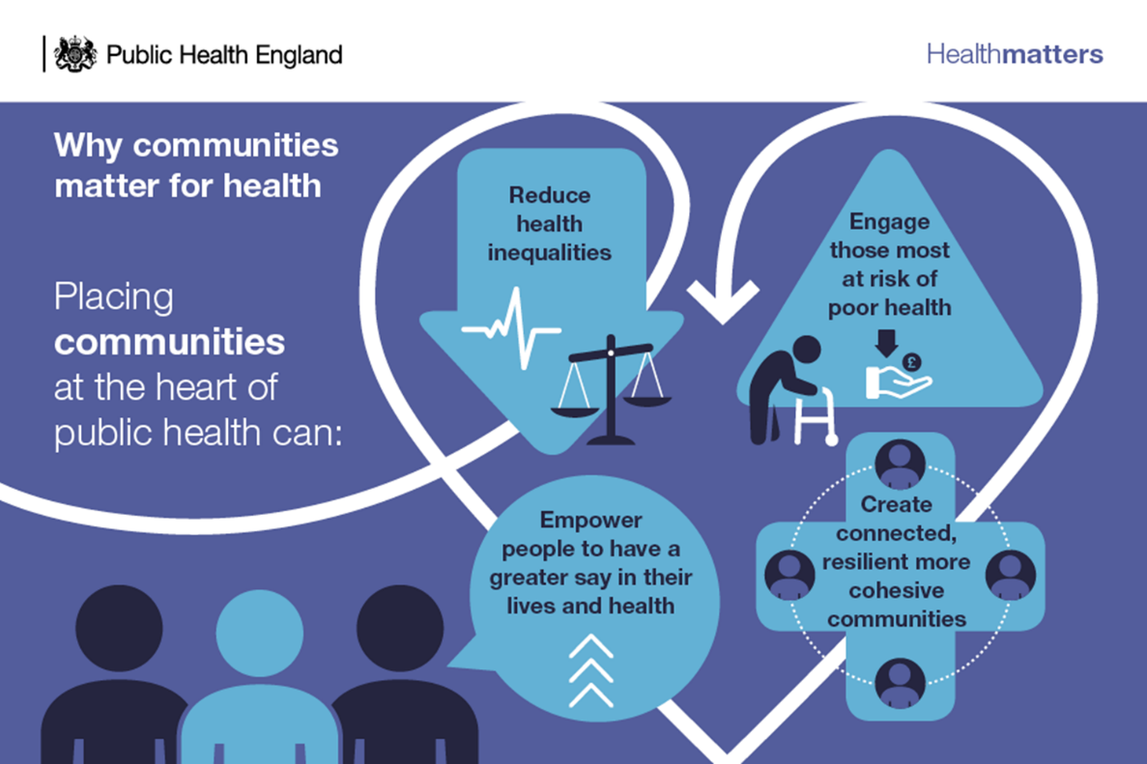
Fig. 1 Why communities matter for health: Health matters
See also: Evidence guide on Psychosocial pathways and health outcomes
Key point: To increase understanding of, and attention to, the contribution of community level determinants within the causal pathway.to health outcomes

What are community-centred approaches?

Community-centred approaches enhance individual and community capabilities, create healthier places and reduce health inequalities. Community-centred approaches are not just community-based, but are about mobilising assets within communities, promoting equity, and increasing people’s control over their health and lives.
Community-centred approaches involve:
- Using non-clinical methods
- Using participatory approaches, such as community members actively involved in design, delivery and evaluation
- Reducing barriers to engagement for people
- Utilising and building on local community assets
- Collaborating with those most at risk of poor health
- Changing the conditions that drive poor health
- Addressing community-level factors such as social networks, social capital and empowerment
- Increasing people’s control over their health
Key point: To use the above principles to guide delivery of community-centred practice.
The ‘family of community-centred approaches’ shows the range of practical and evidence-based approaches that can be scaled in local neighbourhoods:
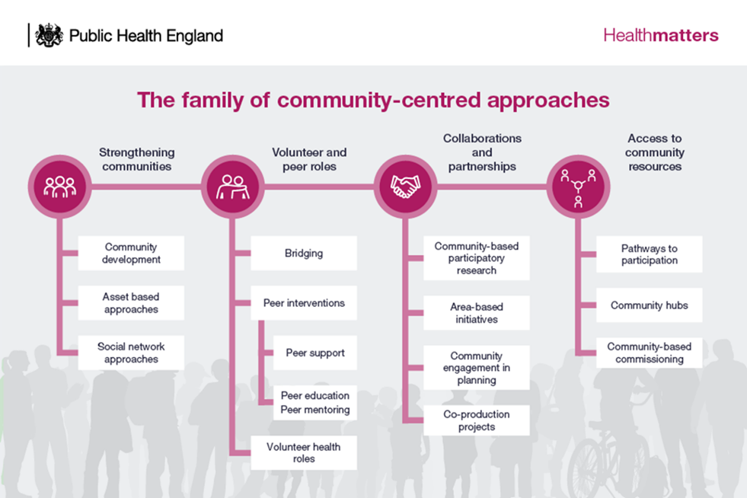
Fig 2. The family of community-centred approaches
PHE guidance: evidence and family of approaches: Guide to Community-Centred Approaches for Health & Wellbeing.
Journal article: evidence-based framework - https://doi.org/10.1093/heapro/dax083
Journal article: Putting the public back into public health - https://doi.org/10.1093/pubmed/fdy041
NICE guidance on Community Engagement provides recommendations for public health, health and social care https://pathways.nice.org.uk/pathways/community-engagement.
NICE Quality Standards for commissioning https://www.nice.org.uk/guidance/qs148, and importantly, standards for promoting health and preventing premature mortality amongst Black, Asian and minority ethnic communities. https://www.nice.org.uk/guidance/qs167
Key point: The family of community-centred approaches has been utilised by local areas to audit current availability and range of approaches across different neighbourhoods/ communities and help plan future commissioning.

Are there examples from practice?
There is a collection of over 50 local community-centred practice examples that provides learning from local implementation (now on the UKHSA library) - https://bit.ly/2xVaBDY
This uses a tested methodology, and the template can be downloaded, and new examples submitted. UKHSA are committed to working with OHID to grow, maintain and continue to share this popular resource.
Journal article: learning from practice examples https://doi.org/10.1093/pubmed/fdac065
Key point: To continue to grow the evidence from practice by collecting, reviewing and sharing local examples (template and collection on the UKHSA library)

How can approaches be systematised to have greater impact?

To have impact on widening health disparities, further action can be taken to put communities at the heart of our services through whole system working. Building trust and relationships between services and communities is an important part of a whole system approach.
Research by PHE identified the elements of a community-centred public health system. This can be achieved by:
- Scaling community-centred approaches across places and communities
- Involving communities in decision-making and being guided by community voice
- Strengthening our workforce and VCSE to reach those most in need
- Sustaining outcomes through long-term actions and measuring what matters to communities
Briefing on framework: Community-centred public health: taking a whole system approach
PHE Blog - https://bit.ly/3b88Qah
Journal article - https://bit.ly/2Rwemwo
Slide-deck - https://bit.ly/3VJiLHU
Key point: The community-centred public health framework can be used to strengthen a place-based approach to reducing health inequalities through taking a whole system approach
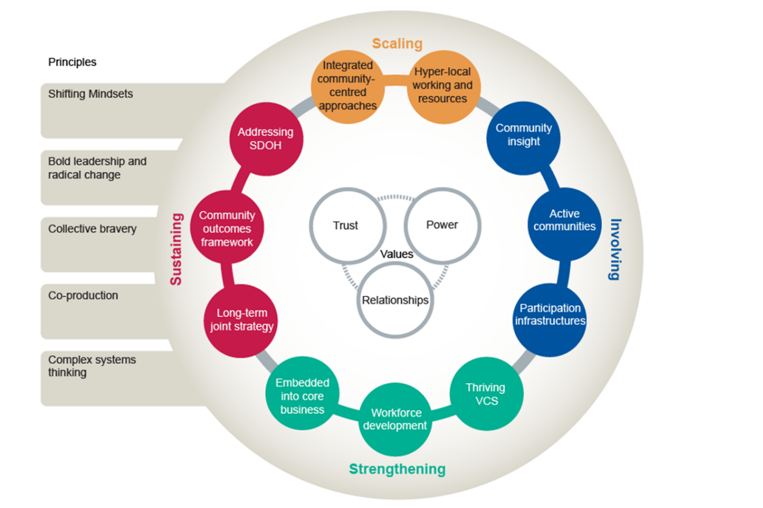
Fig 3. Community-centred public health: taking a whole system approach
Examples and tools to support systems working:
Whole system practice-examples - https://bit.ly/3ZlfkdA
Test and learn: Role of LAs and community businesses - https://bit.ly/3Gd4Eop
Community-centred public health implementation resources (INTERNAL) –
Maturity matrix quality improvement tool to stimulate thinking and action across national/ regional PH programmes (INTERNAL) –
Place based approaches to reducing health Inequalities: Framework and Maturity Matrices - https://bit.ly/3ClUUXX
Tool B:
HEAT guidance – community-centred approaches in update 2021 - https://bit.ly/3QjfJZR
NHSE Statutory guidance on working with people and communities - https://bit.ly/3GmwUFl
Key point: The different frameworks and tools are complementary and intended to stimulate thinking about how to develop community-centred public heath as part of place-based approaches to reducing health inequalities

What is the role of the VCSE sector?

The VCSE sector is well-placed to provide leadership and delivery of community-centred approaches and systems.
DHSC, NHSE, and UKHSA work with the Voluntary, Community and Social Enterprise sector via the Health and Wellbeing Alliance. See https://www.england.nhs.uk/hwalliance/ and https://www.gov.uk/government/news/charities-unite-to-tackle-health-inequalities
PHE and OHID has worked with Alliance members over the years to strengthen community-centred ways of working in public health. For example:
NAVCA: https://files.constantcontact.com/ca3da02a001/f2f5fe9f-9a61-4f93-911b-bb556b270ec1.pdf
NCVO: Voluntary sector case studies https://ukhsalibrary.koha-ptfs.co.uk/practice-examples/caba/wsa/ncvo/
Locality: https://locality.org.uk/reports/community-anchors-and-the-wider-determinants-of-health
Locality https://locality.org.uk/reports/creating-health-and-wealth-by-stealth
Key point: The HWB Alliance is an important national resource for progressing community-centred approaches for health and wellbeing within national delivery and policy.

What are the implications for workforce development?

The Public Health Skills and Knowledge framework includes several elements relevant to community-centred approaches:
Health Promotion:
A2.1 Influence and strengthen community action by empowering communities through evidence based approaches
A2.3 Initiate and/or support action to create environments that facilitate and enable health and wellbeing for [individuals, groups and] communities
A2.6 Facilitate change in [organisations,] communities [and/or individuals]
Service re-design:
B 5.3 Engage stakeholders (including service users) in service design and development, to deliver accessible and equitable person-centred services
Policy:
B1.3 Develop and implement action plans, with, and for specific groups and communities, to deliver outcomes identified in strategies and policies
Collaboration:
B2.5 Connect communities, groups and individuals to local resources and services that support their health and wellbeing
Commissioning:
B3.3 Commission and/ or provide services and interventions in ways that involve end users and support community interests to achieve equitable person-centred delivery
Democracy:
B4.4 Help [individuals and] communities to have more control over the decisions that affect them and promote health equity, equality and justice.
A job role on working with communities has been mapped against the PHSKF. This could be used to embed public health knowledge and skills into a range of community roles as well as embed community-centred knowledge and skills into public health roles –
The Public Health Specialty training curricula 2022 includes the following relevant learning outcomes:
Health Intelligence
1.7/ 1.8 Health needs assessment
Policy and strategy development and implementation
3.4 Engagement and co-production with the public
Strategic leadership and collaborative working for health
-
Health improvement, determinants of health, and health communication
5a Theory and practice of community development
5.3 Influence community actions and services, by working with and empowering communities using participatory, engagement or asset-based approaches
Health protection
-
Health and Care Public Health
7.4 Advocate proposals for improving health or care outcomes working with diverse audiences
Professional personal and ethical development
9.8 Demonstrate cultural competence and is able to work effectively in cross-cultural situations both internally and externally to the organisation.
There is an Apprenticeship Standard for community health and wellbeing workers that can be used by employers to build local capacity - https://www.instituteforapprenticeships.org/apprenticeship-standards/community-health-and-wellbeing-worker/
Other frameworks that include working with communities:
Public Mental Health https://www.gov.uk/government/publications/public-mental-health-leadership-and-workforce-development-framework
Person-centred approaches https://www.skillsforhealth.org.uk/info-hub/person-centred-approaches-2017/
eLearning
Bite-sized learning for health practitioners on community-centred practice at All Our Health https://www.gov.uk/government/publications/community-centred-practice-applying-all-our-health
E-Learning for Health also has more in-depth (Masters-level) learning for public health practitioners/ specialists on healthy communities and community-centred approaches - https://www.e-lfh.org.uk/programmes/community-centred-approaches-to-health-improvement/

Article: Building Community Capacity: What can health visitors do? - https://doi.org/10.12968/johv.2016.4.3.138
Key point: There are no relevant standards within the PH practitioner curriculum, despite roles often having a community-facing element.

What was learnt from the COVID-19 pandemic?
The COVID-19 pandemic demonstrated the important role that communities play in health and the need to listen, involve and empower communities. This has been identified as a strength of the response that needs to be built on as part of a community-centred legacy.
Blog on the role of communities in COVID response - https://bit.ly/2PUuszH
Report: Beyond the Data: understanding the impact on BAME communities - https://www.gov.uk/government/publications/covid-19-understanding-the-impact-on-bame-communities
Journal article: Strengthening and sustaining community resilience in the context of COVID - https://bit.ly/3xSlvrx
Journal article: Community resilience and social capital - https://doi.org/10.21203/rs.3.rs-1521540/v1
Recovery plan assurance checklist/ Key lines of enquiry (could be adapted for other assurance) –
Internal briefing -
The government’s 2022 Resilience Framework includes strengthening community resilience and working with communities and VCSE in emergencies. https://www.gov.uk/government/publications/the-uk-government-resilience-framework

Community champions
Community champions are a community-centred approach that involve community members as volunteers in public health and healthcare. This approach was used extensively in the COVID-19 pandemic, supported by DLUHC funding.
A review of the evidence on community champions approaches can be found at https://www.gov.uk/government/publications/community-champion-approaches-rapid-scoping-review-of-evidence
Programme guidance and resources to support those designing and implementing community champions programmes in local areas is available here: https://www.gov.uk/government/publications/community-champions-programme-guidance-and-resources
Watch a video from practice at https://www.youtube.com/watch?v=vWgEeLnhwN4&t=4s
Further examples of community champion local practice are available on the LGA public health learning exchange: https://khub.net/web/public-health-learning-exchange
OHID has utilised R&D CAF funds to commission a scoping of local community champions schemes: learning and current status. This is being carried out by the Kings Fund with York University and will report in 2023.
Key point: The pandemic left a legacy of community-centred public health on which to build momentum for community-centred approaches and systems.

