**Case study**

**Creating a single point of access for the Harrogate community secondary mental services for older people**

**Harrogate Dementia Collaborative**

**Background**

This project is the second piece of improvement work led by the Harrogate Dementia Collaborative. The Harrogate Dementia Collaborative was set up in 2012 by leaders responsible for providing and commissioning health and social care services in Harrogate and District.

**A one stop shop for mental health community services means older people with Dementia and memory problem will get the support they need more quickly.**

The project aims to support the local Dementia Strategy and address The Prime Ministers challenge on Dementia in the Harrogate area.

To do this, the project will use the North East Transformation Services Quality Improvement System to deliver large-scale change across organisational boundaries to improve the quality and experience of services accessed by people with Dementia

The organisations leading the collaborative are:

* Harrogate District Foundation Trust (HDFT)
* North Yorkshire County Council (NYCC) who provide social care services to older people who have problems related to illness, disability or ageing
* Harrogate and Rural District Clinical Commissioning Group (HCCG) who commission local health services
* Tees, Esk and Wear Valleys NHS Foundation Trust (TEWV) who run the local mental health services

The need to improve access to the community mental health services for older people and support earlier diagnosis through the memory clinic was sparked by multi-agency high-level mapping event held in April, 2012.

This issue was addressed using a Rapid Process Improvement Workshop (RPIW) to drive patient-centred improvement.

A RPIW is a rigorous five day event that eliminates waste and improves flow by redesigning ineffective processes. An RPIW encourages ‘thinking differently’ and evidence-based action. Importantly, the people who do the work design the work in an RPIW with staff empowered to make the changes needed.

**Stakeholder involvement**

The direction the RPIW took was led by the views of carers, GPs and social care colleagues gathered at stakeholder focus groups. All the stakeholders felt that once accessed, the mental health services provided to older people were good. Some of the issues captured included:

* It can be difficult getting a diagnosis
* Carers want to have improved communication and involvement with the services
* How the services fit together is not easily understood
* GPs expect to get knocked back by some services
* Referrals can get bounced around the different teams wasting time
* There is lots of waiting involved in the process
* Hard to keep up with all the service changes

**Removing waste in the system and using our resources more effectively means that clients will now be sooner by the services that best fit there need.**

**Planning and preparation**

The planning for the improvement event commenced six weeks prior to the event to gather evidence from which to make improvements. During this time each step of the processes were observed and timed. This identified multiple, complex and confusing routes for referrals. This resulted in resources being used ineffectively and significant waits for clients.

**The improvements made**

The volume and quality of the improvements made by the staff was staggering. In total 16 new standard operations were created. These standards support the:

* Definition and function of the new single point of access duty worker to triage all referrals to the most appropriate service
* Release of clinicians’ time to spend with clients
* Removal of the backlog of patients waiting for appointments
* Prompt assessment by the memory clinic (within 14 days) and onward referral for Dementia diagnosis if required
* Development of more consistent high quality practice in the clinics
* Use of visual control boards to ensure resources are used more effectively to meet clients’ needs
* Development of a simple service navigation tool
* Creation of a new link-worker function to improve liaison with GP practices
* Using electronic systems to send and receive referrals by GPs
* Use of shared, electronic diaries by staff
* Improved communication with all stakeholders
* Creation of a better work environment for staff

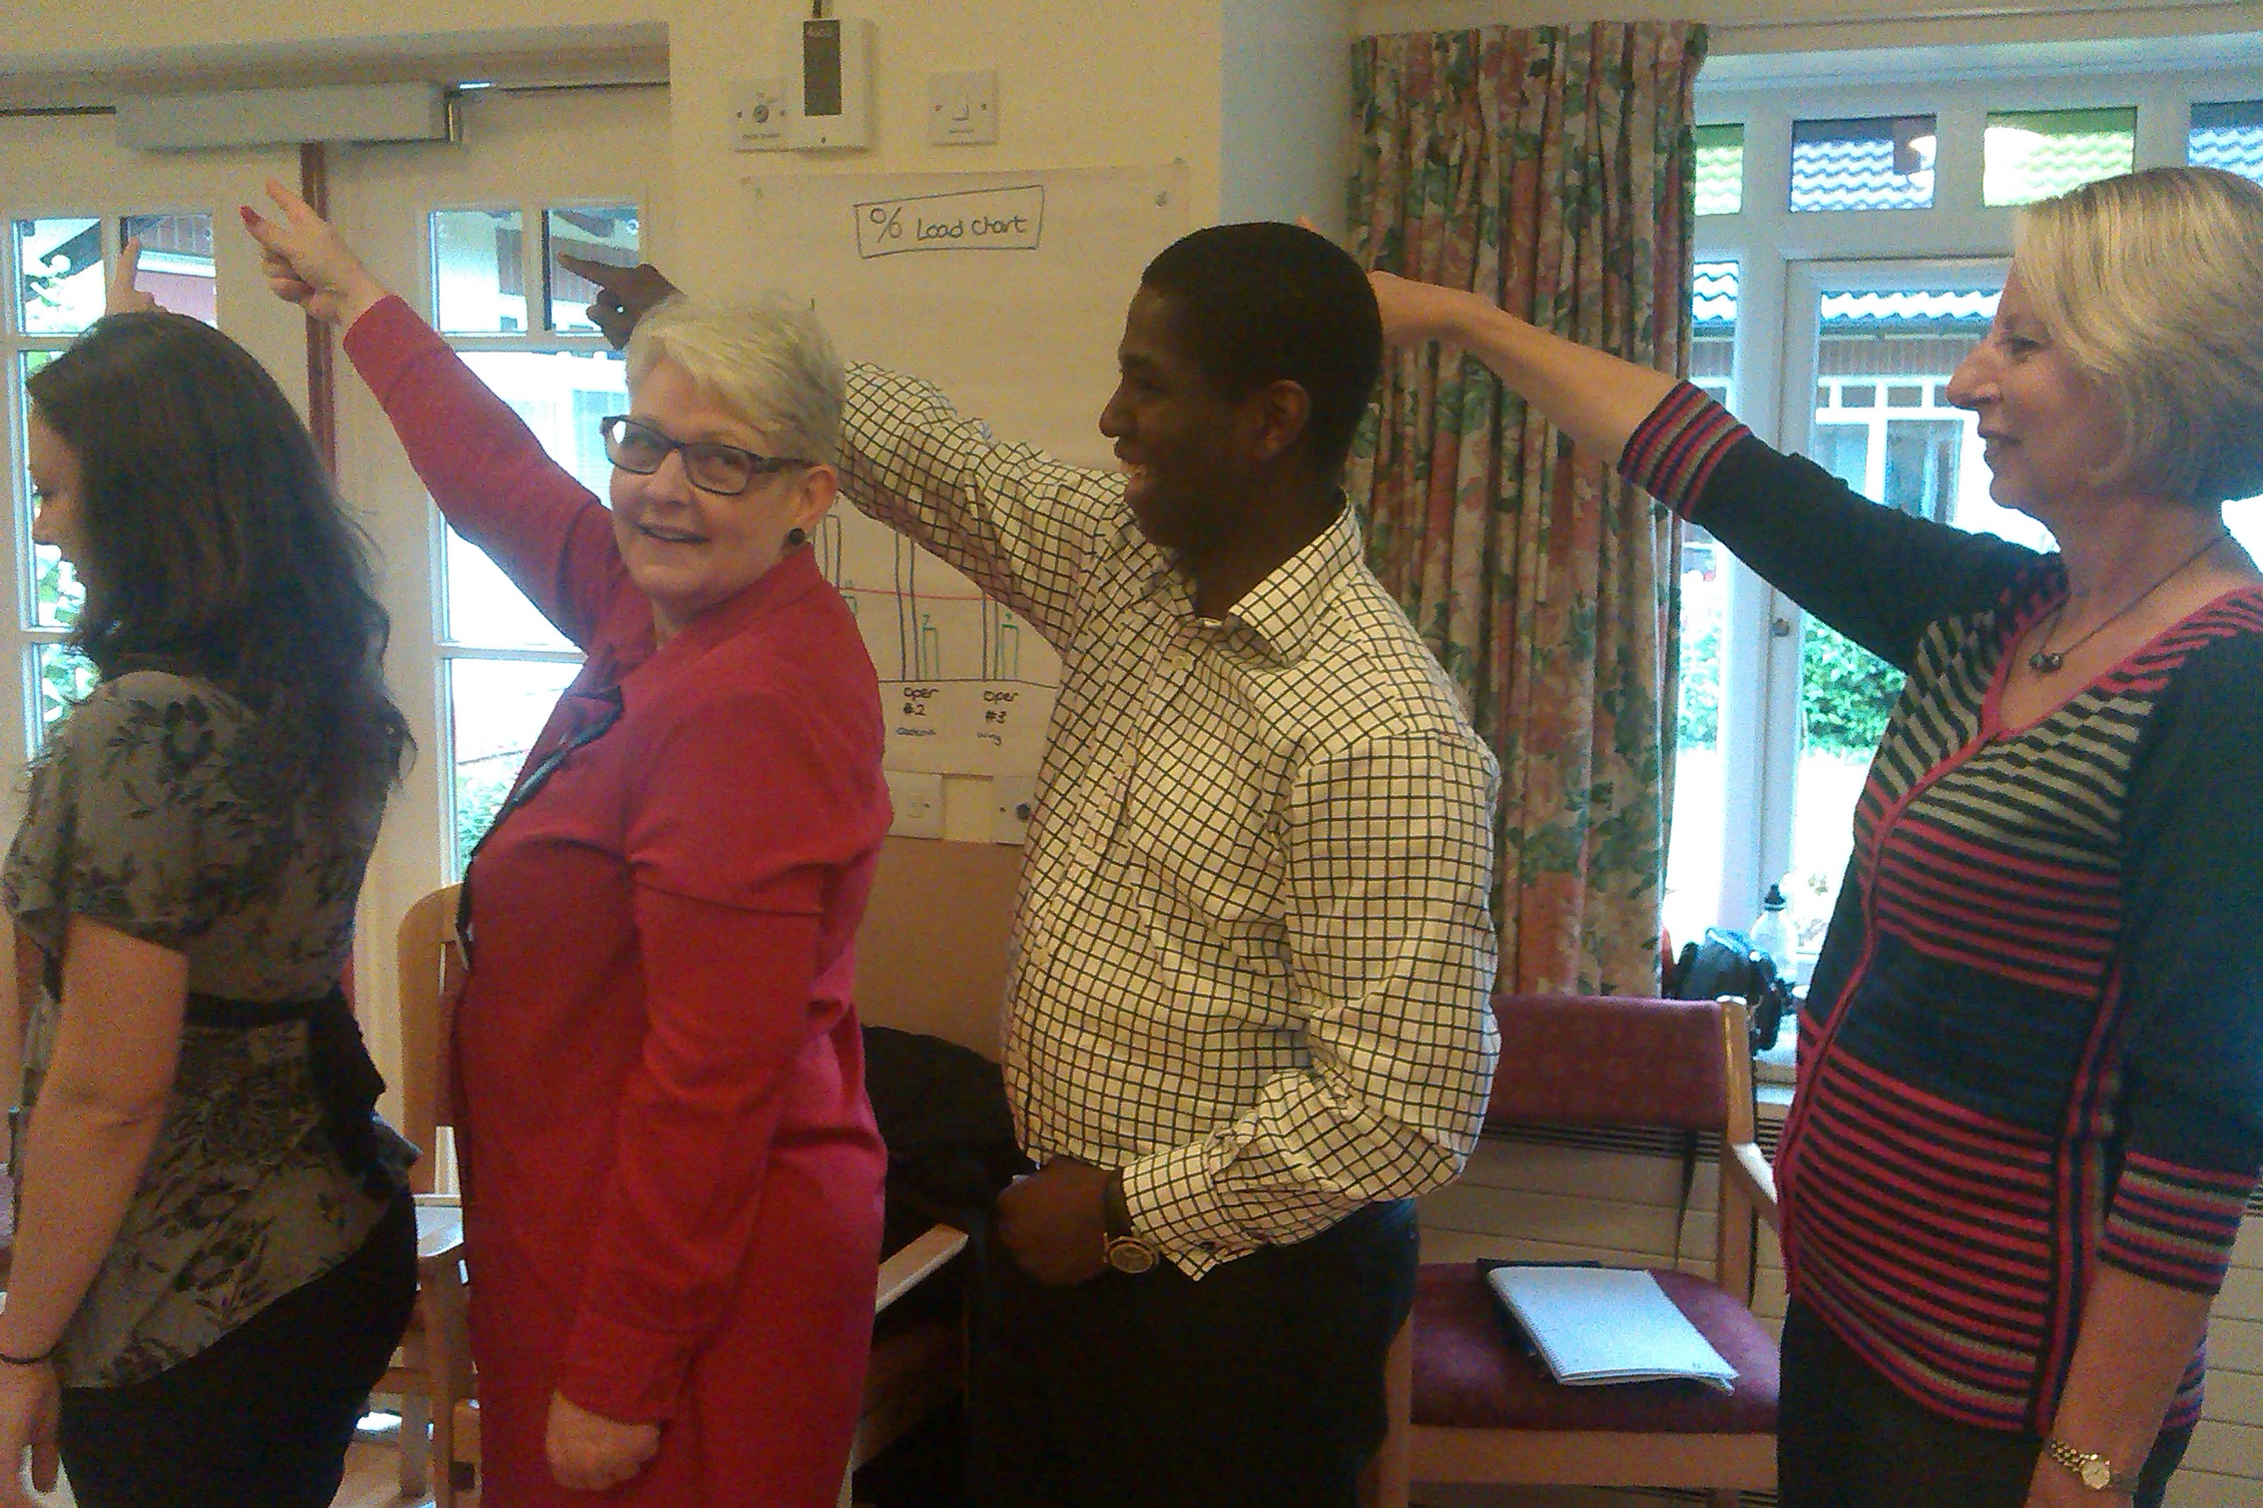

**The new process**

The result is a timely, robust and consistent approach to allocating a referral to the services best suited to the clients’ needs.

Gone are complex and confusing processes.

Now there is one point of access with three simple steps for all the Memory Service, Rapid Response Intermediate Care, Elderly Mental Health (RRICE) team, community mental health nurses, occupational therapists and also the psychology team.

A referral is now triaged by a skilled duty worker who will indentify the most appropriate key worker for the client. Immediately the earliest appointment is booked into the key workers diary who will then confirm with the client.

**Referral to secondary mental health future process**



**Challenges**

The RPIW was an intensive week that made rapid changes. A key challenge will be maintaining the momentum as staff return to their normal roles. The changes went beyond the mental health team. To drive implementation; a Newspaper has been created containing an action plan for each of the 19 improvements to ensure sustainability

**“*With over 150 years of health and social care experience we knew we could address the issues presented to us*”**

**Next steps**

The process of continual improvement starts now. The changes were made during the RPIW with the intention of meeting the targets listed. Progress toward these will be measured at 30, 60 and within 90 days after the RPIW.

* Appointment slots to be identified within 1 day
* For RRICE clients to be seen within 4 hours
* For the Memory Service and other teams, clients to be seen within 14 days of referral being received
* Data quality to be improved
* Clients receive relevant information
* All GPs to receive details about appointments and outcomes from appointments