Estimating the contribution of influenza, COVID-19 and extreme cold weather to excess mortality – a working paper update for 2026

Winter 2025 to 2026, with backdated estimates to 2012 to 2013

Using an adapted FluMOMO model

Nick Andrews¹
Conall Watson¹

¹ Immunisation and Vaccine-Preventable Diseases Division, UK Health Security Agency

1. Introduction
The burden of influenza-related mortality has been estimated for many years based on assessing all-cause mortality and influenza incidence. Spikes of excess mortality are often seen when influenza circulation is at its peak or highest in a given winter period. This has led to regression models being developed that model a baseline mortality along with an attributable influenza component to estimate contribution of influenza. The baseline model is typically a Serfling (sine/cosine wave) with a trend.¹ More recently models have been extended to take into account extreme weather such as the FluMOMO model.²

The FluMOMO model has been used by the UK Health Security Agency (UKHSA) for many years to estimate influenza-related mortality and is published in annual reports.³⁻⁶ In 2023 the model was adapted to include COVID-19 and to deal with the very high level of mortality in the first waves of COVID-19. The temperature modelling was also slightly changed. Full details of the new model are given in the working paper.⁷ Results of running the model in 2023 to 2024 and 2024 to 2025 with some minor adaptations are in the working paper for those years.^{8,9}

For the 2025 to 2026 winter the adapted model was run again using data from week 40 2012 to week 13 2026. This produced estimates of attributable mortality for the 2025 to 2026 winter and also updated estimates for the previous years. In this paper we also compare the output to the model run in 2025.

2. Data used for the 2026 model
The all-cause mortality data were the same as used in the 2025 model but updated to week 13 of 2026 based on the EuroMOMO registration-delay corrected deaths from the model run in week 17 of 2026.¹⁰ The data were stratified by week of death and age group (<5,5-14,15-64,65+).

Influenza activity by age group was included in the model using data on rates of influenza like illness (ILI) extracted from the Royal College of General Practitioners (RCGP) Research and Surveillance Centre database. The ILI rates were multiplied by the overall weekly swab influenza positivity rates from samples taken by a subset of RCGP practices to give the influenza indicator.

As in 2023 and 2024 the temperature element used thresholds at 3°C (low) and 18°C (high). The Met Office Hadley Centre Central England Temperature (CET) dataset was used to create a weekly national mean temperature to measure against.¹⁰ The difference from the threshold was calculated when temperatures went beyond them, so, for example, a weekly mean CET of 1°C was given a parameter value of 2 (3°C minus 1°C).

Figure 1 shows the temperature data, with thresholds just over 1°C above or below the modelled summer maximum and winter minimum temperature indicated. The thresholds identify several high weeks each summer and low weeks most winters to represent extreme weeks.

Figure 1. Mean Central England Temperature (with fitted line and the cut-offs used for extreme temperature)

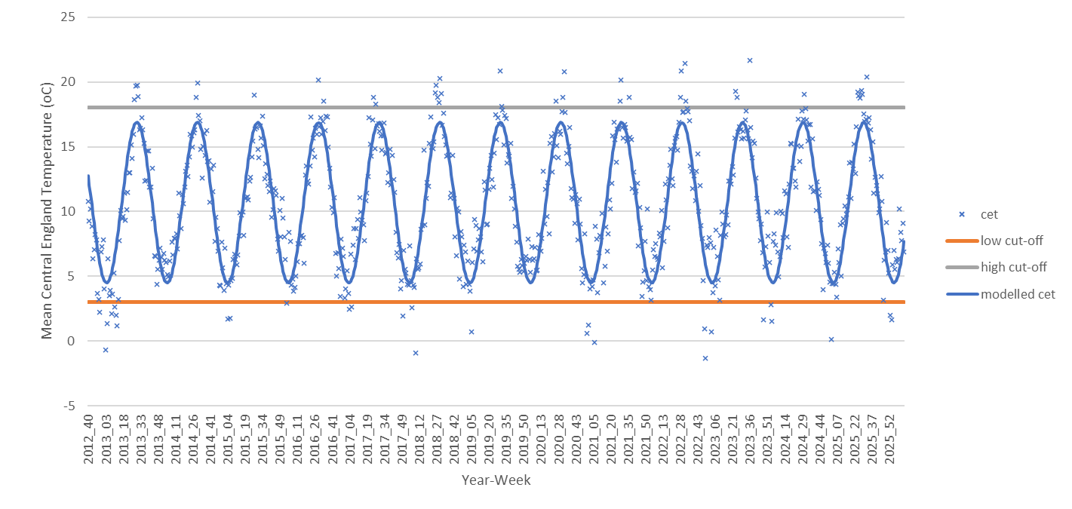

As was done in the 2023, 2024 and 2025 models, to address the initial two largest COVID-19-related spikes in number of deaths, and the low number in the weeks following the second spike, the period from week 13 2020 to week 26 2021 was given zero weight when fitting the models and excess mortality in the winter of 2019 to 2020 and 2020 to 2021 was not estimated for COVID-19. To further down-weight any remaining outliers, the model was re-weighted twice with standardised residuals <-2 or >2 given a weight of 1/(residual^2).

Also as done in 2023, 2024 and 2025, to account for COVID-19 in the period from week 27 2021 weekly ONS COVID-19 death occurrences were included as an explanatory variable in the model. These were split into two series comprising deaths assumed to be due to the Delta variant from week 27 2021 to week 1 2022, and deaths assumed to be due to the Omicron variant from week 2 2022 onwards, meaning that two COVID-19 parameters for the contribution of Delta and Omicron to all-cause mortality were included in the model. Figure 2 shows the numbers of COVID-19 deaths with the Delta and Omicron periods that were included in the models highlighted. The COVID-19 deaths were extracted in week 17 of 2026 back to the start of the pandemic and did include some additional deaths throughout the pandemic that were registered late.

The model of all-cause mortality therefore had explanatory variable for heat (1 parameter), cold (3 parameters to allow lags of up to 2 weeks), influenza (42 parameters to cover 14 seasons and within each season lags of up to 2 weeks), COVID-19 (2 parameters to cover Delta and Omicron), and baseline (6 parameters to cover a constant, a trend and sine and cosine waves with periods 26 and 52). Models were run separately for each age group and fitted using Poisson regression with a rescaling of standard errors to allow for over-dispersion.

Total deaths were calculated by summing across the 4 age groups. The 95% Confidence Interval (CI) for this was based on the standard errors of each of the estimates for each age group.

Figure 2. COVID-19-related deaths (ONS death certificate) week 10 2020 – week 13 2026 with the Delta and Omicron periods used in the analysis shown,

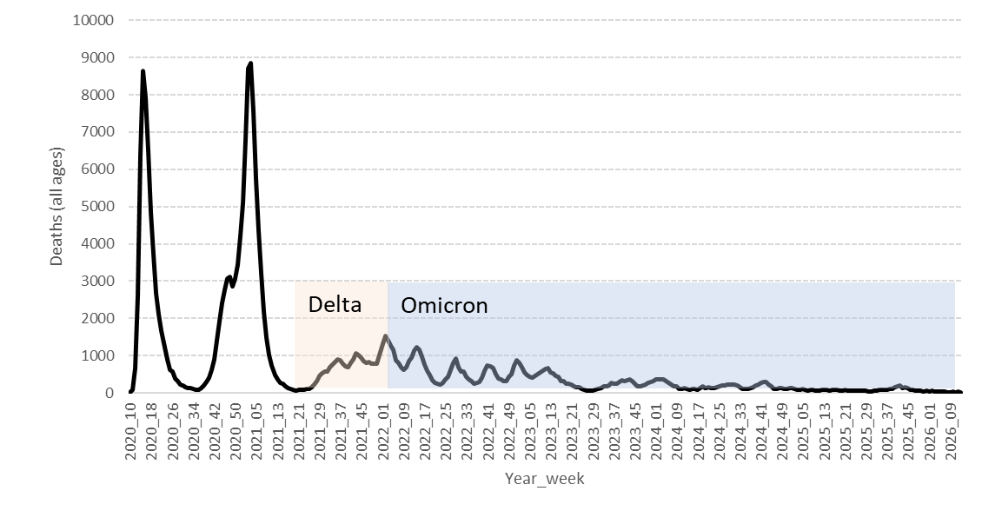

3. Results

3.1. Descriptive
Results are based on deaths to week 13 2026, extracted in week 17 2026 to allow time for data to be more complete and less dependent on corrections for delayed death registration. The influenza indicator is shown in Figure 3. Activity in 2025/26 was similar, although earlier in the season than 2024/2025. Note however that it is the timing within each season of influenza activity compared to mortality spikes that matters, not the overall level within any year.

The modelled contribution of influenza, COVID-19 and temperature, when looking at the model with all ages combined, is shown in Figure 4. Note this is not the model used for all age estimates, as that combines across the individual ages. Figure 5 shows the most recent four winters and does combine across ages here to get the totals.

Figure 3: Influenza activity incidence by year 2012 to 2026

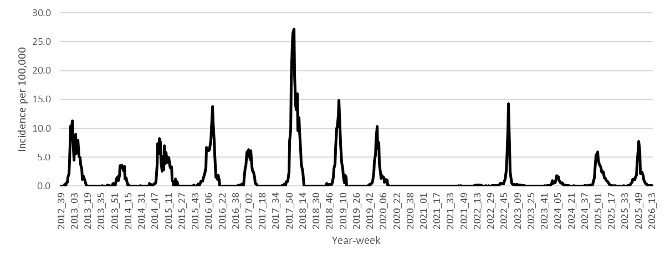

Figure 4: Modelled excess mortality
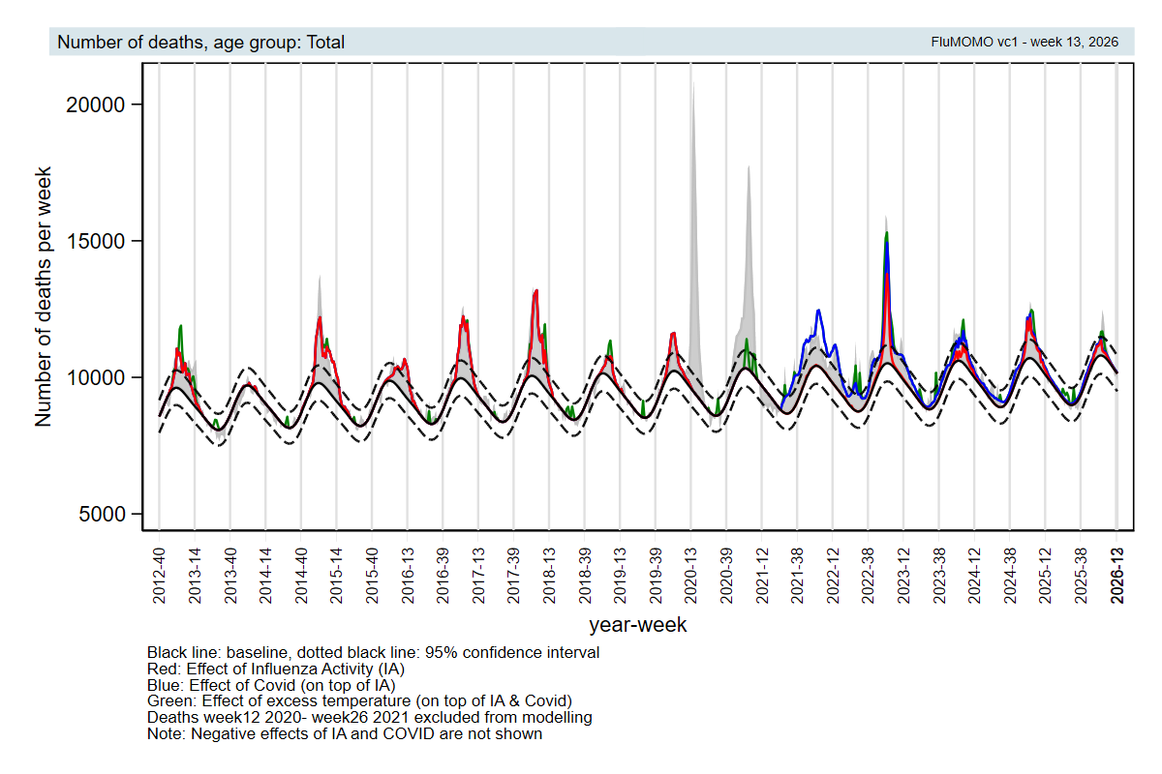

Figure 5: Modelled excess with focus on data since week 40 2022

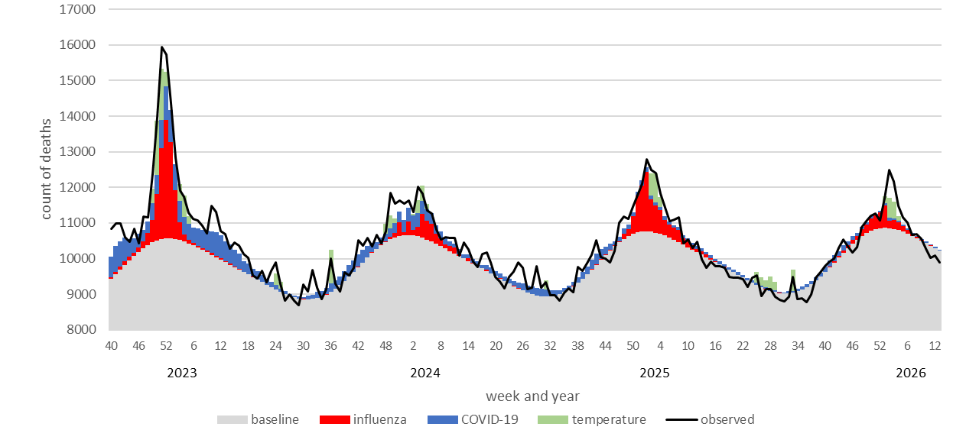

3.2. Full results from the model
The estimated number of deaths in all-age total and by age group for 2025 to 2026 are shown in Table 1 below. Values in paratheses are 95% CI. They do not include uncertainty from model specification. The 2023 working paper sensitivity analyses demonstrated results for temperature and to a lesser extent COVID-19 can vary depending on the model.

Table 1 Estimates of mortality by age 2025 to 2026

Age | Influenza | COVID-19 | Cold | Unexplained | Total
0-4 years | 7 (2-13) | 0 (-1-1) | 5 (2-8) | -40 | -28
5-14 years | 3 (1-6) | 0 (-1-1) | -1 (-2-0) | -36 | -34
15-64 years | 346 (301-394) | 266 (241-293) | 84 (66-104) | -471 | 226
65+ | 3442 (3140-3753) | 1576 (1439-1718) | 1299 (1161-1442) | 222 | 6540
Total | 3798 (3488-4108) | 1842 (1700-1984) | 1387 (1245-1529) | -325 | 6704

Note that estimates in children should be treated with caution, as the method is unlikely to be reliable enough to estimate such small excesses with accuracy.

The all-age total estimates by year are shown in Table 3 below, including unexplained excess and total. Unexplained is negative if the estimated excess from influenza, COVID-19 and cold is more than the observed total excess above the baseline.

Table 2: Estimates of attributable all cause mortality by season (week 40 to week 20)
Year | Influenza | COVID-19 | Cold | Unexplained | Total
2012/13 | 11418 | 0 | 5243 | 4357 | 21020
2013/14 | 661 | 0 | 0 | -6165 | -5503
2014/15 | 33281 | 0 | 1307 | -4482 | 30107
2015/16 | 12356 | 0 | 45 | 1207 | 13608
2016/17 | 19074 | 0 | 464 | 3266 | 22805
2017/18 | 24742 | 0 | 2896 | 7662 | 35300
2018/19 | 5332 | 0 | 1261 | -2735 | 3858
2019/20 | 9123 | n/a* | 0 | 55592 | 64715
2020/21 | 0 | n/a* | 4126 | 46864 | 50990
2021/22 | 432 | 35540 | 0 | -7004 | 28967
2022/23 | 14378 | 17474 | 5064 | 6621 | 43537
2023/24 | 4431 | 7702 | 1743 | 2684 | 16560
2024/25 | 9740 | 4003 | 1690 | -969 | 14465
2025/26 (week 13) | 3798 | 1842 | 1387 | -325 | 6704
*n/a as the period covering the first two COVID-19 waves was not included in the model.

Comparison to the 2024 model results is shown in Table 3.

Table 3: Estimates of attributable mortality from the models run in 2026 and 2025

 | Influenza |  | COVID-19 |  | Cold
year | 2026 model | 2025 model | 2026 model | 2025 model | 2026 model | 2025 model
2012/13 | 11418 | 16870 |  |  | 5243 | 4405
2013/14 | 661 | 1229 |  |  | 0 | 0
2014/15 | 33281 | 35949 |  |  | 1307 | 1103
2015/16 | 12356 | 12792 |  |  | 45 | 38
2016/17 | 19074 | 19191 |  |  | 464 | 392
2017/18 | 24742 | 25161 |  |  | 2896 | 2450
2018/19 | 5332 | 5537 |  |  | 1261 | 1069
2019/20 | 9123 | 8973 | n/a | n/a | 0 | 0
2020/21 | 0 | 0 | n/a | n/a | 4126 | 3497
2021/22 | 432 | 788 | 35540 | 30583 | 0 | 0
2022/23 | 14378 | 15867 | 17474 | 14198 | 5064 | 4292
2023/24 | 4431 | 3555 | 7702 | 6272 | 1743 | 1484
2024/25* | 9740 | 7757 | 4003 | 2763 | 1690 | 1439
*2024/25 was to week 13 for the 2025 model and to week 20 for the 2026 model.

4. Comment
Influenza-related mortality is estimated to be around 3,800 deaths for winter 2025 to 2026. This presents a fairly low estimate in comparison to the average of about 12000 (this is the average when excluding the COVID-19 seasons of 2020/21 and 2021/22). Because the effects of cold on mortality continue over a few weeks (hence the inclusion of lag terms) and because the Omicron COVID-19 waves have not shown large spikes, the method is less well suited to provide reliable estimates of the mortality contribution of these factors. The estimates mortality due to COVID-19 in 2025 to 2026 is about 1,800 which is similar to the ONS coded observed number of 1,822. For temperature-related mortality, the ~1,400 estimate is based on 2 cold weeks and gave similar estimates to 2023/24 and 2024/25. Note that this estimate is contingent on the definition of cold used and will differ to those produced in the annual UKHSA cold mortality report.¹² If thresholds were changed to assign more weeks to be cold weeks then it is likely more deaths would be attributed to severe cold weather, however the aim was to look at extreme cold weather only.

When updating the model fit in 2026 there were some changes to the previous year’s estimates although most were fairly small. The changes indicate that the estimates are sensitive to model specification. Even modest changes to underlying trends can shift past estimates, particularly at the ends of the data such as the 2012/13 estimate which did reduce a fair amount. If the model continues to use many years of data consideration of a non-linear will be necessary. COVID-19 estimates increased by about 15-20% from last year’s estimates.

There are other factors not attributed that may contribute to winter mortality, such as pressures on acute health services and the circulation of other infections. The model methods assume these factors are captured in the seasonal component. The influenza estimates, in particular, are quite robust to other factors (unless those factors cause spikes at the same time as the influenza spike). Whilst further possible causes of winter mortality could be modelled the methodology is unlikely to give reliable estimates unless effects are large and occur in concentrated periods.

References
- Serfling R. Methods for current statistical analysis of excess pneumonia-influenza deaths. Public Health Reports (1896) 1963: volume 78, issue 6, pages 494-506
- Nielsen J, Krause T, Molbak K. Influenza‐associated mortality determined from all‐cause mortality, Denmark 2010/11‐2016/17: The FluMOMO model Influenza and Other Respiratory Viruses 2018: volume 12 issue 5, pages 591-604
- UK Health Security Agency Surveillance of influenza and other seasonal respiratory viruses in the UK, winter 2021 to 2022 and previous reports backdated to 2011/12: Public Health England Annual flu reports, Health Protection Agency Influenza, viewed 22 May 2023
- Pebody RG, Green HK, Warburton F, Sinnathamby M, Ellis J, Mølbak K, Nielsen J, de Lusignan S, Andrews N. Significant spike in excess mortality in England in winter 2014/15 - influenza the likely culprit. Epidemiology & Infection (146;9) 2018
- Pebody RG, Warburton F, Andrews N, Sinnathamby M, Yonova I, Reynolds A, Robertson C, Cottrell S, Sartaj M, Gunson R, Donati M, Moore C, Ellis J, de Lusignan S, McMenamin J, Zambon M. Uptake and effectiveness of influenza vaccine in those aged 65 years and older in the United Kingdom, influenza seasons 2010/11 to 2016/17. Eurosurveillance 23;39) 2018
- Sinnathamby MA, Warburton F, Reynolds AJ, et al. An intercountry comparison of the impact of the paediatric live attenuated influenza vaccine (LAIV) programme across the UK and the Republic of Ireland (ROI), 2010 to 2017. Influenza Other Respi Viruses (17;2) 2023
- Andrews N, Clare, T, Sinnathamby M, Watson, C. Working Paper – Estimating the contribution of influenza, COVID-19 and extreme cold weather to excess mortality, winter 2022/2023. 2023
- Andrews N, Watson, C. Estimating the contribution of influenza, COVID-19 and extreme cold weather to excess mortality – a working paper update for 2024. Contribution of flu, COVID-19 and cold weather to excess mortality
- Andrews N, Watson, C. Estimating the contribution of influenza, COVID-19 and extreme cold weather to excess mortality – a working paper update for 2025. Contribution of flu, COVID-19 and cold weather to excess mortality
- The EuroMOMO model: Methods and Rationale. EuroMOMO Network, viewed 22 May 2024
- Central England Temperature datasets Met Office Hadley Centre, viewed 22 May 2024
- UK Health Security Agency Cold mortality monitoring report, England: winter 2024 to 2025, viewed 11 May 2026

